DPW - n-tier web application configuration guide
Best Practices and Techniques

Microsoft Consulting Services
Greater Pennsylvania District
July 1, 2003

1. Introduction
Contents

2. DPW Overview
Program Offices
POSNet
Mainframe data
Web Development

3. Commonwealth e-commerce overview
Overview
Security
Web Applications farm

4. N-tier web application architecture
Overview

5. N-tier application development recommendations
Presentation
Business Logic
Data Access
Legacy Data Access Methods
Web Development and Publishing

6. N-tier architecture configuration recommendations
Internet Gateway Infrastructure
Security
Internet access
Intranet access
Extranet access
Administration
Remote administration

7. Performance
N-tier development architecture
N-tier architecture configuration
Web Servers
Component Servers
Data Servers
Direct access vs. Proxy access
WAS (Microsoft Web Application Stress tool)
Monitoring

8. Sample configuration: Child Adoption website

9. Futures

10. Additional Information

Appendix A: IIS 4.0 Tuning guide
Appendix B: Securing IIS 4.0
Appendix C: VPN Overview

In the vast landscape of e-commerce and web related technologies, it is not only difficult to decide what technologies to use but how to use and configure technologies once chosen. Technologies such as virtual private networks (VPNs), COM (Component Object Models), IIS (Internet Information Services) and others require skilled and experienced IT professionals to design and deploy into a cohesive inter-technology information system framework. In addition, the administration and maintenance of these information systems need a well-planned strategy in order to gain the financial benefits of newer technologies. With all of these options available, some companies need third-party assistance in either deciding on technologies to use or how to configure technologies in relation to a company’s strategic business initiatives.

introduction

Goal
The Department of Public Welfare (DPW) requested a proposal from Microsoft Consulting Services for the configuration of components in n-tier web applications. The proposal supplements the DPW Internet, Intranet and Extranet Development and Maintenance policy and procedures. The combination of these 2 documents lays a foundation for web environments based on best practices and techniques on developing, configurating, and deploying n-tier web applications.

The goal of this document is to provide DPW with a configuration guide for n-tier applications within Internet, Intranet, and Extranet application environments while maintaining a balance of performance, security and administration within DPW’s existing information technology environment.

Audience
The audience for this configuration guide is DPW IT personnel that have responsibility for the development, administration, management, security and operations aspects of Internet, Intranet, and Extranet applications within DPW. In addition, those personnel within the Commonwealth of PA that have production operation support of these applications.

Scope
The scope of this configuration guide is to aid DPW IT professionals in the design and configuration of n-tier web applications for an Internet, Intranet, and Extranet environments. This includes a recommendation on partitioning of web applications into an n-tier component environment with respect to the following:

- Security
A security framework for the configuration of web Internet, Intranet, and Extranet applications to meet DPW’s security requirements. In addition, the recommendation and configuration of supporting technologies that facilitates secure access to DPW resources from remote locations by business partners.

- Performance
The physical configuration of each tier (presentation, component, and data) in an n-tier web application architecture to provide maximum performance based on usage, user population and business requirements. This can only be expressed in general terms – real performance must be gauged on a case –by-case basis.
- Administration
The configuration of an administration model for n-tier servers that provides the greatest flexibility, ease of administration and maintenance for both local and remote locations.

As stated earlier in the goals section, this proposal supplements the DPW Internet, Intranet and Extranet Development and Maintenance policy and procedures; thus does not directly discuss items addressed in that document. However, since web development (technologies, processes and methodologies) are constantly changing; there are no guarantees that statements within this does not conflict with earlier statements made in the earlier published documents. In addition, this document does not directly discuss any of the following:

- Implementation plans
- Migration strategies
- Development styles and coding standards
- Database standards

Finally, these recommendations are neither evaluations nor criticisms of current DPW’s application architectures, networks, applications and processes. These guidelines are derived from industry best practices and techniques for designing, administrating, and maintaining n-tier web environments within DPW. The intent of this document is to aid DPW in developing a scalable and manageable n-tier web environment. Lastly, to create a roadmap for DPW to allow easier integration and interoperatability with the Governor’s E-Commerce strategy.
DPW and its Program Offices are just beginning to ramp-up their e-commerce efforts. CYO&F has rolled out a web site to provide children adoption services over the Internet. There are also several Intranets in production and many of DPW’s Program Offices expect an increase in web development projects in the near future. With this increase of web development activity, it becomes increasingly difficult to create integrated systems that are easy to administer and monitor. In addition, the effort to consolidate these many efforts to gain economies of scale with these new platforms increases proportionally.

DPW OVerview

Program Offices
DPW consists of several business units or program offices, which cover all aspects of public welfare. Each unit is responsible for administrating and maintaining their data. After meeting with some of the larger units regarding their web development environment, application architecture, and strategic web development plans, it became clear that much of the units’ primary concern is enabling secure external access to their information and their internal web sites by business partners – or an extranet.

Other concerns centered on web content creation, management and secure access internally and externally from DPW. Most of the units are forging ahead with their web application plans using whatever resources they have at their disposal. Although a “grass-roots” effort is sustainable in small to medium environments, properly scaling and integrating these efforts in larger more complex environments are more difficult unless standards or guidelines for configuration, performance analysis, and systems integration are available.

POSNet
A private network of DPW business partners that have dedicated or dial-up connections into DPW. Most partners use POSNet to access internal only applications. With the growth in Internet and VPN technology, business partners are beginning to ask why they cannot access DPW through the Internet instead of POSNet. Today, the costs of POSNet lease lines are expensive to maintain and dial-up access to POSNet is not 100% reliable and available.

Legacy data
Today, about 90% of the data that DPW uses is stored in hierarchical databases (DMS and RDMS) on Unisys OS2200 mainframes. The majority of the applications are front-end terminal (“green-screen”) style, which retrieve data from these mainframe databases. Although, there are a few C/S applications most mission critical applications still reside on the mainframe.

Web development
The majority of new development efforts for DPW and its Program Offices are web centric. Currently, these development efforts are primarily level 1 and 2 type web applications. Meaning that most of the information is ready-only static pages – information that does not vary frequently (level 1) and dynamic page generation based on databases and request information – search engines and form submittal (level 2). Whereas level 3 web applications are full n-tier C/S applications with a GUI, business logic, and data tiers supporting transactional components.

DPW’s web development environment consists of Microsoft FrontPage, Allaire HomeSite, and Microsoft Visual Interdev and Source Safe. Currently, there is no integrated web development and publishing method.

The current web development model is to develop on a local workstation using either Visual Interdev or FrontPage and Visual Source Safe to track code changes. Then the developer publishes to a development web server via FTP for the rest of the development team to use. When the site is ready to move into production it is released in Visual Source Safe by the developers and moved to production by the production web administrators.
The Commonwealth of PA’s e-business strategy is in its early stages of development. Much work in the areas of design, technology selection, architecture, implementation, and deployment need to be completed.

COmmonwealth e-business strategy

The following statements and information were gathered form a meeting with Dan Zenzal, MCS Senior Consultant, working directly with the Commonwealth on it’s e-business strategy. More information on this strategy will be available shortly on the OIT internal web site. <dan is this okay?>

The e-business strategy at a high level can be broken down into 5 sections:

- The PA portal interface – “PAPowerPort”
This will be the new interface into the Commonwealth of PA web site. The goal here is to provide a common interface that users can access all areas of the Commonwealth from a single point.

- E-government
This will be the interface for local governments, townships, municipalities and other interstate agencies performing government related functions. Essentially, becoming a “Single face to Government” to users of the government. Users will be able to access services throughout the Commonwealth without being hindered by agency boundaries and incompatible systems.

Using technologies such as XML (Extensible Markup Language) and having guidelines for agencies to create common data definition schemes for their data structures, interoperatability between information systems across the Commonwealth can be achieved. The fundamental idea is that e-government will become the model implementation by which other agencies within the Commonwealth can use as a template.

- E-commerce
This will define recommendations and solutions for doing electronic procurement, invoicing and a central credit card validation-processing center. Basically, providing agencies within the Commonwealth a central point for doing commerce and commerce related transactions within applications without the administrative overhead for doing these types of transactions.

- E-education
The Commonwealth is working with third-party vendors to develop the curriculums and plans to be used by the education system.

- E-citizen
E-Citizen will provide state citizens with e-mail and easier Internet access.

Security strategies for Commonwealth e-business
The security strategies to compliment this business strategy consist of general guidelines for agencies to follow so that security configurations are interoperatable and cost effective across the Commonwealth. These security guidelines will be forthcoming in the E-Commerce plan.

Web applications that are hosted centrally will need to perform routine security audits and risk assessments of their application prior to application deployment. Today, there are 2 matrixes (Management Directive and IT Bulletin) available to gauge the security and risks of a web site. Both are available on the OIT web site (http://paoit.state.pa.us).

The IT Bulletin defines 3 categories or levels of risk:

- User Authentication
- Encryption
- Certificates

However, there is no provision for the use of digital certifications. Instead, the Commonwealth is looking into standardizing digital certificates and its process so each agency does not need to manage their own PKI (Public Key Infrastructure). Each agency will use the PKI for the Commonwealth. The idea here is that users accessing the Commonwealth and its agencies will have one digital certificate to present to any agency. For applications requiring greater security, there will be the ability to create custom certificates but this will be on a case-by-case basis such as JNET. The default (most applications) will use the standard PKI provided by the Commonwealth. If there is a business need today to use PKI you must contact the OIT.

Web Applications Farm
Finally, a common web applications farm will be provided to Commonwealth agencies for Internet, Intranet, and Extranet hosting. The following are benefits to an agency for using this facility:

- Centrally managed by help desk (3 tier level support planned)
- Provides for backups, hw monitoring, maintenance of logs, and general OS support
- Working with vendor to identify appropriate second level support and route applications issue to the responsible agency.
- Super secure environment locked room with individual server cages for additional security.
- A production Internet and Intranet database environments will be available on a case-by-case basis if no mainframe or SQL data storage capability is available from the agency.

With the exception of a few items such as security much of the e-business strategies will be high-level concepts without in-depth implementation details. This type of approach will allow for flexibility in how each agency decides to implement their portion of the overall E-Commerce strategy. Agencies need to adhere to technology standards and guidelines for the purpose of creating systems that are interoperatability and supportable across the Commonwealth enterprise.
Overview

n-tier architecture
A n-tier application architecture allows for the partitioned design of an application in such a way that each tier can independently provide services or additional functionality to the other tiers without the knowledge of how the other tiers are implemented. Typically, an n-tier application refers to an application that is logically separated by user interface, business rules, and data. Usually, an object model approach is used to encapsulate each tier. The interfaces to each tier are used to link together the other tiers. These object interfaces provide the connection points for the other tiers. A benefit of this is that the internal architecture of each tier can be changed without modifications to the other tiers. In general, n-tier applications are more (1) scaleable, (2) reusable, and (3) extensible compared to their monolithic predecessors.

- Scalable
  - Can grow to multiple severs (web farm)
  - Can move business objects to a middle-tier server (COM Server)
  - Can move data tier to a data server (SQL Server

- Reusable
- Component based development
- Callable from server-side scripting (ASP)
- Callable from traditional clients (VB, Office, Win32 Apps)

- Extensible
- Can use built-in components
- Can extend with third-party components
- Can build custom components
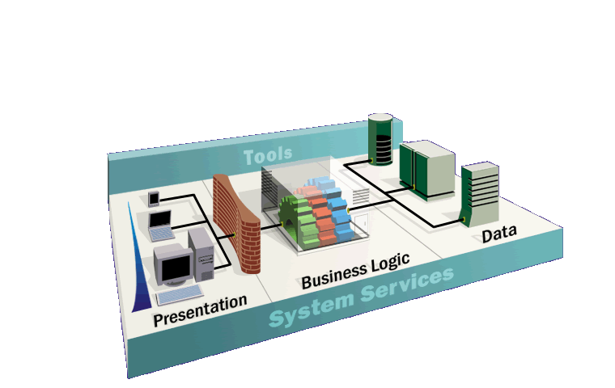
External
Applications
Legacy Systems
Databases
Thin
Client
Rich
Client

Figure 4.1 – N-tier application architecture

The figure above illustrates a typical n-tier application architecture by which each tier (presentation, business logic, and data) can support various physical implementations at each tier.

Presentation tier
The presentation tier consists of standard HTML web browsers and servers, Office applications, and custom Win32 applications. This tier’s primary concern is the presentation (formatting) of information to the client. Each client can render its version of the information received from the business logic tier in a way that best utilizes the client platform.

In a web based environment, server-side scripts (ASPs) allow this tier to link with the business logic tier. In the Microsoft model, Active Server Pages or ASPs can call business logic components either local or remote from the web server and return the resulting data to the presentation tier where the server renders it into the form of HTML to the client.

Business Logic tier
The business logic tier consists of objects that encapsulate business rules and functions. These objects provide services to the presentation tier through common object interfaces; thus, making them compatible with different presentation tier implementations.

Data tier
The data tier consists of access to database servers and data sources through a common data provider such as OLE-DB.

N-tier is a logical partitioning
The n-tier application architecture denotes a logical partitioning of an application not a physical one. Meaning, that each tier can exist on one or many servers – web farm or data center. In fact, all 3 tiers can exist on 1 or many server(s) if server resources permit. Thus, making n-tier architectures high scalable and best suited in high volume environments such as e-commerce.

Example
The figure below shows a quick example of a search engine partitioned into an n-tier application.
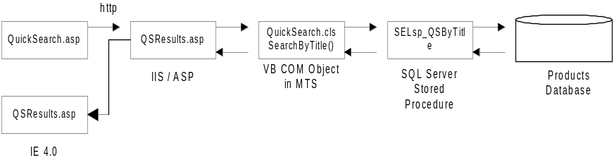

Figure 4.2 – Sample n-tier partitioning

Quicksearch.asp is displayed to the browser as HTML using HTTP. The ASP script on the page calls QuickSearch.cls (search components) which in turn calls a SQL stored procedure residing in the database to retrieve the desired data

- Presentation tier
Quicksearch.asp and QSResults.asp rendered using IIS/ASP

- Component tier
QuickSearch.cls running in MTS or COM+ Services

- Data tier
SELsp_QSByTitl in SQL Server ties can be utilized without regard to security issues.
Current N-tier web development within DPW is a 2-tier implementation where tier 1 is the web server (IIS) and tier 2 is the database servers (SQL). While this an acceptable practice, DPW should begin to migrate its web applications into a n-tier model. Also, new application development should utilize a n-tier architecture design.

n-tier development Recommendation

In addition, a n-tier architecture would allow DPW to better aligned with the overall Commonwealth E-Government strategy – “A single face into government”. This can be accomplished by creating components (at the middle tier) that can be used by external agencies to retrieve information from DPW without understanding the internal details of the operation. Overall, DPW should begin to “look at applications as functional rather than specific to an agency” – Dan Zenzel (Microsoft Consultant for the Commonwealth of PA). DPW should not only provide information to internal applications but to other agencies within the Commonwealth. Using an n-tier approach in design can begin to facilitate this architecture.

- Presentation tier
DPW should create standards regarding browser versions to support for each user population (Internet, Intranet, and Extranet). The following guidelines should be met:

  - Internet
DPW should support browsers 3.x and higher. This is defined as an unknown population of public users that can use any versions of the browser. If browser specific functions are needed, creating a separate site for each browser version is recommended.

  - Intranet and Extranet
DPW should support the standard internal browser versions. This is a known and controllable population. Web site functionality and features can be tuned for specific browser version. However, given the rate of change in the web world, applications that where once thought as “internal only” should be able to be ported to the Internet quickly. Thus, developers should be cautious when using browser specific functions and features.

In general, the presentation tier should be targeted for the lowest common denominator and only deviate if business functionality or feature requires it.

So in terms of web applications, what is the presentation tier? The presentation tier for web applications is plain and simple HTML. HTML should be used to present or format all information that is sent to the browser with the exception of using embedded objects or applets for special purpose applications.

- Business Logic tier
DPW business logic should be written as components with well-defined interfaces for DPW applications to use. This allows for a reusable strategy when developing new applications. In addition, it allows other agencies to use these components (with adequate permissions) in other applications outside of DPW; thus, adhering to the Commonwealth e-Government strategy.

For example, Income Maintenance (OIM) creates a component that retrieves income information for a PA citizen from its database on the DPW mainframe. Now all agencies requiring income information could use this component to lookup a citizen’s income without the administrative overhead of contacting OIM and understanding the underlying data schema. Thus, creating an interagency transaction, which is transparent to the user.

Since most of DPW’s web applications today are done using ASP (Active Server Pages) caution must be taken when partitioning a web application between presentation and component tiers. ASPs should be used as “glue code for components” whenever possible. Today, ASP 3.0 is an un-complied script language; thus, not suited for processing large sections of business logic. Large sections of business logic should be encapsulated into a component and processed within an object broker such as the Microsoft Transaction Server (MTS) or its successor Component Object Model Services (COM+). This will provide several advantages: (1) faster response times, (2) greater scalability for high volume, (3) more modular code design and (4) inclusion in a transaction.

- Data tier
An issue that DPW faces today is how to access data on the mainframe from a web application? The “knee-jerk” reaction in providing data to web applications is by doing a file extract from the mainframe and import it into SQL Server. Although this method is fairly straightforward and simple to perform, in some cases such as when data updates are allowed, this may not be the best solution. There is; however, other methods that are in place within DPW. Some of these are:

- WebTS
WebTS provides a web or HTML interface to terminal style applications allowing data to be retrieved and sent directly to the mainframe database. Since WebTS puts a web interface on an existing terminal application, the web interface is limited to existing screens within the terminal application. WebTS does not allow for the modification or server-side processing of data outside of the terminal application.

- ClearPath Open Data Access
ClearPath Open Data Access program, designed to enable the full participation of ClearPath enabled mainframes in open, distributed data environments. This allows for the continued use of DMS and RDMS on the mainframe to manage your data rather than doing adhoc migrations or replications of data onto other systems.

ClearPath consists of InfoAccess and UniAccess to connect to DMS and RDMS databases on the Unisys mainframes. Both of thee products can use standard (ODBC and OLE DB) connections to legacy databases on the mainframe.

Given that most of DPW’s data is on the mainframe, when architecting the data tier DPW should look into using Unisys’s ClearPath technologies to access their DMS and RDMS data on the mainframe. UniAccess and InfoAccess offers OLE DB connections to ClearPath enabled mainframes. Thus, information can be obtained from the mainframe without the need for other middleware technologies. These components can be integrated into other business logic components and included into a transaction. Accessing mainframe data from web site using UniAccess and InfoAccess would be the preferred solution for the data tier.

However, if website performance becomes an issue then migrating the data to SQL Server would be the easiest solution but this should only be considered as an exception and not the norm.

Web Development and Publishing recommendations
Web application content management, development and publishing can be a very difficult procedure without the proper tools and guidelines in place. As DPW’s web environment grows more complex there chosen tools must be able to scale and still be able to handle the overall process of managing, developing and maintaining web applications both in production and development.

Features and functionalities of a properly designed web environment should consist of the following:

- Seamless integration
The web development environment must be integrated from various stages (function, unit and system tests) of development through staging and production. In addition, developing web applications is a multi-skilled discipline requiring skills in multiple programming languages and technologies. For example, web developers require skills in HTML, a script language such as JavaScript or VBScript, a traditional programming language such as C++, VB and Java, and SQL Server. With this large array of tools, web developers need an integrated environment that encompasses all these skills easily.

- Version control
The ability to track and save changes of an application from each version. Version control provides the ability to rollback changes that are not desired or ill behaving.

- Ease of security and administration
Tight security should be maintained throughout the development process without adding complex administrative overhead into a RAD environment.

Of the various integrated web development packages available none offer the flexibility and integration as Microsoft’s Visual Studio development environment. More specifically, included in Visual Studio are

- Visual InterDev 6.0
Creating HTML and ASP files and overall content management of the web site. Provides the ability to develop, manage, and publish from a single interface.

- Visual Basic, Visual J, and Visual C++
Used for the development of business logic components and Win32 apps

- Visual Source Safe
Used for version and content management control.

- Integrated Development Interface
Provides for a single interface to the above applications.

This tool combined with IIS 4.0 running FrontPage Extensions offers a very compelling solution for small and large web environments. The easiest way to provide an example of this is to walk through the development of a typical ASP (Active Server Page) web project.

The new web project begins with the program manager creating a new web site through Visual InterDev connected to the development web server via FrontPage Server Extensions. After which, members of the development team are added to the web authors group (NTLM) for the new website and given permissions (NTFS) accordingly through the Visual InterDev interface.

As developers connect to the development web server with Visual InterDev, a local project is created on their workstation and synchronized with the server. Adding, deleting and editing web pages, components folders, and files can be made easily through the “explorer” like IDE. All a developer needs to do is “double-click” the file to make it writeable (file icon changes to a pencil and paper) or locked. Once a developer locks a page other developers can only get a read-only version of that file (denoted by a lock and paper) until the original developer releases the file. This ensures that no developers can overwrite someone else’s work. This editing control is in addition to using the integrated Visual Source Safe version control tool. Throughout the development of the project, files are updated and immediately available to other developers. The entire development cycle of the web project can be managed through one interface.

A drawback to using this web development model is with FrontPage Server Extensions (FSE). FSE does not scale well on high volume web sites. Therefore, FSE should only be used on development servers and not on production servers.

Once development is complete and ready for business acceptance testing, the project manager can move or publish (via FTP or a Win32 file copy) the site to the staging server, which the production team can move to the production environment when it passes business acceptance testing.

Synchronous vs. asynchronous applications
The synchronicity of a web application must be determined on a case-by-case basis. It is difficult to determine whether an application should be designed with synchronicity from the start without analyzing the business rules driving the application. However, here are some general guidelines for deciding whether to use synchronous and asynchronous components within an application.

- Synchronous
Applications that do not need an immediate response to information to proceed. For example, an airline reservation system is a synchronous system since seats must be committed before continuing to prevent conflicts in seating assignments.

These systems are usually slower and need more resources to sustain adequate response times when transaction volumes are high.

- Asynchronous
Applications that do not need an immediate response to information to proceed. For example, e-mail systems are asynchronous since the sender does not need to wait for a reply to the message before allow another message to be sent.

Usually, asynchronous applications are faster then their counterparts because it does not need to wait for a confirmation of response before it continuing.

High volume web applications should be asynchronous whenever possible. This allows for fast response times to the user even when load increases. Since each transaction does not need to wait for a response from backend systems such as database servers and mainframes, users can continue without waiting for the system. There are some products on the market that can enable asynchronous or message queuing web applications. Microsoft’s recommendation is:

- MSMQ (Microsoft Message Queuing)
A message queue service that provides COM interfaces to developers. This is the preferred queuing system when using Microsoft web technologies. If integration with another queuing system is required MSMQ can be integrated with MQSeries using a product from Level 7 Systems.

Integration with E-Government
Although a discussion into XML technologies and DPW’s integration with E-Government is not in the scope of this proposal, it is important to take note that DPW should look into creating XML data type definitions that describe the information contained in its data stores – namely on the mainframe. Once DPW’s data is defined in terms of XML, consumers (DPW and other agencies within the Commonwealth) can begin to create common interfaces to DPW’s information systems through XML data translations. Thus, enabling the development of new applications (web and traditional) easier and faster.
Overview

n-tier architecture recomendation
As more applications start to utilize web technologies the configuration, administration, management, and maintenance of the various servers that house these web technologies become increasingly difficult. Today, most companies separate their Internet and Intranet applications for security reasons. Moreover, some companies create two web server farms to facilitate this separation – this is overkill. The management of 2 large web farms is difficult and expensive to maintain. In addition, an increasing number of once “internal only” web applications are now made available to the Internet community. This is meant to foster the idea of “self-service” to decrease administration overhead of processing requests from the increased user community. To this end, it is recommended that DPW have an integrated n-tier architecture configuration for both Internet and Intranet applications.

This is a departure from what DPW is accustom to in terms of separation of web sites. Also, this model shifts most of the security burden away from networking personnel to where it belongs - the application architects and developers in conjunction with security policy makers. It will be up to each application to provide access permissions for users within their application. The networking team will still maintain overall security but will not be concerned with controlling applications.

This section first outlines a web application farm for a n-tier web architecture configuration that is scaled to handle a high volume web environment as well as extranet access to DPW. After which, a scaled down version of the configuration is discussed and a roadmap leading to the former. Throughout both configurations security, performance and administration is addressed.

Internet Infrastructure
Although, the recommended infrastructure assumes a scaled n-tier architecture, not all components shown are required to maintain this secure environment. It is designed so that components such as component servers, the additional SQL subnet can be added later. Components that are required and optional will be identified.

The diagram places the majority of the components within the OIT facility’s connection to the Internet. This architecture can be used at anywhere a secure web site configuration is required. Since OIT’s facility might not be ready to provide such services to agencies, DPW should partially implement the below architecture (see figure x.3) for their web application configuration until such time the OIT facility can offer similar services.

The following diagram describes the recommended solution for securing a gateway system for authenticated and non-authenticated communications to the Internet. The two major components of a gateway system that need to be secured are the network infrastructure and the NT machines that provide the gateway’s functionality and domain services.

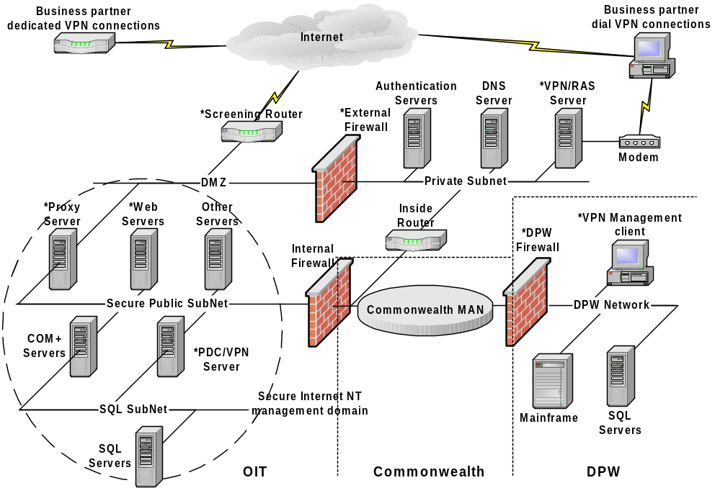

Figure 6.1 - Scaled Internet Gateway Infrastructure

Internet Gateway Infrastructure components
- Screening router
Required component for first line of defense against unauthorized access to internal network.

The screening router is the initial point of contact between the outside world (Internet) and gateway’s DMZ. The Internet-side interface is exposed to all traffic sent from the Internet as specified by the Internet Service Provider. Filter rules defined by the network administrator should only allow known traffic to pass through the router and on to the DMZ.

The Internet interface is the focus of most Internet attacks. By testing all ports with various types of data, weaknesses/bugs are often found in the router software that can result in either system compromise or denial of service. It is safe to assume that your exposed router will come under attack at least once in its operational lifetime.

- DMZ network
Required component for the overlapping buffer zone for internal and external systems.

The DMZ (demilitarize zone) is the segment of the network where there exists an overlap between internal and external systems. Any equipment that directly receives external requests is considered to be sacrificial.

- Proxy Server
Required component for web access security.

The proxy server performs two basic functions:

  - Application level security
  - Physically link the screening router to the Secure Public Network.

Proxy Server uses reverse proxying and reverse hosting to send requests downstream to a Web server or group of Web servers located behind the Proxy Server-based computer.
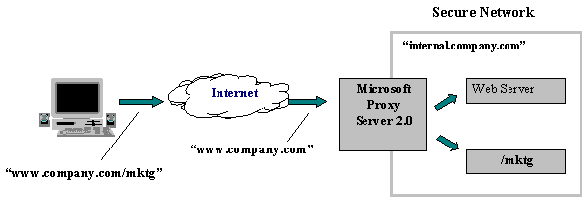
Figure 6.2 – Web Publishing
Reverse proxy and reverse hosting offload Web publishing duties from the Web servers and let you securely connect your Web servers to the rest of your intranet.
Reverse proxying causes the Proxy Server-based computer to “impersonate” a Web server to the outside world. The Proxy Server-based computer fulfills client requests for Web content from its cache and forwards requests to the real Web server only when the requests cannot be served from its cache. Meanwhile, your Web server sits in its secure environment and maintains access to other internal network services.
Virtual, or reverse, hosting is an extension of the concept of reverse proxying. Virtual hosting allows any server sitting behind Proxy Server to publish to the Internet, giving superb flexibility in Web publishing. In this case, the Proxy Server-based machine simulates virtual roots on a Web server and then redirects requests for a particular domain and root combination to a single Web server. Reverse proxy works at the application layer and supports HTTP only.
This approach to Web publishing requires that only one “hole” be punched through the firewall for HTTP requests, thereby enhancing security.

- Secure Public Network
Required component for networking all information servers on the Internet gateway.

The Secure Public Network is isolated from the DMZ by the proxy server for incoming traffic. Since the proxy server protects the private “non-routable” IP address of the public web server all necessary management protocols can be readily opened and used internally on the web server without the possibility of exposing the server.

A non-routable address schema should be used on this segment.

- Information servers
Required component for publishing information to the Internet, Intranet and Extranet.

These servers contain only one interface card connected to the Secure Public Network and are members of the Secure Internet NT Domain.

- Component Servers
Not required unless there are n-tier applications using business logic components and physical separation is required of the application. In this diagram, these servers separate the data servers (data tier) from the web servers (presentation tier); however, if component servers are not need then an alternative method would be needed to connect the web servers to the data servers. The most common approach would be to use a router.

These are the business logic components servers. In a fully developed n-tier architecture these are the only servers that should talk to the database servers. Routing is not turned on.

- Secure Internet Domain PDC / VPN Server
Required to create the NT Internet domain for the management of information servers.

The Secure Internet Domain is the NT domain that envelops the proxy, information, and all servers connected to the Secure Public Network. The secure Internet domain provides authentication for system administrators, operations personnel, and possibly support representatives.

- Internal Firewall
Required component for securing the information servers from attacks from within the Commonwealth. If this level of security is not required then this firewall can be excluded from the system.

The purpose of the internal firewall is to prevent attacks to the Secure Public Network from within the Commonwealth. The internal firewall should be configured to only accept incoming traffic from the Commonwealth – it should not allow traffic originating from the secure public network. In order for remote management of the Internet NT domain, these firewalls must open port 1723 for PPTP traffic.

- External Firewall
Required component for creating an extranet connection to both dedicated and dial VPN business partners.
The purpose of this firewall is to protect the VPN Server and the internal network. Since the VPN server connects directly to the internal network on the inside of the internal firewall any comprise of the VPN server can lead to access to the internal network. This firewall should be configured to only allow incoming PPTP traffic.

- Authentication Servers
Required for RADIUS and eventually PKI types of authentication for users. If using standard security mechanisms then these servers are not needed.

These are the servers that store the userids for business partners accessing to the internal network via the Extranet. Both the external firewall and the RAS/VPN servers can be configured to authenticate users against them. They can either be RADIUS servers or PKI servers in the future. These servers can be a part of an NT domain to centralize userids but that is not a requirement.

- VPN/RAS Server
Required for creating VPN connections for business partners connecting from dial or the Internet.

Provide users with VPN sessions connecting via a modem or Internet. This is where the VPN tunnel terminates for both Internet and modem connected users; thus, creating the Extranet connection. The diagram shows only one server but more servers can be added as load increases. These servers should be monitored very carefully as all business partner traffic will pass through these systems.

- DNS Server
Required if no other DNS Services are currently available.

Configured as the authoritative zone for the external and internal namespace.

- Inside router
Required component for VPN connections. This router connects the private subnet and the internal network.

- SQL SubNet
Not required component unless physical separation of data tier is required.

The physical network connection for the SQL Servers and the COM+ Servers.

- SQL Servers
Required component for production Internet and Intranet web servers needed fast access to information. However, if performance is not an issue then data could be retrieved from anywhere within the Commonwealth network granted access permissions is allowed. This type of access would need to be gauge on a case-by-case basis.

Store production Internet and Intranet web site information.

- Remote administration workstation
Required for remote management of information servers within the secure public network. However, this does not need to be a dedicated computer. What is required is a VPN client, NT management tools such as MMC, and a userid on the Internet NT domain.

These are NT workstations loaded with administration tools within DPW that are allowed to connect to the Secure Internet Domain using a VPN client.

DPW Interim architecture
A fully scaled n-tier configuration (figure 6.1) will probably not be available from the start. Instead, a similar but smaller implementation should be used to test, understand, and establish the processes such as remote administration, change management, and monitoring services prior to deploying the full-scale model. This interim architecture is basically the same as the full-scaled version without the component servers, SQL subnet and VPN servers. Again, this architecture is modular in design so components can be added without impacting the rest of the system. The following diagram represents the interim architecture for DPW.

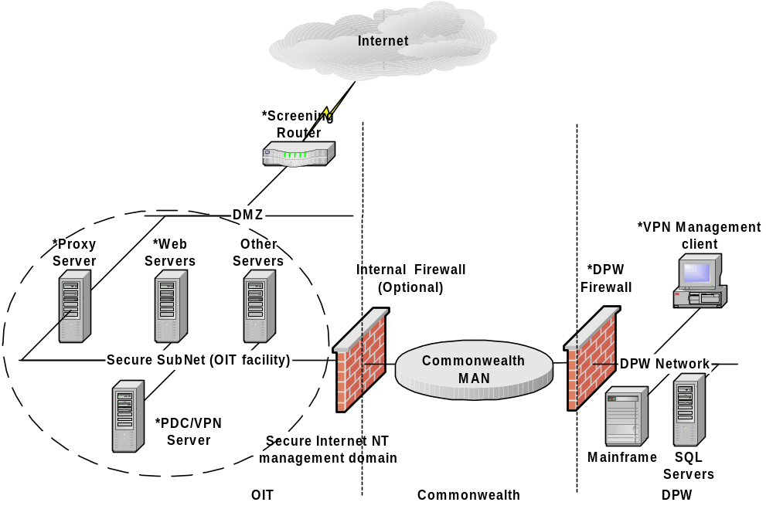
Figure 6.3 – DPW interim architecture

Internet Access
In the above diagram, the screening router filters incoming Internet requests and only traffic on certain authorized ports such as HTTP, FTP, SMTP and PPTP (administrator definable) will be allowed to pass. Once at the proxy server all HTTP requests will be forwarded through the proxy server to the appropriate web server via a process called “Web publishing” – available on MS Proxy Server 2.0 and all other traffic will be passed to the respected servers on the Secure Public Network.

NOTE: If more than one public web site is hosted, a process know as “Reverse Hosting” will be needed on the Proxy Server. See below for more details.

On those servers determined to be public access, an authentication schema for “anonymous” should be used on the servers.

Intranet access
DPW users can access Intranet applications directly from the internal network through the Commonwealth MAN. As depicted in the diagram, an Internal firewall or Proxy Server could be setup to further protect the web servers from compromise from within the Commonwealth.

Extranet access
Business partners access DPW via a VPN connection from the Internet or dial-in is sent to the secure private subnet. Connections from the Internet pass through the external firewall where it routes them directly to the VPN server for authentication and encryption. Upon validation the user’s sessions are encrypted over the public medium (Internet) and allowed to access internal resources (access rights allowed).

In the beginning, not all business partners will use the Internet for VPN connections; thus, a private dial-in server must be maintained for down level users. However, users are still authenticated against the same security processes; thus, eliminating the need to administrate 2 separate systems.

Advance Internet security
If it is necessary to increase the security of the system by preventing the possible attack of the proxy server on the DMZ, a firewall can be placed in front of the proxy server. Thus, the firewall will be connected to the DMZ and directly to the proxy server, which is connected to the Secure Public Network.

NOTE: This creates a one-to-one connection between the firewall and the proxy server so if load increases another firewall-proxy setup will be required.

The following diagram better illustrates this concept:

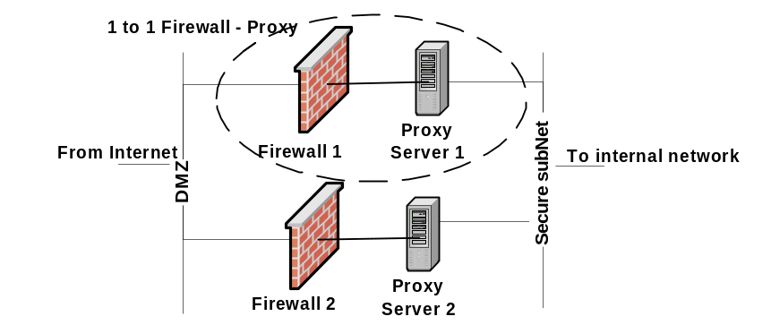
Figure 6.4 – Firewall-Proxy configuration

Since the firewall is directly connected to the Proxy server, as the systems scales this relationship must be maintained so that security is not compromised.

Change management and Security Evaluation Tools
Once you establish a secure DMZ, you have to understand how to monitor and manage changes to the security model to ensure its soundness. Failure to authorize or track changes can result in debilitating security issues. For example, a developer turned on default author rights for FrontPage extensions, creating a security hole that would have allowed a hacker to overwrite the Web site. (the hacker identified the hole and reported it, rather than committing any mischief. This company dodged a large-caliber bullet.) Also, inadvertent damage to information resources (a directory unintentionally destroyed) is just as troublesome and expensive as a commando-style attack. You need to protect your infrastructure and resources against all kinds of damage.

Some type of change management for performing modifications to the configuration of this web environment is an absolute necessity. The Microsoft Solutions Framework (MSF) formalizes the change management process used at Microsoft. (See www.microsoft.com/solutionsframework for more detail.) Control is the issue: you can create a Web site that allows people to submit change requests for authorization. When permission is given, an engineering change notice is generated and the security document updated.

Even with change management in place, the administrator still needs some tools for ongoing DMZ monitoring. Windows NT Server comes with some utilities useful in this effort:

- User Manager - Manage rights and user accounts.
- Network Monitor - To capture and diagnose traffic at a protocol level.
- Server Manager - To track connections, shares, and server status.
- Event Viewer - To study system, security, and application-level events.

WebTrends Inc. (www.webtrends.com) offers a complete suite for products that offer excellent web site traffic, proxy reporting, monitoring, and quality control for a web environment. In addition, their Security Analyzer and Firewall suite is the most comprehensive reporting tool in the industry.

Administration
Administration of servers on secure remote networks using native Windows socket applications such as MMC, Server Manager, User Manager, etc… requires addition ports to be made available by the firewall – “punch a hole through the firewall”. This adds administrative overhead for the network and security administrators and introduces another possible entry point for intruders to comprise a secure network. HTML based tools are available but they are limited in functionality and lack the “richness” compared to native Windows applications.

The recommended solution is to use a VPN or Virtual Private Network to create a “tunnel” through the Commonwealth MAN in a manner that provides the same security and encryption features formerly only available within the DPW network. The use of a VPN in this scenario would allow the NT administrator(s) to tunnel through the corporate network and establish a link to the public web servers with native administration tools. The following diagram describes a basic VPN setup.

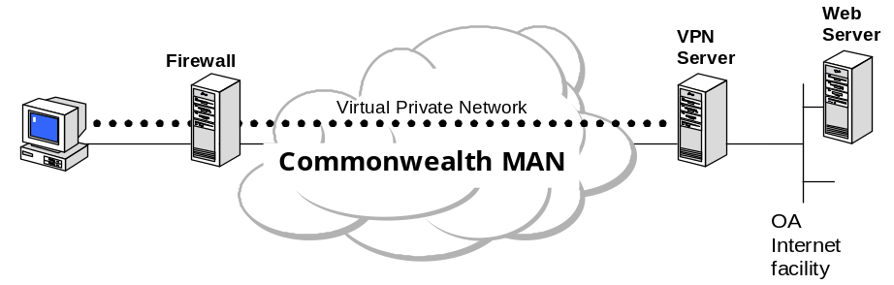
Figure 6.5 VPN Management

Although there are some tools that can provide an overall performance index for a web site, in general performance tuning a web environment is somewhat of an imperfect science. The nature of the Internet, a connection-less system, makes it difficult to collect data on end–to-end web site performance unless it is being conducted within a controlled environment. However, each component such as network paths, web servers, component servers, and databases can be gauged and tuned individually.

Performance

The idea behind this approach is that the overall performance of the web site is only is fast as the slowest component given that all other components are operating at maximum limits. So, the trick here is to tune each component (web interface, business objects, data access, and network bandwidth) to its peak performance but keeping in mind that the main gauging factor is user response time. If user response time is slow for the application then it does not matter how optimally tuned the environment is – the application must be re-architected.

DPW User Community
Based on the information collected during interviews with each Program office, it is determined that DPW’s overall user community is medium in size and that the projected volume for web capacity is low to moderate compared to a high volume site such as Amazon or Yahoo. Thus, advance performance tuning is not required but more of an optional task. That is all of Microsoft’s web technologies (NT 4.0, IIS 4.0, MTS, SQL) are per-tuned for small to medium web sites and DPW can use the default (“out of the box”) configurations.

N-Tier development architecture
ASP Code optimization
The greatest method to increase the capacity and performance of an ASP (Active Server Pages) website is to optimize the ASP scripts, any VB components, and any data access calls such as ODBC (Open Database Connectivity), ADO (Active Data Objects) and OLE DB (successor to ODBC used for universal data access). Although, this guide does not cover code optimizations, here are some basic tips in ASP code optimizations:

- Cache application-scoped objects
- Combine output of “Response.write” calls
- Use “<object>” tags instead of “Server.CreateObject”
- Use local variables and avoid public variables
- Use client-side validation of user input
- Copy individual values from collections into local variables
- Turn off session state for entire application
- Avoid large amounts of data storage in session objects and session state
- Do not provide empty “Session_OnStart” and Session_OnEnd”.
- Designate the applications as “Out of Process” for debugging only
- Avoid redimming arrays.

Data Access tips
- Cache result sets from data sources that are stable or vary predictably
- Avoid putting ADO in session state
- Use native OLE DB connection strings
- If supported, use stored procedures for data calls
- Avoid using ADO “AddNew” and “Delete” use SQL calls instead.
- Set ADO cache size to number of records expected if less than 100
- Use ADO 2.0 “AdExecuteNoRecords” flag if not result set is expected
- Disable temporary stored procedures

N-Tier Architecture configuration
Network
Standard 100Mbit LANS should be used to connect all the servers in the Internet Gateway system. VLANS can also be used if network performance begins to decrease. Use tools like NetMon or other network sniffing tools to determine current network bandwidth usage. See below for performance tools.

Web Servers
The web servers should be placed in the secure subnet behind the proxy server. The proxy server’s external address is the only address given to the public and traffic is redirected to the actually web server on the subnet. The web server should be placed at the OIT facility and managed remotely via a VPN tunnel from the DPW network.

Component Servers
Since the ASP scripts on the web servers do RPC (Remote Procedure Call – synchronous communication) to the component servers when creating the objects, these servers should be placed near the web servers.

Data Servers
The data serves (SQL and mainframe) will be located on the DPW network. These servers may be within the DPW SAN if desired. Since the web and component servers are housed at the OIT web facility access across the Commonwealth may pose an issue at times of high volume. This must be gauged on a case-b-case basis. WAST (mentioned below) is an excellent tool for gauging capacity of a web site. If performance were determined to be unacceptable because of network bandwidth on the MAN then a dedicated line (T1) from the OIT web facility to the DPW network would most likely be the solution.

Internet Access: Direct vs. Proxy
As discussed in a previous section placing a web server behind a proxy server provides an added security measure but this security method does have an impact on web site performance. The amount of impact proxy access has on overall system performance depends on several factors assuming that everything else is held equal. These factors can be classified into the flowing categories

- Static content
Content that does not change over short periods of time

- Dynamic content
Content that is created “on-the-fly” usually based on user input

Normally, direct access would be faster than proxy access since there are fewer components between the server and the client. However, the Microsoft Proxy Server 2.0 has a caching feature that stores frequently requested web pages from clients. Thus, the proxy server can serve cached pages instead of sending the request to the actual web server. When serving static pages this can be as efficient as direct access to the web server.

On the other hand, dynamic content such as search queries creates the resultant web page “on-the-fly”; thus, web page requests would rarely be cached on the proxy server since the content is changing so frequently.

Overall, unless a web site is receiving hundreds of thousands of connections per day the impact of direct access vs. proxy access is small when compared to all the other performance factors on the Internet. Therefore, the security benefits of using proxy access outweigh the performance impact of a proxy server.

Intranet Access
Other than tuning the web server (IIS 4.0) to desired levels there is not much “tweaking” that needs to be performed to increase the performance of internally accessed websites.

Extranet Access
Extranet performance is largely dependent on the load of the VPN server. The VPN server is where all VPN connections are encrypted and decrypted for transport across the public medium. Each concurrent session on the VPN Server requires processor and memory resources.

Web Server (Tuning IIS 4.0)
In general, IIS 4.0 out of the box can serve the needs of DPW and its business partners. It has built-in performance tuning controls for small, medium and large web sites. However, if additional performance tuning is required see Appendix A for details on tuning the IIS 4.0 Server.

MS WAST (Microsoft Web Application Stress Tool)
The Microsoft Web Application Stress tool web stress tool is free tool designed to realistically simulate multiple browsers requesting pages from a web site. This can gather performance and stability information about a web application - ASP. This tool simulates a large number of requests with a relatively small number of client machines. The goal is to create an environment that is as close to production as possible so that you can find and eliminate problems in the web application prior to deployment. For more information and download of this tool go to:

http://homer.rte.microsoft.com

Monitoring
Network Health
Along with monitoring configuration changes, you should also monitor issues that affect the system’s running state so that administrators can be alerted in the case of a failure. There are 2 options for monitoring system health and failures. These are:

- Use the Built-in Performance Monitor and Event Log
Windows NT has some built-in tools to monitor system failures. You can set up the event log and Performance Monitor to alert administrators of critical system resource failure, including system, security, and application events. Windows NT also supports Simple Network Management Protocol (SNMP) and can be integrated with an existing SNMP network management solution.

- Third-Party Solutions
You can use a third-party solution such as WebWatcher from Avesta Technologies to monitor system health. It monitors Web servers and other network devices, automatically detecting the applications running on Web and FTP servers and testing them in real-time. Administrators can use it to search for any TCP-supported server type. In addition to watching the Web, this tool also watches routers and gateways, and has support for SNMP agents. When a device fails to respond, WebWatcher notifies the appropriate people by e-mail.

Other tools include WebSniffer from Network Associates, which includes agents that gather network protocol and server statistics, a repository that acts as the central database, and software that monitors communications between the Web Server and its users to identify performance problems and provide early warning of slowdowns.

It is important to test these solutions in a lab before choosing one. The operations described in this section are intrusive and you must thoroughly understand and test them before you use them in your production environment.

N-tier application monitoring
EcoScope from Compuware provides an end-to-end performance analysis of n-tier web applications. More specifically, EcoScope can:

- Analyze n-tier application performance by profiling application behavior.
- Troubleshooting performance problems.
- Identifying resource impact and planning capacity.

EcoScope is a solution for monitoring the networkability of n-tier web applications where performance under heavy loads is critical to enterprise success. More information see:

http://www.compuware.com/products/ecosystems/ecoscope.htm

Web site Traffic and Security monitoring
WebTrends Enterprise Suite and WebTrends Security Analyzer from WebTrends offer:

- Web site and streaming media traffic analysis.
- Proxy server reporting
- Link analysis and quality control
- Alerting, monitoring and recovery
- Supports large server clusters
- Security assessment solution
- Discover and fix the latest known security vulnerabilities on Internet, intranet and extranet servers

http://www.webtrends.com/products/system.htm

NT Server monitoring
Use performance monitor to track system and performance level counters to generate alerts, look for errors or issues, and track system capacity. (The Windows NT 4.0 Resource Kit has complete details on ways to use PerfMon.)

Here are some counters to track:

Performance Counters to track
Object | Ideal value
General System
Memory\Pages/Sec | 0-20 (> 80 indicates trouble)
Memory\Available Bytes | at least 4MB
Memory\Commited Bytes | < 75% of physical memory
Memory\Pool Nonpaged Bytes | Steady (slow rise may indicate a memory leak)
Processor\% Processor Time | < 75%
Processor\Interupts/Sec | Depends on processor. Up to 3500 on P90; 7000 on P200; however, less is better.
Processor\System Process Queue Length | < 2
Disk (Logical or Physical) % Disk Time | low as possible
Disk (Logical or Physical) Queue Length | < 2
Disk (Logical or Physical)\Avg. Disk Bytes/Time | High as possible

Web Server (IIS 4.0)
IIS Global\Cache Hits % | High as possible
Web Service\Bytes Total/Sec | High as possible
ASP\Request Wait Time | low as possible
ASP\Request Queued | 0
ASP\Transactions/Sec | High as possible

The table above categorizes Performance Monitor counters into general and web Server. The general counters can be used to track COM+ and SQL Server resources running on the system. In general, both of these systems are tuned to optimize memory and processor utilization on a server. Thus, if the server’s memory or processor utilization falls below the recommended limits on either the COM+ server or the SQL Server then performance of these services will degrade.

Child Adoption website

Sample Configuration
Migrating the Child Adoption web application architecture to a n-tier web architecture is not easy task. As with all application development management processes and programming and design disciplines must be followed in order to properly migrate the application architecture. The following provides a model of the Child Adoption web site in a n-tier architecture.

The following is only provided as a sample for general steps in migrating an application to a n-tier architecture. The Child Adoption Web site is used since it’s the most functional of all the current DPW web sites. By no means the following procedures represent a detailed analysis of the Child Adoption Web site. This sample only takes the technical aspects for the migration and assumes that business and political issues are resolved.

- Presentation and Business Logic Tier
Today, the child adoption website consists of two ASP driven HTML interfaces (1) the public interface and (2) the internal interface implemented on separate web servers. The pubic interface is for searching and reading of information on children and the internal interface is for DPW personnel to update child information. The information on both of these interfaces is created dynamically using ASP script technology and a separate SQL Server data store. All business logic and validation rules are written in ASP script running on the web server. See the Child Adoption architecture paper for more details.

In migrating the Child Adoption website to an n-tier architecture, all of the ASP script would need to be examined for specific business logic and rules.

    - This business specific code segments would then need to be extracted from the ASP script and rewritten in a COM compatible language such as VB. Since the ASP code is already written in VBScript porting the code to VB would be trivial.
    - The existing ASP code (most presentation code) would then need to be rewritten to call the new business logic components.

Once the presentation tier is completed the public and private HTML interfaces can be combined into a single website. Security could be handled with logon ids and passwords allowing certain components to process only if the user had the proper rights. Thus, eliminating the need to manage two separate websites for Child Adoption. In addition, if a richer interface is required for private use then it can be easily created within architecting the new interface from scratch. The new interface can simply use the existing Child Adoption components on the Business logic tier.

- Data Tier
Any generic data access calls within the business logic tier should be removed and rewritten using data source specific calls to optimize performance. For example, “on-the-fly or inline SQL” calls should be moved into stored procedures within SQL Server. The business logic tier should only call stored procedures within its data access components.
Internet Access
Users access the Child Adoption website would connect to the external IP address of the Proxy Server. Since the Proxy server is using the Web Publishing feature, the external DNS name of the Child Adoption web site should resolve to this address. All requests made to the external interface of the proxy server will be sent to the actual web server on the secure public network.

Access permissions should be set to “anonymous access” on the web server.

Intranet Access
Internal users (those updating children information) would connect to the site through the Internal firewall to the Child Adoption web server directly on the secure public subnet.

Security at the web server level should be set to either “Basic Authentication or NTLM”. This could be just a generic logon that allows or denies access to the private interfaces; however, this is a business level decision. A product like Microsoft Site Server could also be used to control access to content at a web server level based on membership. The Site Server membership database can be configured to use an LDAP compliant directory or NTLM. Application level security could be used to control user access to certain functions within the application. Whichever method is chosen only users with proper permissions should be able to see the extended interfaces for updating information on children.

NOTE: The updating function should be restricted from being access through the Internet access under all circumstances. This function should only be available through Intranet access. A guaranteed method for securing the update function is to only allow only internal IP address ranges to connect to a portions of the website. For more information see the “IP Address Access Control” within Appendix A: Securing IIS 4.0.

Extranet Access
Business partners requiring access to the Child Adoption website’s private interface can connect to it via a VPN connection from either the Internet or dial-in servers.

Security and access control for VPN access should be maintained on the RADIUS authentication servers. After business partners are validated on the VPN servers access to the Child Adoption website should be handled by the web server and application.

Performance
The Child Adoption website is not a high volume site so “out-of-the-box” tuning features of IIS 4.0 is sufficient to handle user capacity for this website; however, monitoring tools such as Performance Monitor and WebTrend’s WebReports should be used to determine usage levels and availability of the site.

Remote Administration
Remote administration of the Child Adoption website can be handled through a VPN connection to the secure public subnet. Administrators assigned to manage the servers within this subnet need to be defined in the Internet NT domain account database. Once a VPN connection is made to the Internet NT domain all native NT management utilities can be utilized without regard to security issues. Management utilities can be utilized without concern of security issues.
Overview

Futures
This section will discuss some technologies that are “up and coming” within the computing industry and the Commonwealth, which may or may not have an impact to DPW and its strategy decisions on technology implementation.

Commonwealth “Connect” project
The primary goal of the “Connect” project is to create an infrastructure that provides a centralized point of management for enterprise related network resources such as user id assignments, messaging, security, etc… When complete user Ids will be placed into a centralized domain and user administration will be delegated to each respective agency for daily operations.

Directory Services – Active Directory
In a nutshell, a directory service provides a fault-tolerance centralized location for the storage and retrieval of network resources. LDAP or Lightweight Directory Access Protocol is the de-facto standard for accessing a directory service. Most directory servers today support the LDAP access protocol. The centralizing of network resource information allows for easier management and lowers the TCO of an IT environment.

A directory service will allow DPW to centrally store user Ids, certificates, and application data. Different directory systems such as Firewall-1, Exchange, NT and application specific can be combined into a single entity and accessed as such. Like, PKI these products must be rewritten to support a directory service in order to gain the benefit of having one in place.

PKI
PKI or Public Key Infrastructure has been in the computing industry for years. Its technologies have been mature for a while but only recently has PKI began being widely adopted for client and server computer authentication. On reason for its slow adoption is that the management of certificates is difficult to do in a cost effective and cost justified manner. However, the recently explosion of e-commerce has brought to light many of the security issues that a PKI can address.

A PKI solution is only effective when it is deployed from an enterprise level – top down. A deployment in this manner addresses PKI issues of management, interoperability, development standards, and change processes. Otherwise, the management of client certificates becomes chaotic.

For example, in a PKI solution each client gets issued a certificate that is used to verify the client with a server. Both the client and the server need to be able to communicate with a third trusted authority – the server that issued the certificate. Now, if each department decided to implement their own PKI solution all clients and servers would need to know about all available certificate authorities. In addition, each client would need a separate certificate from each authority. In contrast, a enterprise deployment of a PKI solution only established one “root” certificate authority for all clients and servers to verify against; thus, easing the management of certificates.

Once the Commonwealth established a root certificate service for the enterprise (deployment dates have not yet been finalized – please see OIT for more information), DPW can begin the registration and issuance of certificates to internal and external users. User certificates and its management can either be handled by DPW or outsourced to the OIT or another vendor. PKI can only authenticate users so access permissions still need to be managed by DPW on a case-by-case basis. DPW application developers have full control access rights into an application. Basically, PKI can only guarantee the system who is accessing it but not where it can go once inside – that is left in the hands of each business.

Certificates can be extended to stored additional application specific information. For example, the JNet project is extending the certificates for their base of users for added security.

IPSEC (IP Security)
Creating a VPN (Virtual Private network) with IPSec is actually a misnomer. Meaning that just IPSec alone does not create the VPN. . In order to create a VPN connect, a tunneling protocol is required. IPSec is only an encryption protocol for securing communications between two hosts on an IP network; thus, only satisfying one piece of the equation. The second part of the equation can be found in L2TP (Layer 2 Tunneling Protocol) that allows 2 hosts to create a tunnel over an IP network. The combination of L2TP and IPSec creates the VPN solution. Therefore, IPSec and L2TP are mutually inclusive when being used for a VPN solution.

To further clarify this point, here is an example of how a VPN works with L2TP and IPSec. The client first establishes a tunnel from itself to the tunnel or VPN server over an “untrusted” network using L2TP – the endpoints of the tunnel being the client and the VPN server. At this point, the communications or data between the two computers are not encrypted. Once a connection is made, the VPN server is configured to request an IPSec connection from the client. If the client responses with the proper credentials (CHAP, MSCHAP, or EAP) an encryption key is negotiated between the client and server and an encrypted session is established.

DPW should seriously evaluate interoperability issues when planning to use an IPSec-based VPN solution for remote access. Due to many factors—the nature of business, the need to let contractors and partners access your corporate networks, and the diverse equipment within the Commonwealth networks—multi-vendor interoperability for VPN is very important. While proprietary solutions may work, it’s important to consider how VPN will be used over the next one to two years and how your VPN solution choice today affects your overall direction in the future.

Using VPNs for business partnering or to support remote access by contract employees who own their own equipment should prioritize VPN solutions that are based on interoperable standards and which support user-based authentication, authorization, and accounting. If proprietary implementations of IPSec Tunnel Mode are being considered, carefully evaluate the near-term availability of solutions based on L2TP/IPSec to support interoperability. DPW should also consider how an L2TP/IPSec solution might be complemented by PPTP-based solutions.

What should DPW do?
- “Connect” project
The impact for DPW is their strategy plans for user management, administration and security access. Once the “root” domain is in place (sometime by summer 2000) DPW can begin to build out their domain from this enterprise root. Their domain (for example, dpw.pa.state.us) will be the point of administration for user Ids and network resources. See “Directory Services – Active Directory” section below for more information on how application developers can take advantage of a common directory service.

- Directory Services – Active Directory
Today, Windows 2000 Server offers a directory service – Active Directory or AD. AD is a LDAP compliant fault-tolerance directory service. With AD DPW can integrate their separate directory services into AD. DPW can use AD to store:

  - User Ids
  - Certificates that are mapped to user or groups
  - Application data such as access control

However, as stated earlier DPW must begin to incorporate AD storage into its application architecture and designs. To enable this, DPW developers should look into the capabilities of ADSI (Active Directory Services Interface) to integrate directory services into their web applications. ADSI provides a COM (Component Object Model) interface on to AD. These components can then be placed into the component tier. Also, the Commonwealth can provide these general user objects to application developers to verify users against AD when accessing the application.

- PKI
Given the enterprise nature of PKI, DPW should wait until an enterprise PKI solution is available from the Commonwealth. The overhead in managing a PKI solution is hard to justify from a business perspective. Economies of scale are need to keep costs at a minimum.

- VPN-IPSec
If a VPN solution is needed with business partners in the short term, DPW should implement a PPTP (Point –to-Point Tunnel Protocol) based VPN. Because of all the challenges when deploying a VPN solution the most difficult aspect of deploying a VPN solution is the deployment of the VPN client to the target workstations where typical client deployment issues such as integration, interoperatability and compatibility exist. When deploying a PPTP-based VPN solution the PPTP client is supported with Windows 9x, Windows NT and Windows 2000. Moreover, Windows 2000 provides support for both PPTP and IPSec; thus, making upgrading to an IPSec-based VPN solution a “no-brainer” on the client side. This would allow DPW to benefit for VPN technologies today while maintaining compatibility for the future.
Microsoft product specific documentation referenced in this guide can be found in

More information

Microsoft Visual InterDev 6.0
Microsoft IIS 4.0
Microsoft Routing and Remote Access Services
Microsoft Proxy Server 2.0.

Books
3-tier Client/Server at Work by Jeri Edwards, 1999, John Wiley & Sons Inc.

Capacity Planning for Web Performance: Metrics, Models, and Methods by Daniel A. Menasce and Virgilio A. F. Almeida, 1998, Upper Saddle River: Prentice Hall.

Optimizing Network Traffic: Notes from the Field by Microsoft, 1999, Microsoft Press.

Windows 2000 Server Resource Kit by Microsoft, 2000, Microsoft Press

Web Sites
Microsoft Windows DNA
www.microsoft.com/dna

Microsoft Component Object Model (COM) technologies
www.microsoft.com/com

Microsoft Universal data access
www.microsoft.com/data

Microsoft Windows technologies
www.microsoft.com/windows

Microsoft Security technologies
www.microsoft.com/security

Microsoft Government web site
www.microsoft.com/industry/government

XML and BizTalk technologies
www.biztalk.org

IIS 4.0 tuning guide

Appendix A
This section is a general guideline on how to optimize a Microsoft® Internet Information Server (IIS) 4.0 installation in a high-volume environment. It is designed for Web server system administrators who are familiar with administering the Microsoft Windows NT® operating system and Microsoft Internet Information Server.

Because every Web site is unique, Microsoft recommends that customers carefully plan, test, and monitor their Web sites, using both the tools in Windows NT Server and the various benchmarking suites available on the market today. This ensures that content deployed on an Internet Information Server 4.0-based Web site is optimized for the intended use.

Unfortunately, today there is no automated tool for determining server compliance with these settings.

Parameter | Settings | Impact
General Tuning Parameters
Set Windows NT Server to AppServer. | On the desktop, right-click Network Neighborhood and select Properties.  On the Services tab, double-click the Server service.  Make sure you select Network Applications. | Internet Information Server 4.0 has grown in size and page faults more under the File Server setting. The AppServer setting instructs Windows NT to trim the file cache more aggressively.
Install the hotfix and remove irrelevant script mappings. | Download and run the hotfix utility from ftp://ftp.microsoft.com/bussys/iis/iis-public/fixes/usa/proxy. You need to choose the appropriate platform (Intel® or Alpha).  Using the Microsoft Management Console, navigate to the Web sites (virtual servers) under the Internet Information Server snap-in.  Right-click Default Web Site and/or any other Web site(s) where your content exists and select Properties.  Select the Home Directory property sheet.  Click the Configuration button under the Application Settings section.  Remove all unused mappings, leaving at least one mapping in place (the server requires at least one mapping). Microsoft recommends leaving the .asp extension in place if no other mappings are being used. | To make it easier for customers to upgrade to Internet Information Server 4.0, Internet Information Server 4.0 checks the extension of each file, even in a read-only directory (a directory that has scripting disabled). This additional overhead can be eliminated. By design, the server requires at least one script mapping, so leave the Active Server Pages mapping in place.

Parameter | Settings |  | Impact
General Tuning Parameters (continued)
Disable logging when not needed. |  | Using the Microsoft Management Console, navigate to the Web sites (virtual servers) under the Internet Information Server snap-in.  Right-click Default Web Site and/or any other Web site(s) where your content exists and select Properties.  From the Web Site property page, uncheck Enable Logging to disable logging.  Click OK. | This frees up system resources and provides better performance.
If logging is enabled, log to a striped partition with a controller that allows write-back caching, especially if you see heavy use on the log disk. |  | Using the Microsoft Management Console, navigate to the Web sites (virtual servers) under the Internet Information Server snap-in.  Right-click Default Web Site and/or any other Web site(s) where your content exists and select Properties.  Select the Web Site property sheet.  Click the Properties button under the logging section.  Make sure the path maps to a striped partition. | Busy sites can see the log disk become a bottleneck, because it is a point of contention. This means that all requests on the server are contending for a single file.
Networking Tuning Parameters
Set receive buffers for the Network Interface Card (NIC) to maximum. If this is in a controlled environment or for a benchmark test, set it on both the client and server. |  | See the documentation for your NIC for details. This parameter can often be set using the properties of the NIC under the Network Control Panel. | Dropped packets on the receiving end cause TCP (Transmission Control Protocol) to retransmit. This minimizes the number of dropped packets on the receiving end, thus increasing performance.
Set TCP parameters in registry. |  | Using Regedt32, navigate to HKLM\CurrentControlSet\Services\TCPIP Parameters.  Add the value MaxUserPort if it's not already there and set to 0xfffe.  Add the value TcpWindowSize if it's not already there and set to 0x4470. | We don't want to run out of user ports. Also, a large window size works better for high-speed networks (TCP stops when the window fills up).

Parameter |  | Settings |  |  |  | Impact
SMP Tuning Parameters
Control number of active Internet Information Server threads. | Monitor the Processor Queue Depth object under System in Windows NT Performance Monitor to see if you have too many threads active.  If you have N processors in your system, a queue depth between N and 3N is good. Leave values at the default if you are not sure.  For static workloads, you can set MaxPoolThreads to 1 and PoolThreadLimit to the number of processors in your system. (These values are set in the Windows NT Registry using regedt32.exe. See the following sections for details on setting these parameters.) |  | There should be enough threads in the system that incoming requests don't get blocked. However, each thread uses system resources and can potentially cause unnecessary context switches.  The goal is to maximize the number of threads Internet Information Server uses without causing excess context switches. Doing so ensures better performance on Symmetric Multiprocessing (SMP) hardware.
Optimizing for Static Workloads
Set Object Cache Time to Live (TTL) appropriately.  Default: 30 Seconds | Using Regedt32, navigate to HKEY_LOCAL_MACHINE\System\CurrentControlSet\Services\InetInfo\Parameters.  Add the value ObjectCacheTTL if it's not already there.  Set to the desired value. If you do not know how long you want Internet Information Server to keep an unused file open, leave ObjectCacheTTL at its default value. |  | This changes the frequency with which the cache scavenger runs. If your content fits in memory and is largely static, you may even disable the scavenger by setting it to 0xffffffff.  A high ObjectCacheTTL works best for sites with a small number of "popular" files. If the number of frequently requested files is large, a high ObjectCacheTTL may not help. Setting this entry high tells Internet Information Server to try to keep unused files open longer. This is useful if you expect these files to be reused within the TTL period. If you do not expect the files to be reused often, or the system appears low on resources, use a lower ObjectCacheTTL to conserve resources. You can also use OpenFilesInCache to limit the number of files Internet Information Server keeps open.
Set OpenFileInCache to a value large enough to cache all the open handles.  Default: 1000 for every 32 MB of physical memory | Using Regedt32, navigate to HKEY_LOCAL_MACHINE\System\\CurrentControlSet\Services\InetInfo\Parameters.  Add the value OpenFileInCache if it's not already there.  Set to desired value. The value depends on the amount of memory you want to make available for Internet Information Server cache and the number of file handles you want cached. |  | Large Web sites need to keep more file handles open for maximum performance. If the content on your site is static, you can greatly increase the performance of your Web server by maximizing the number of files served from RAM (random-access memory) instead of from disk.  You can monitor the number of cached file handles using the Cached File Handles counter under Internet Information Service Global in the Windows NT Performance Monitor.

Parameter | Settings |  |  |  |  | Impact
Optimizing Active Server Pages (ASP) Performance
Set ProcessorThreadMax to a low value. |  | Using Regedt32, navigate to HKEY_LOCAL_MACHINE\SYSTEM\CurrentControlSet\Services\W3SVC\ASP\Parameters.  Add the value ProcessorThreadMax if it's not already there.  Decrease the value and monitor performance. If performance decreases, revert to the previous value. | This changes the number of threads per CPU that Internet Information Server allocates for MTS. For well-written scripts, low numbers are better. This lowers the amount of contention.
Set the AspScriptEngineCacheMax property to ProcessorThreadMax, multiplied by the number of processors in the system.  Default: 30 |  | Configuration information related to Web sites, directories, and pages is stored in the Internet Information Server configuration data store (metabase).  Internet Information Server 4.0 includes a number of scripts that you can use to change settings in the metabase.  From the SystemRoot, navigate to /System32/inetsrv/adminisamples.  Type adsutil.vbs. Set w3svc/AspScriptEngineCacheMax to ProcessorThreadMax multiplied by the number of processors in the system. | This allows each ASP thread to cache a script engine, which results in processing ASP pages more efficiently.
Enable buffering for ASP applications. |  | Using the Microsoft Management Console, navigate to the Web sites or ASP application name spaces under the Internet Information Server snap-in.  Right-click the site or application and select Properties.  Select the Home/Virtual Directory property sheet.  Click the Configuration button under the Application Settings section.  Click the App Options property sheet.  Click the Enable Buffering option.  Click OK, then OK again. | Setting this option buffers ASP output to the browser. This allows the server to deliver the entire response to the client as opposed to delivering the content as the server generates it.
Minimize the Session Timeout value. |  | Using the Microsoft Management Console, navigate to the Web sites (virtual servers) under the Internet Information Server snap-in.  Right-click Default Web Site and/or any other Web site(s) where your content exists and select Properties.  Select the Home Directory property sheet.  Click the Configuration button under the Application Settings section.  Click the App Options property sheet.  Set Session Timeout to the minimum amount of time you need to maintain a user's session state. | Maintaining session using the Session object in ASP requires system resources. Imagine there are 1,000 users connected at any given time. This means that the server needs to allocate resources to maintain the session state for each user.The longer the server needs to maintain the session state, the longer resources are tied up. Therefore, minimizing the Session Timeout value optimizes the server’s resources and improves performance.
Securing Microsoft IIS 4.0

Appendix B

IIS and Virtual Directories
The Internet Information Server uses a virtual root and virtual directories to secure and separate a web site from the rest of the data on a physical machine. IIS setup requires the administrator to define a virtual root (home directory) for the WWW service. Virtual directories are setup within the “Properties” tab on the WWW service. All virtual directories must exist under the virtual root. All disk access initiated by a web client must be through the use of a virtual directory; the client cannot gain access to data above the virtual root.

How ISAPI DLL's Work
ISAPI applications are similar to CGI applications except that CGI applications are implemented as external applications that run out of process, and ISAPI applications are implemented as Dynamic Link Libraries (DLLs) that run in process with the server. The advantage is that ISAPI applications do not have the process start/stop overhead that CGI applications have.

The following diagram illustrates the ISAPI application relationship:

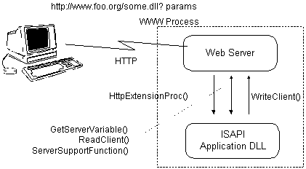
ISAPI application relationship

The ISAPI extension DLL loads on the first URL request that contains a reference to the DLL. Upon loading, the server calls the initialization function GetExtensionVersion() API in the DLL. The initialization function is called in the security context of the IIS Service (typically SYSTEM).

With the Windows NT File System (NTFS) and proper Access Control Lists (ACLs), even access by SYSTEM can be controlled, if so desired. However, do so with extreme care because restricting access to SYSTEM can cause unexpected behavior changes in Windows NT. Normally, it is not necessary to restrict access to SYSTEM unless the ISAPI DLL is not trusted.

When a URL request comes in that maps to the ISAPI extension, the function HttpExtensionProc() in the DLL is called by IIS. The call is always done in the context of the web client (IUSR_computername if anonymous). Thus, NTFS and ACLs can be used to manage file and program access. Furthermore, the ISAPI application itself can make access decisions based on the identity of the remote web user.
Anonymous Logons
The anonymous logon is defined in the “Service” properties tab of the WWW service. This allows users to gain access to the IIS server without a specific prompt for a user name and password. We recommend that public Internet servers use this option because IIS authenticates users and passwords by host pass-through. An IIS server configured to prompt for passwords requires that the specific client must be able to handle NT’s challenge/response protocol (currently only IE3.0 handles this), and that each user name and password must be defined within the NT domain. This adds additional operational support that is not needed because the anonymous logon (IUSR_computername) has very restricted access to all disk and system objects

All write permissions are denied to this user via the NTFS access control list. Furthermore, if the server has been set up to allow anonymous access only, no one can use a Windows NT account maliciously. For example, anonymous-only settings prevent anyone from gaining access by using the Administrator account or any other account with permissions sufficient to alter the server.

Security Access Control
In order to properly secure a web site, it is important to understand how the Internet Information Server handles a request, in particular, the security precedence of access. This section discusses IIS/PWS access control in conjunction with Windows NT security.

Security Precedence
Internet Information Server is built on the Windows NT security model. Windows NT security helps you protect your computer and its resources by requiring administrator-assigned user accounts and passwords. You can control access to computer resources by limiting the user rights of these accounts. NTFS enables you to assign permissions to folders and files on your computer. You can control access to folders and files by preventing unauthorized users from copying files to or from a folder, or by preventing unauthorized users from executing files in certain folders.

In addition to the Windows NT security features, Internet Information Server enables you to deny access to computers with particular IP addresses. IIS also supports the Secure Sockets Layer (SSL) protocol, which securely encrypts data transmissions between clients and servers.

When an IIS Web server receives a browser request for information, it determines whether the request is valid. A simple overview of the security process used on each request is presented in the following illustration. The steps are discussed in more detail later in this section.
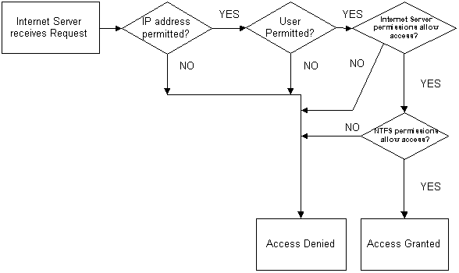
IIS Access logic

This diagram shows the basic security precedence, but does not account for any additional access control checking performed by databases and server extensions (e.g., CGI and ISAPI applications). For example, a database may deny access, even though the above steps have been completed successfully, because the authenticated user may not have the correct database permissions. An ISAPI or CGI application, or even an ISAPI filter, may deny access based on additional criteria.

When diagnosing a security problem, it is important to understand the order of the security verification steps taken by Internet Information Server.

IP Address Access Control
Microsoft Internet Information Server can be configured to grant or deny access to specific IP addresses. For example, you can exclude a harassing individual by denying access to your server from that person’s particular IP address. You can even prevent entire networks from gaining access to your server. Conversely, you can choose to allow only specific sites to have access to your service.

The source IP address of every packet received is checked against the Internet Information Server settings in the “Advanced” property sheet. If Internet Information Server is configured to allow access by all IP addresses, except those listed as exceptions to that rule, then access is denied to any computer with an IP address included in that list. Conversely, if Internet Information Server is configured to deny all IP addresses, access is denied to all remote users except those whose IP addresses have been specifically granted access. IP address access restrictions are available for each of the IIS services.
When controlling access by IP address, be aware that many web users will be passing through a proxy server and/or firewall. The incoming connection to your web server will appear to have originated from the proxy server or firewall itself (i.e., the IP address of the originator will be that of the proxy server or firewall, and not the IP address of the originator). This may be useful in a corporate network as an added security measure to prevent access by anyone from outside your IP address domain.
To grant or deny access based on the IP address, go to the Advanced tab for the particular service in Internet Service Manager. Access based on the IP address is independently controllable for each IIS service. However, it is not controllable on a per virtual directory basis. If IP address restrictions are required on a per virtual directory basis, you must implement an ISAPI filter or purchase one from a 3rd party. The ISAPI filter examines the URL (or mapped directory path) and the originator’s IP address, then grants or denies access as desired.
User Permitted
In the “User Permitted” step, there are five criteria for a successful logon. These are:
- Valid User name and Password supplied;
- Account Restrictions (e.g., time of day, etc.) permit access;
- Account is not disabled or locked out;
- Account password has not expired;
- The applicable logon policy (i.e., “Log on Locally,” “Access this computer from the Network”) for the logon protocol used permits logon.

The last item is the most common reason that a particular user cannot gain access to the WWW or FTP service. By default, on a Windows NT Server, ordinary users (i.e., users who do not belong to the Administrator’s group) do not have the “Log on Locally” user right. If FTP or WWW Basic Authentication is used, Internet Information Server, by default, attempts to logon the user as a local user. Although this is configurable in IIS 2.0 or later, it is the most common reason for access failure.

Internet Server Permissions
Once the user has been granted access, the server examines the URL and type of request. For the WWW service, the request may indicate a read or an execute action. The applicable WWW virtual directory or virtual root must have the appropriate permission enabled. Otherwise, the WWW service returns a "403: Access Forbidden" error.

Permissions are set on the Directories tab of the WWW service in the Internet Service Manager application. These server permissions are not based on the user’s logon identity. They are based on the permissions for the applicable virtual root / directory.

File System Permissions
All of the restrictions required by IIS have been fulfilled if:
- The IP address restrictions are satisfied;
- The user is validated;
- The service virtual directory permissions are satisfied.

IIS then attempts to gain access to the specified resource (based on the URL) using the security context of the authenticated user. For anonymous access, this is typically the IUSR_computername account. If authentication has been performed, it will be an actual user account. IIS never gains access to a requested resource using the SYSTEM context. It always uses the context of the requesting user. This allows the operating system to handle access control enforcement, as it should.

Some web server products elect to handle all access control within the confines of the web server itself, then gain access to the requested resource in the SYSTEM context. There are two problems with this. First, there is the potential that the web server will inadvertently grant access due to an unforeseen circumstance or bug. Second, the web server-based access control checking is redundant with the operating system’s own security. Regardless of the platform, operating systems are best at handling their own security. Applications, including web servers, should never bypass the operating system’s security.

The NTFS file system allows ACLs to be placed on directories and the files contained within them. ACLs can be used to implicitly and/or explicitly grant or deny access to a particular file or directory.

Note Internet Information Server always restricts access to files and programs to the applicable virtual directory and its subdirectories. Thus, it is not possible for a web or FTP user to gain access to other disk partitions and directories.

With NTFS and ACLs, you can control who has access to specific files and programs within the virtual directories and subdirectories.

VPN overview

Appendix C
A Virtual Private Network (VPN) connects the components of one network over another network. VPNs accomplish this by allowing the user to tunnel through the Internet or another public network in a manner that provides the same security and features formerly available only in private networks (see Figure 1).
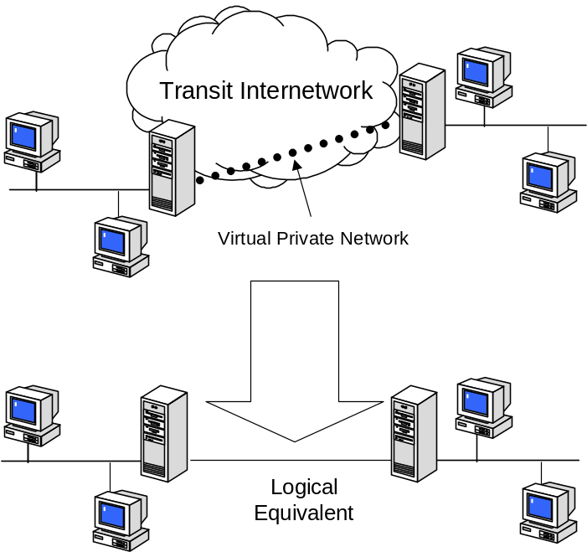
Figure 1: Virtual Private Network
VPNs allow users working at home or on the road to connect in a secure fashion to a remote corporate server using the routing infrastructure provided by a public internetwork (such as the Internet). From the user’s perspective, the VPN is a point-to-point connection between the user’s computer and a corporate server. The nature of the intermediate internetwork is irrelevant to the user because it appears as if the data is being sent over a dedicated private link.

VPN technology also allows a corporation to connect to branch offices or to other companies over a public internetwork (such as the Internet), while maintaining secure communications. The VPN connection across the Internet logically operates as a Wide Area Network (WAN) link between the sites.

In both of these cases, the secure connection across the internetwork appears to the user as a private network communication—despite the fact that this communication occurs over a public internetwork—hence the name Virtual Private Network.
VPN technology is designed to address issues surrounding the current business trend toward increased telecommuting and widely distributed global operations, where workers must be able to connect to central resources and must be able to communicate with each other.

To provide employees with the ability to connect to corporate computing resources, regardless of their location, a corporation must deploy a scalable remote access solution. Typically, corporations choose either an MIS department solution, where an internal information systems department is charged with buying, installing, and maintaining corporate modem pools and a private network infrastructure; or they choose a value-added network (VAN) solution, where they pay an outsourced company to buy, install, and maintain modem pools and a telecommunication infrastructure.

Neither of these solutions provides the necessary scalability, in terms of cost, flexible administration, and demand for connections. Therefore, it makes sense to replace the modem pools and private network infrastructure with a less expensive solution based on Internet technology so that the business can focus on its core competencies. With an Internet solution, a few Internet connections through independent service providers (ISPs) and VPN server computers can serve the remote networking needs of hundreds or thousands of remote clients and branch offices, as describe below.

Common Uses of VPNs
The next few subsections describe the more common VPN situations in more detail.

Remote User Access Over the Internet
VPNs provide remote access to corporate resources over the public Internet, while maintaining privacy of information. Figure 2 shows a VPN used to connect a remote user to a corporate intranet.
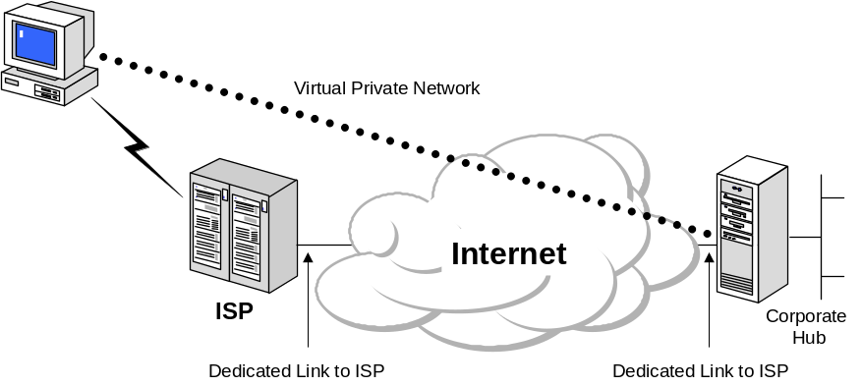
Figure 2: Using a VPN to connect a remote client to a private LAN
Rather than making a long distance (or 1-800) call to a corporate or outsourced Network Access Server (NAS), the user calls a local ISP. Using the connection to the local ISP, the VPN software creates a virtual private network between the dial-up user and the corporate VPN server across the Internet.

Connecting Networks Over the Internet
There are two methods for using VPNs to connect local area networks at remote sites:

- Using dedicated lines to connect a branch office to a corporate LAN. Rather than using an expensive long-haul dedicated circuit between the branch office and the corporate hub, both the branch office and the corporate hub routers can use a local dedicated circuit and local ISP to connect to the Internet. The VPN software uses the local ISP connections and the Internet to create a virtual private network between the branch office router and corporate hub router.

- Using a dial-up line to connect a branch office to a corporate LAN. Rather than having a router at the branch office make a long distance (or 1-800) call to a corporate or outsourced NAS, the router at the branch office can call the local ISP. The VPN software uses the connection to the local ISP to create a VPN between the branch office router and the corporate hub router across the Internet.

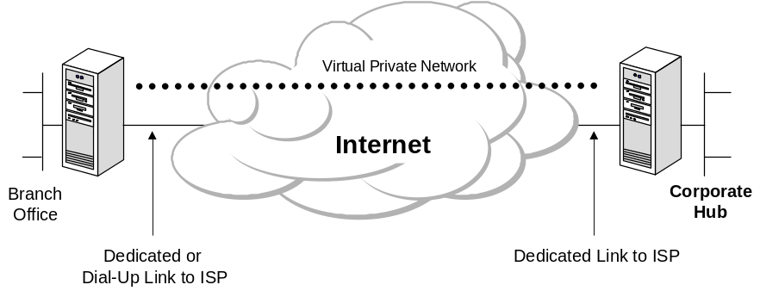
Figure 3: Using a VPN to connect two remote sites
In both cases, the facilities that connect the branch office and corporate offices to the Internet are local. The corporate hub router that acts as a VPN server must be connected to a local ISP with a dedicated line. This VPN server must be listening 24 hours a day for incoming VPN traffic.

PPTP and Firewalls
There are two approaches to using firewall techniques for protecting a PPTP server and the private network to which it is providing secure internet access (1) place the PPTP server on the Internet with a firewall behind it to protect the served network, or (2) place a firewall server on the Internet, with the PPTP server between the firewall and the private network.

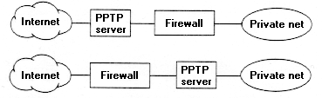
Figure 5: PPTP Server location options
In the first case, the administrator enables PPTP filtering on the PPTP server so that the server receives only PPTP packets. Then, additional filtering in the firewall behind the tunnel server can be applied to admit packets based on source and destination addresses or other criteria.

In the second case, the firewall must be enabled to recognize and pass PPTP packets to and from the PPTP server in addition to any other filter criteria.

The first approach is better because it screens all but PPTP packets from the tunnel server, then submits the data carried in the tunnel to additional filtering after decryption and decompression. The second approach can raise a security issue because the firewall filters cannot look inside the PPTP packet.

Firewall Requirements
PPTP sends data using IP GRE packets (IP protocol 47) and controls the tunnel using a TCP connection to port 1723. To filter PPTP packets through a firewall, you must make these changes:

- Configure the firewall to allow traffic on IP protocol 47. This enables PPTP GRE packets, which carry the data flow. The data within the GRE frame can be encrypted and/or compressed if the client and server are so configured.

- Configure the firewall to allow traffic sent to or from TCP port 1723. This is the PPTP control channel for configuring and managing the tunnel between the client and the tunnel server. The packet filter should include the address of the tunnel server. That is, out-bound traffic with port 1723 as the source port or the destination port should be allowed only from the tunnel server, and in-bound traffic with port 1723 as the source port or the destination port should be allowed only to the tunnel server. This is not necessary, but it enhances firewall security.

Remote Access VPN Requirements and IPSec-based Implementations
Remote access VPN solutions require User Authentication (not just machine authentication), Authorization, and Accounting to provide secure client-to-gateway communication and Tunnel Address Assignment and Configuration to provide manageability. IPSec-based implementations that do not use L2TP are using non-standard proprietary methods to address these key remote access VPN requirements.

User Authentication
Many IPSec-tunnel mode implementations do not support user-based authentication with certificates. When machine-based authentication is used by itself, it is impossible to determine who is accessing the network in order to apply proper authorization. With today’s multi-user operating systems, many people may use the same computer, and without user-based authentication, IPSec tunnel mode cannot distinguish between them. Thus, using IPSec tunnel mode without user authentication is inappropriate for use in remote access VPNs.

Third-party IPSec tunnel mode implementations based on XAUTH, a non-standards-track proprietary technology, attempt to address this issue by supporting proprietary user authentication technologies along with group pre-shared keys. As a result, a group pre-shared key introduces a “man-in-the-middle” vulnerability, allowing anyone with access to the group pre-shared key to act as a “go-between,” impersonating another user on the network.

IPSec tunnel mode was designed for gateway-to-gateway VPN, in which user authentication and tunnel addressing is less of an issue. Because gateway-to-gateway VPNs are usually between routers, fewer boxes simplify address assignment. And since routers often do not have user-level authentication, machine authentication may be sufficient in many cases. Microsoft supports IPSec tunnel mode in Windows 2000 for gateway-to-gateway configurations that require IP-only, unicast-only communications. Here user authentication is not an issue and interoperability is good.

Note: For remote access, Microsoft strongly recommends customers deploy only L2TP/IPSec due to the authentication security vulnerabilities and non-standard implementations of IPSec tunnel mode. Microsoft also recommends L2TP/IPSec for multi-protocol, multi-cast gateway-to-gateway configurations.

While many customers are interested in eventually deploying smart card authentication, in most cases it remains necessary to support legacy authentication methods such as passwords or token cards during the transition period. Some customers may also want support for advanced authentication technologies such as biometrics (such as retinal scans, fingerprint, and so forth.) There needs to be a standard way to accommodate both legacy authentication as well as authentication methods emerging in the future.

IPSec tunnel mode, as originally specified, only supports user authentication via user certificates or pre-shared keys. However, most IPSec tunnel-mode implementations only support use of machine certificates or pre-shared keys. L2TP uses PPP as the method of negotiating user authentication. As a result, L2TP can authenticate with legacy password-based systems through PAP, CHAP, or MS-CHAP. It can also support advanced authentication services through Extensible Authentication Protocol (EAP), which offers a way to plug in different authentication services without having to invent additional PPP authentication protocols. Because L2TP is encrypted inside of an IPSec transport mode packet, these authentication services are strongly protected as well. Most importantly, via integration with RADIUS and LDAP-based directories, L2TP gives the industry a common way to authenticate in an interoperable way while supporting the authentication services that most customers and vendors already have in place.

While there are vendors working on and proposing other authentication services for IPSec only, these alternatives are not on an IETF-standards track. Rather than supporting existing IETF standards for extensible authentication, these proposals introduce yet another authentication framework—with serious known security vulnerabilities. Microsoft believes that customer needs are best served by keeping implementations standards-based.

Future directions
Microsoft's customers, the press, and analysts have told Microsoft that they prefer if Microsoft creates the single standard VPN client for Windows because it allows for easier deployment, better Windows integration, and better reliability.

Microsoft is supporting L2TP/IPSec as its only native remote access VPN protocol based on IPSec because it remains the only existing interoperable standard that addresses real customer deployment issues.

In addition, Microsoft continues to support PPTP for both remote access VPN scenarios and site-to-site scenarios—in order to meet special-needs situations that cannot be addressed with any IPSec-based solution.

© 2000 Microsoft Corporation. All rights reserved.

The information contained in this document represents the current view of Microsoft Corporation on the issues discussed as of the date of publication. Because Microsoft must respond to changing market conditions, it should not be interpreted to be a commitment on the part of Microsoft, and Microsoft cannot guarantee the accuracy of any information presented after the date of publication.

This paper is for informational purposes only. MICROSOFT MAKES NO WARRANTIES, EXPRESS OR IMPLIED, IN THIS DOCUMENT.

Microsoft, Windows NT, Windows 2000 are either registered trademarks or trademarks of Microsoft Corporation in the United States and/or other countries. Intel is a registered trademark of Intel Corporation. Other product and company names listed herein may be the trademarks of their respective owners.

