COMMONWEALTH OF PENNSYLVANIA HEALTH & HUMAN SERVICES ELIVERY CENTER
INFORMATION TECHNOLOGY STANDARD

Name of Standard: | Number:
Network Capacity Planning | STD-ENSS017
Domain: | Category:
Network | Wide, Metropolitan & Local Area Network
Date Issued: | Issued by Direction Of:
05/09/2001
Date Revised: | Jonathan Arnold, Chief Technology Officer  Health & Human Services Delivery Center
06/04/2020

Abstract:
The Health & Human Services IT Delivery Center (HHS DC) network may need network expansion or additional functionality to meet the needs of everyone using the network.

The Health and Human Services Delivery Center (HHS DC) Technology Services Office (TSO) is responsible for Network Capacity Planning for the Departments of Health (DOH), Human Services (DHS), Aging (PDA), Drug and Alcohol Programs (DDAP) and Military and Veterans Affairs (DMVA).

General:
The purpose of this document is to inform the reader of some of the responsibilities of network coordinators and the HHS DC network manager in expanding and adding functionality to the HHS DC network.

Standard:
Roles and Responsibilities
It is the responsibility of all Application Development Teams (Contractors and the HHS DC Solution Management) and vendor facility managers to notify the HHS DC network manager of all planned expansions or functionality enhancements to the network at least six months before the planned implementation date. Changes should be communicated to the Network Team directly and in Architecture Review Board (ARB) meetings.

The prescribed format for submitting bandwidth change requests is shown in the template below:

Area | Description (e.g.) | Firewall Zone | Current Size | Change Expected
Network Bandwidth | County Assistance Offices require more circuit bandwidth to accommodate a new application, such as Skype for Business. | User Zone | 10 mb/sec | 20 mb/sec
 |  | App Zone | 10 mb/sec | 20 mb/sec
 |  | Perimeter Zone | 10 mg/sec | 20 mb/sec

Firewall Zones are delineated in the following drawing:

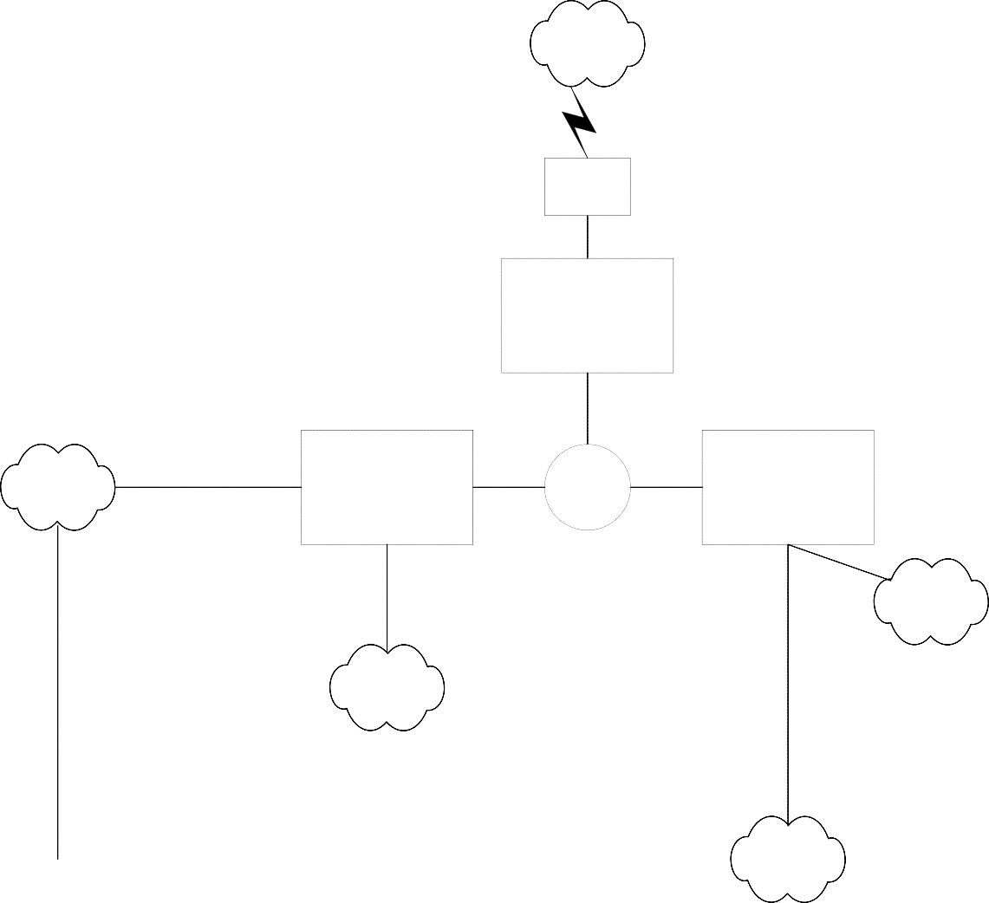
Application Zone User
Zone Perimeter
Zone

FortiGate Content Analyzer

Business Partners
Internet
Willow Oak/ DGS
Annex Complex
Remote HHS
Sites (CAO, SHC)
Ethernet Sites: H&W, Forum Place, SSQ
User 6509
A/B Switches
User Zone Firewall
Servers
App Zone Firewall
2 Cisco 3800
Switches (Core)
Perimeter Firewall
CoPA
Network
XNET
ISA Servers
Human Svcs
Webservers
Exemptions from this Standard:
There will be no exemptions to this standard.

Refresh Schedule:
All standards and referenced documentation identified in this standard will be subject to review and possible revision annually or upon request by the Health & Human Services Delivery Center Domain Leads.

Standard Revision Log:

Change Date | Version | Change Description | Author and Organization
05/09/2001 | 1.0 | Initial Creation | Unknown
04/04/2002 | 1.1 | Edited for style | Beverly Shultz
05/24/2004 | 1.2 | Content change | Tom Zarb
03/02/2009 | 2.0 | Revised with new content | Doug Rutter
09/24/2010 | 2.0 | Reviewed content – No changes | Doug Rutter
02/24/2011 | 2.0 | Reviewed content – No changes | Doug Rutter
12/06/2013 | 2.0 | Reviewed content – No changes | Matthew Messinger
04/06/2015 | 2.1 | Changed DPW references to DHS | Robert Gordon, BIS-DTE
03/07/2016 | 2.2 | Updated the CTO’s name | Aamir Qureshi, BIS-DTE
05/19/2020 | 3.0 | Review for Content/Organization Change | Michael E. Sites TSO
06/03/2020 | 3.1 | Changes to Abstract & Roles and Responsibilities | Patricia Gillingham, TSO
06/04/2020 | 3.1 | Updated network device models, site map. | Robert Gordon, BIS-DTE

