Pennsylvania
Department of Public Welfare
Bureau of Information Systems

Procedures for Updating Anti-Virus Software on Servers

Version 1.0

January 6, 2005

Procedures for Updating Anti-Virus Software on Servers
Introduction
Protecting our servers from virus’s is critical. Our organization is extremely huge and complex. We serve recipients all across the state. These recipients depend on us for their livelihood. Our network extends to not only recipients but to our business partners as well. The work that DPW does is vital to all of our welfare recipients. We cannot afford to have downtime because of a virus attack. Virus’s cost millions of dollars when they strike. Therefore it is critical that we protect all of our servers.

Purpose

The purpose of this document is to make known the procedures to be used for updating the anti-virus software on our servers.

Procedures for Updating the Anti-Virus Software on Servers

- There are two sources to download the two dat update files:
  - http://www.nai.com/us/downloads/updates/default.asp
  - http://www.ctc.state.pa.us/antivirus/datfiles/4.x/sdat/
    - Sdat4???.exe ( sdat4290.exe)
    - 4???xdat.exe (4290xdat.exe)

- Download both the weekly dat file and the weekly superdat file.

- Copy them into the following directory on DPW-ST1. You must have “write” access on DPW-ST1.
  - \\dpw-st1\avsw\win95\install\datfiles

- Delete the file named datupdt.exe
  - If you have problems deleting this file, edit the control file “datver.ini” and decrease the dat file version number to .4100
  - After modifying the “datver.ini” file the logon script should not call for “datupdt.exe” to be executed. You should now be able to delete this file.

- Rename the current Sdat4???.exe to “datupdt.exe”

- Edit the control file “datver.ini” and increase the number to the corresponding datfile number
  - 4.0.4289 or 4.0.4100 becomes 4.0.4290
  - Be sure and Save the file after you rename it

- Run the “AVSW.BAT” file. This will copy these two files to all other directories.

- The last step is to copy the datupdt.exe to the OIS Web Site location
  - Right click on the “datupdt.exe” file and say “copy”
  - Go to the OIS Website directory
    - \\Hbgpwisiis04\WebSites\NewOIS\Web Application\Pgm\exe\resources
    - Right click in the window and click “paste”
    - Answer “yes to overwrite this file.

- Send an e-mail to all POC contacts…..or look at the one sent out weekly and use that as a base.

Step # 1
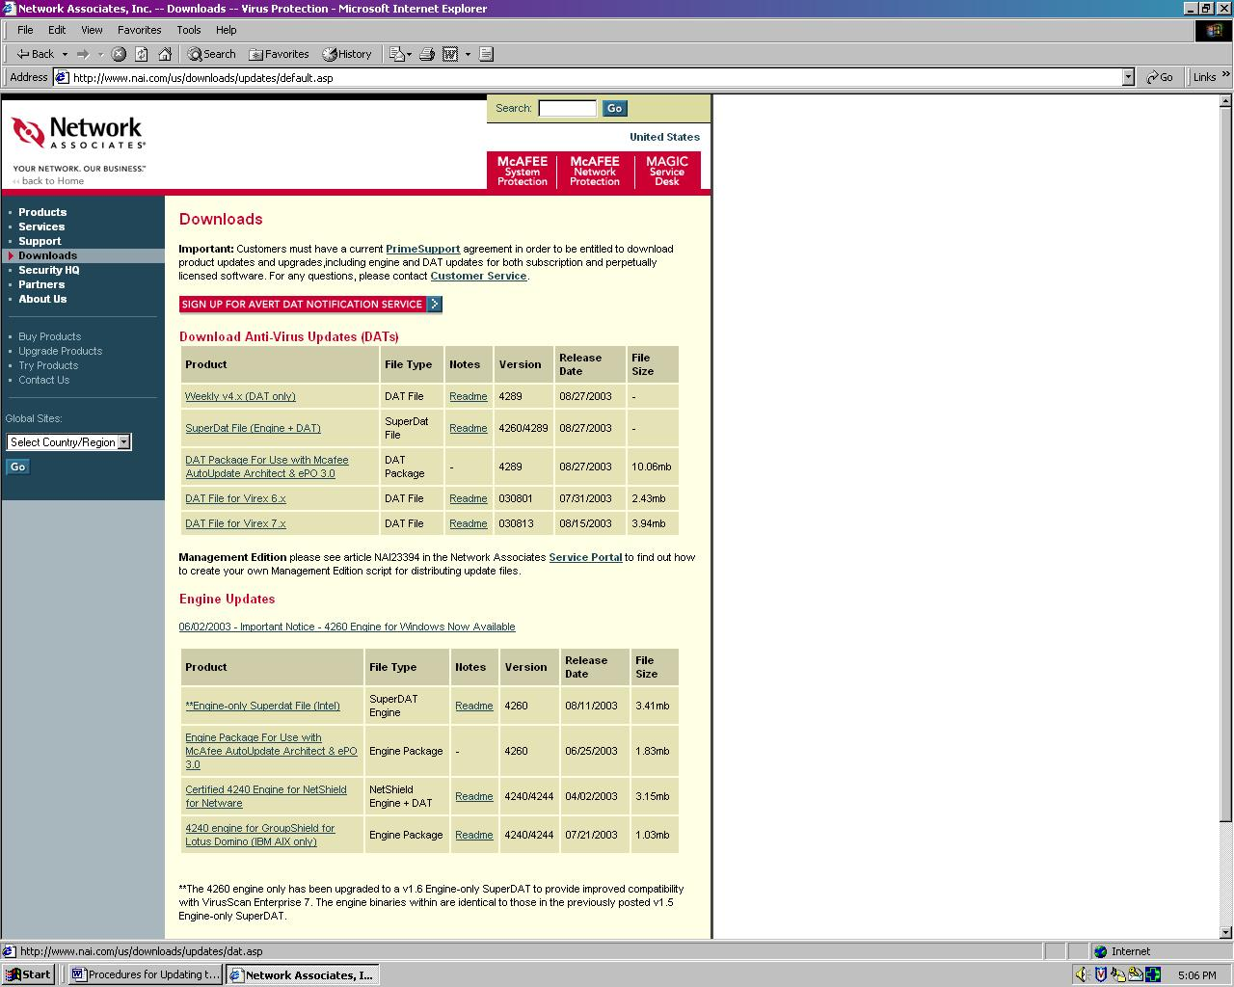

Step # 2a
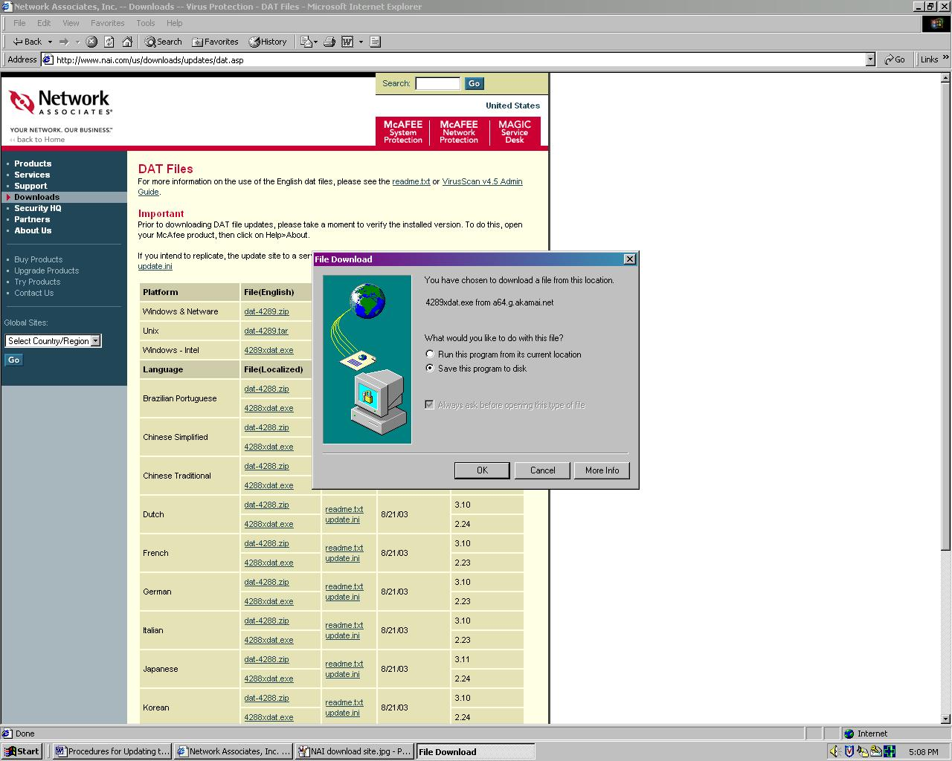

step # 2b
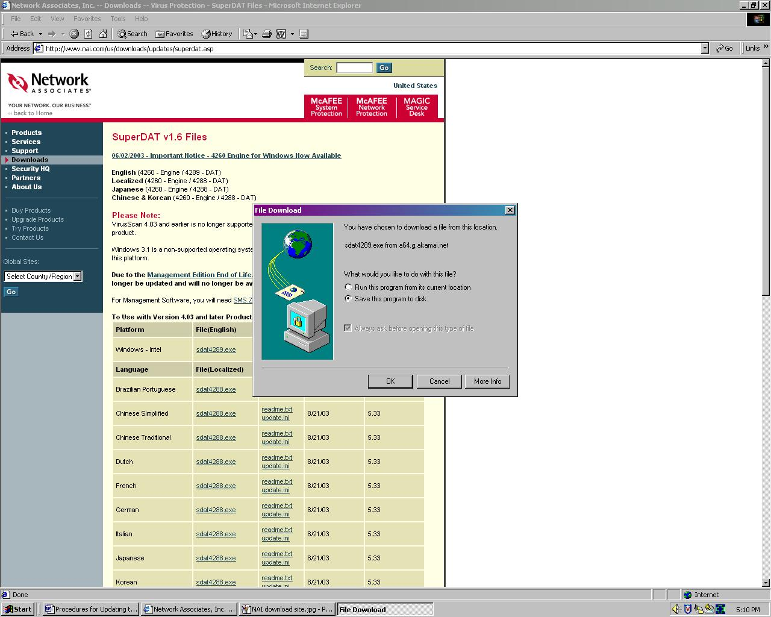

step # 3
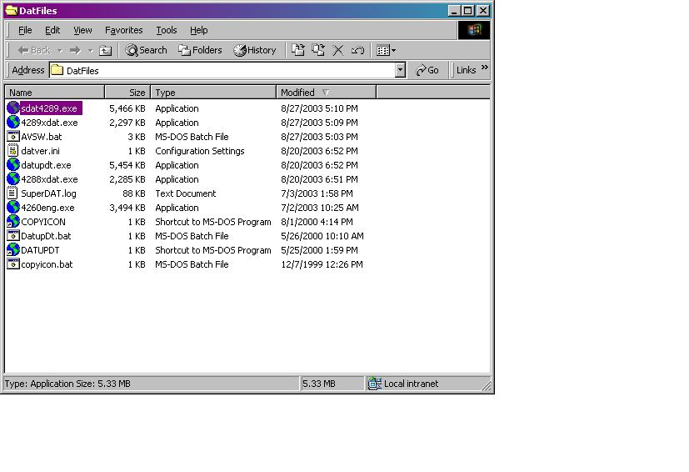

Step # 4
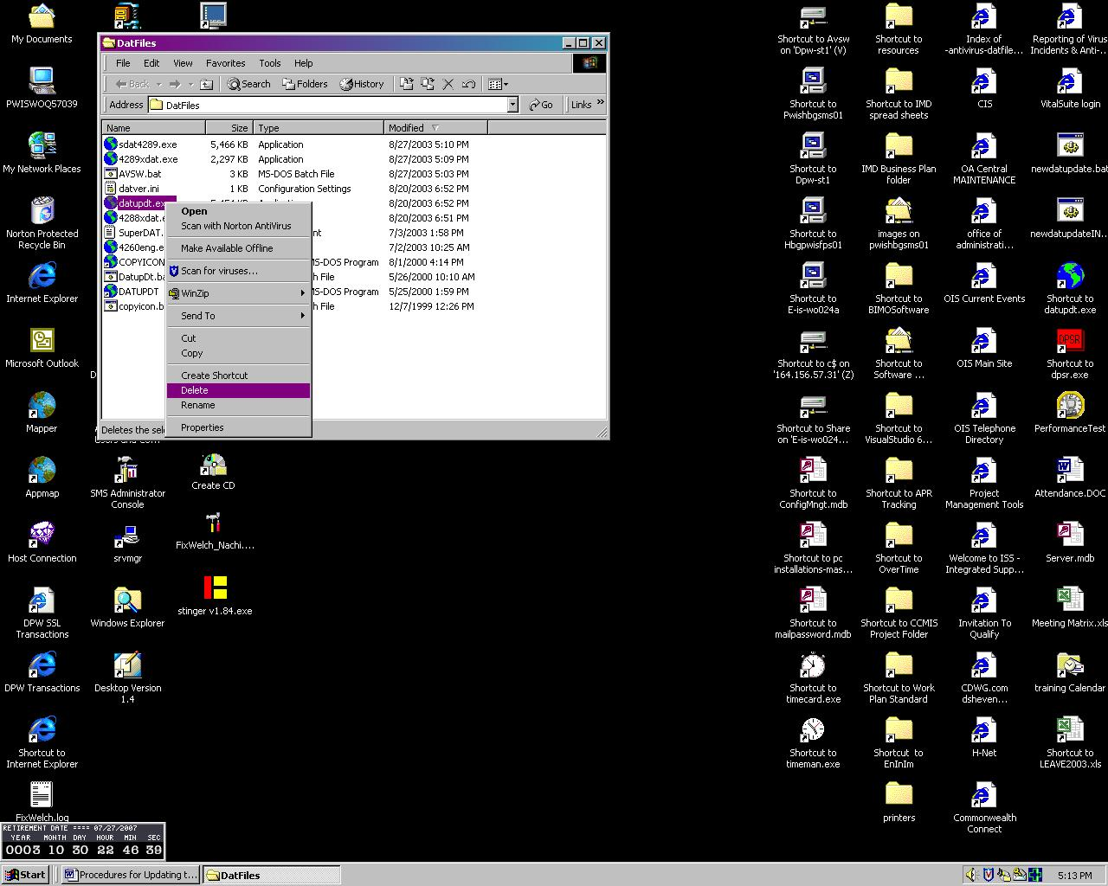

Step # 5
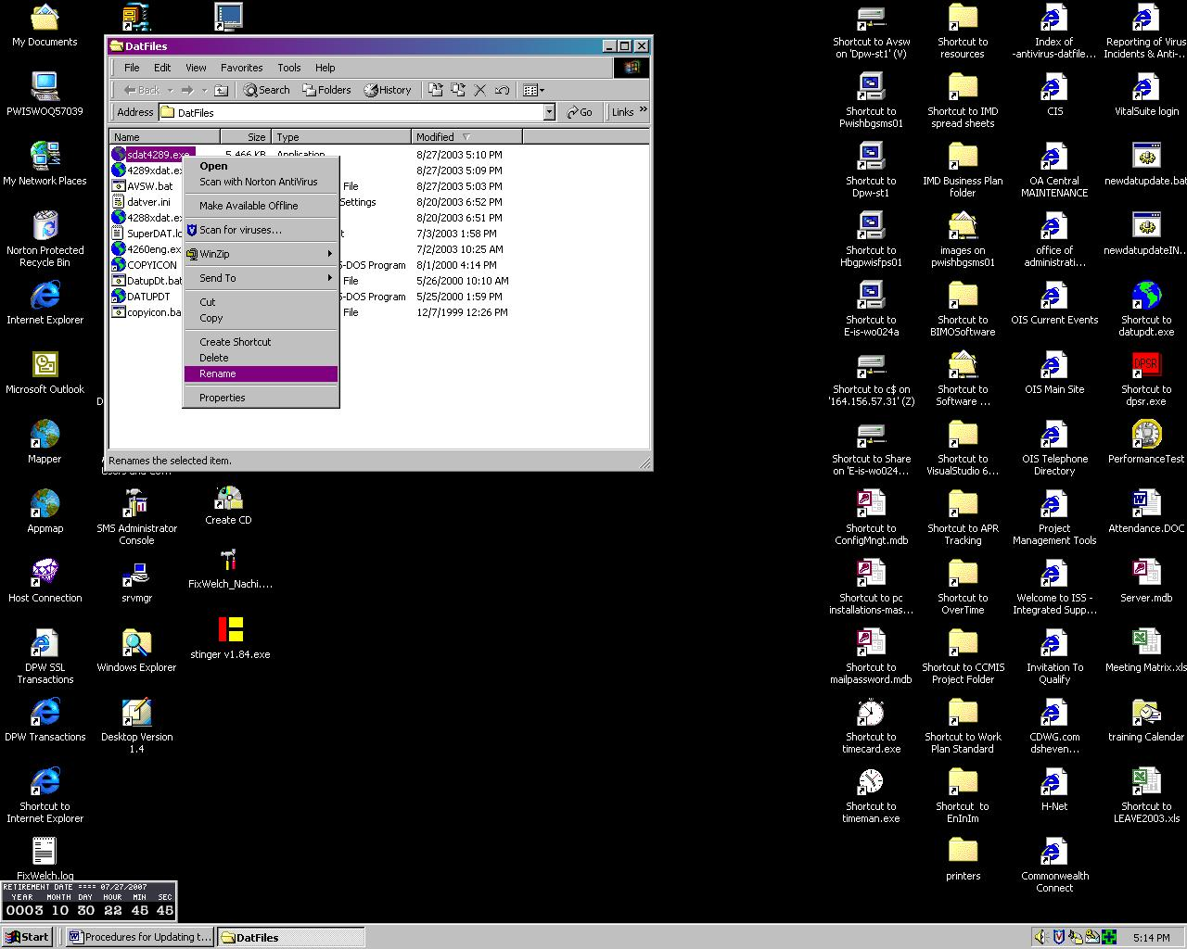

Step # 5 after rename complete
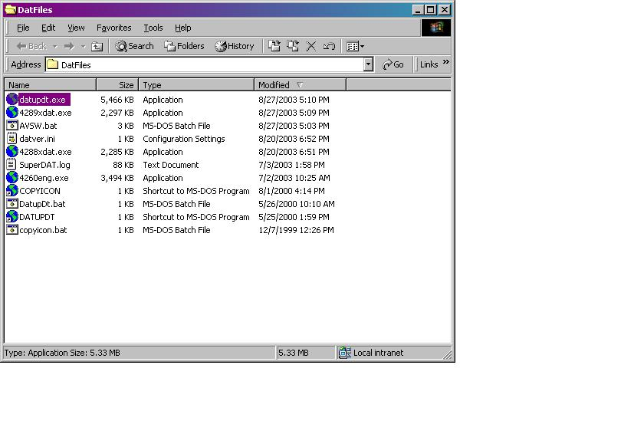

Step # 6
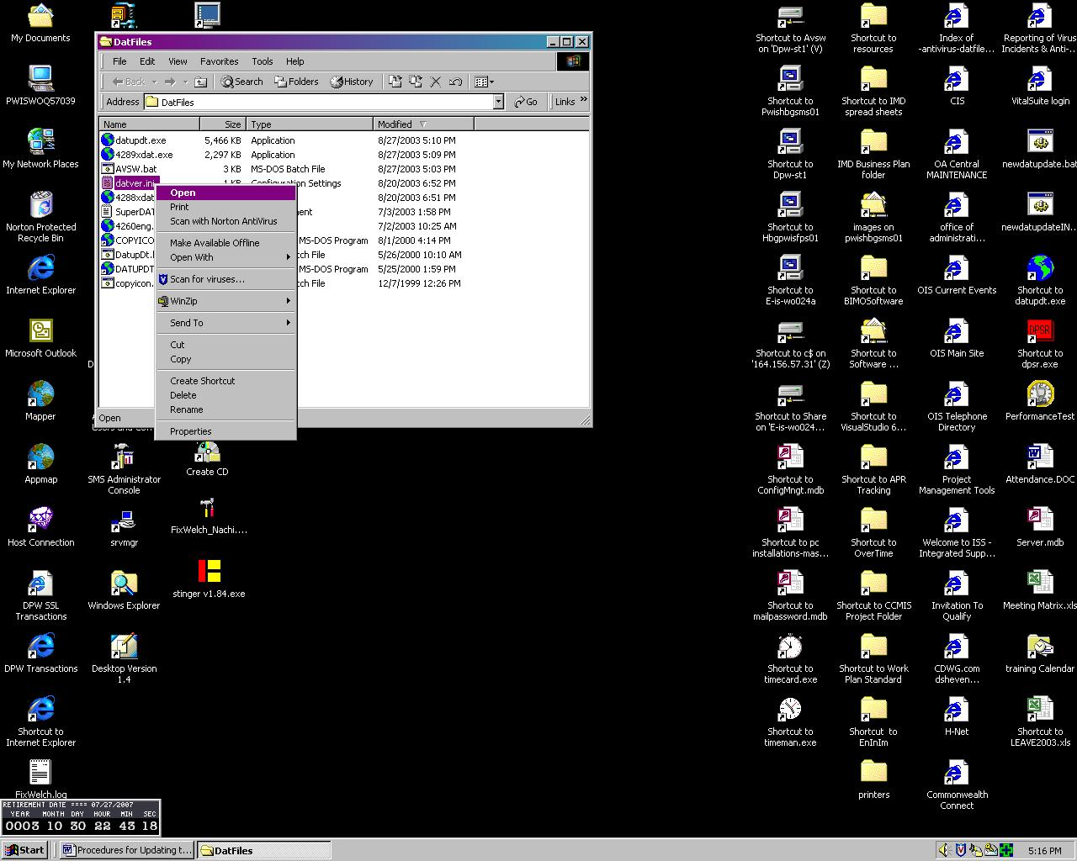
Step # 6a after file has been updated
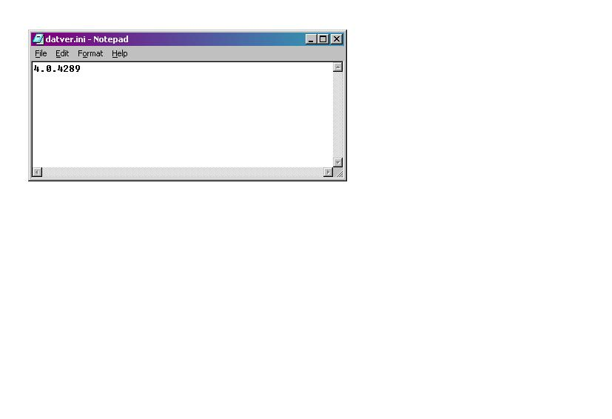

Step # 6b with new dat file name and file saved
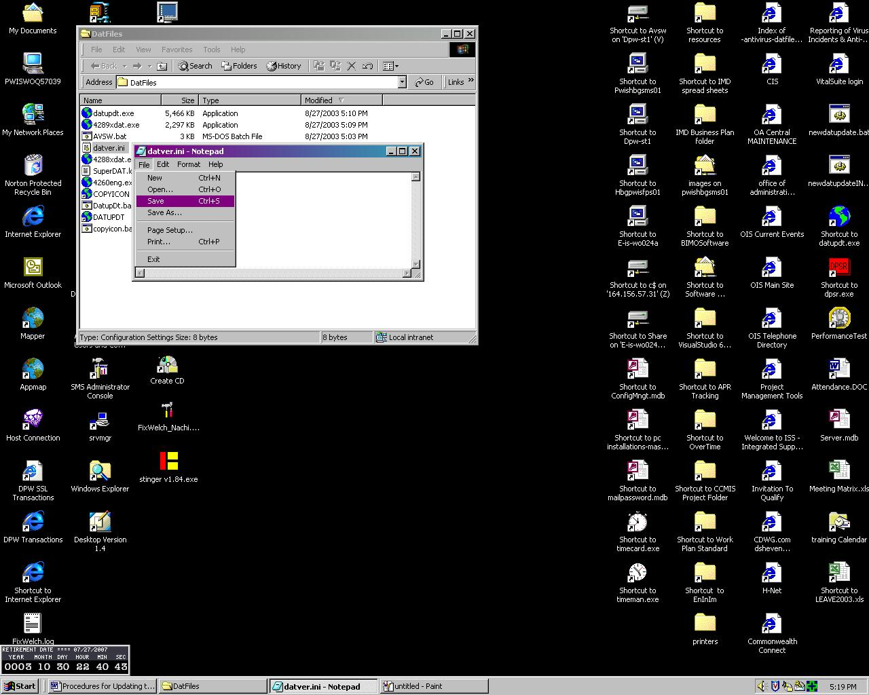

Step # 7
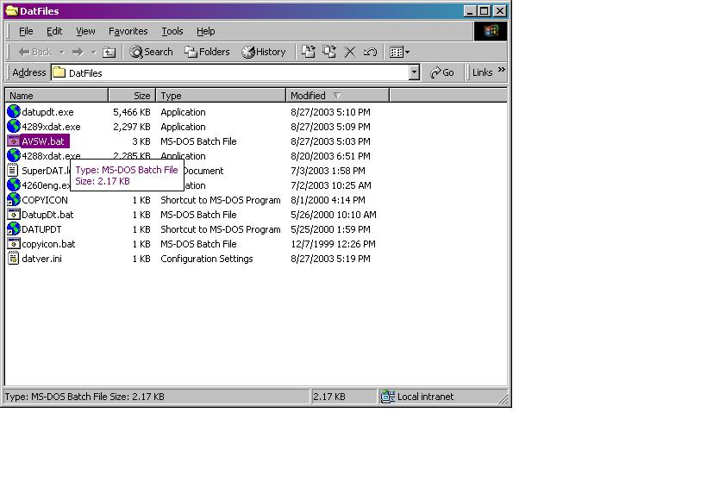
Running Step # 7
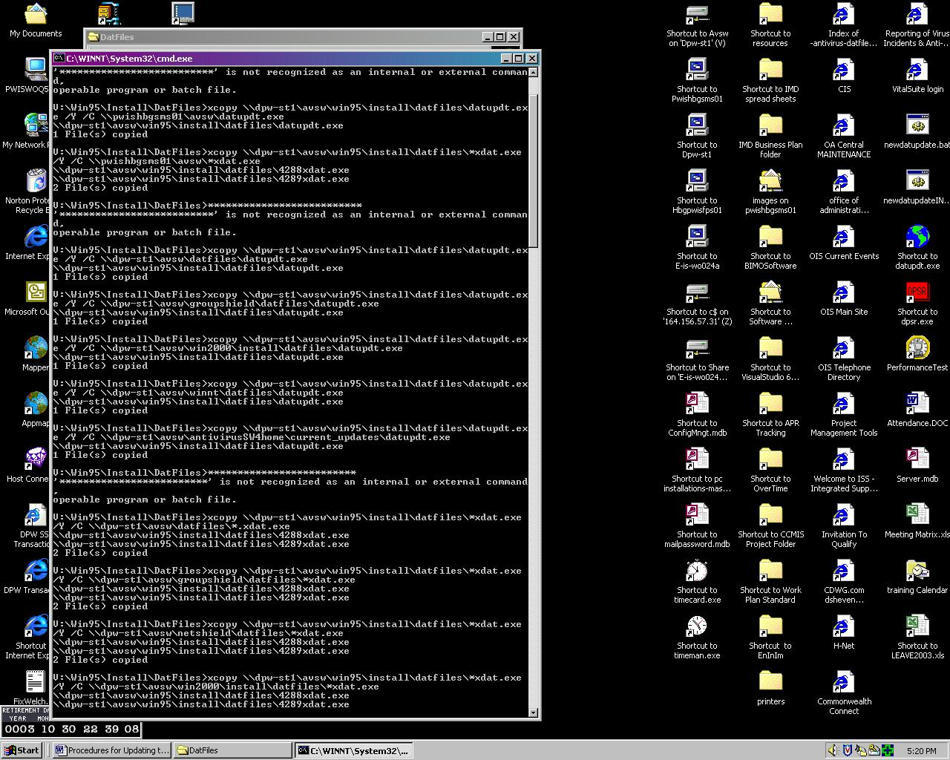

Step # 8a
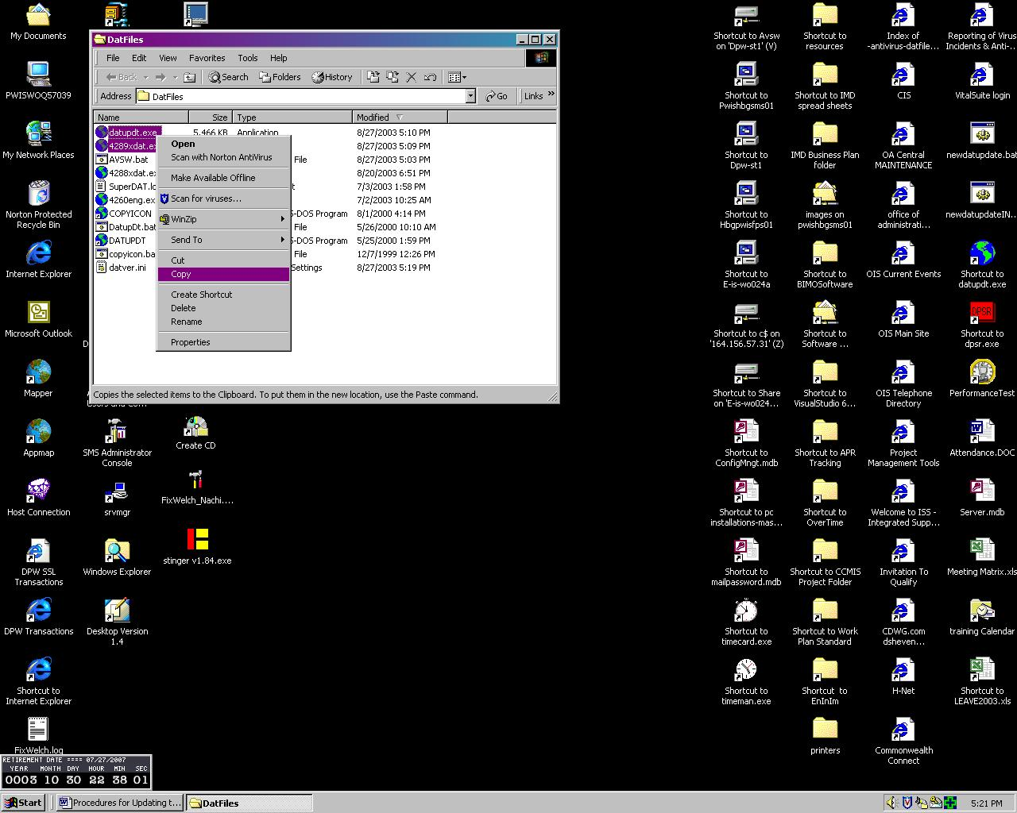

Step # 8b
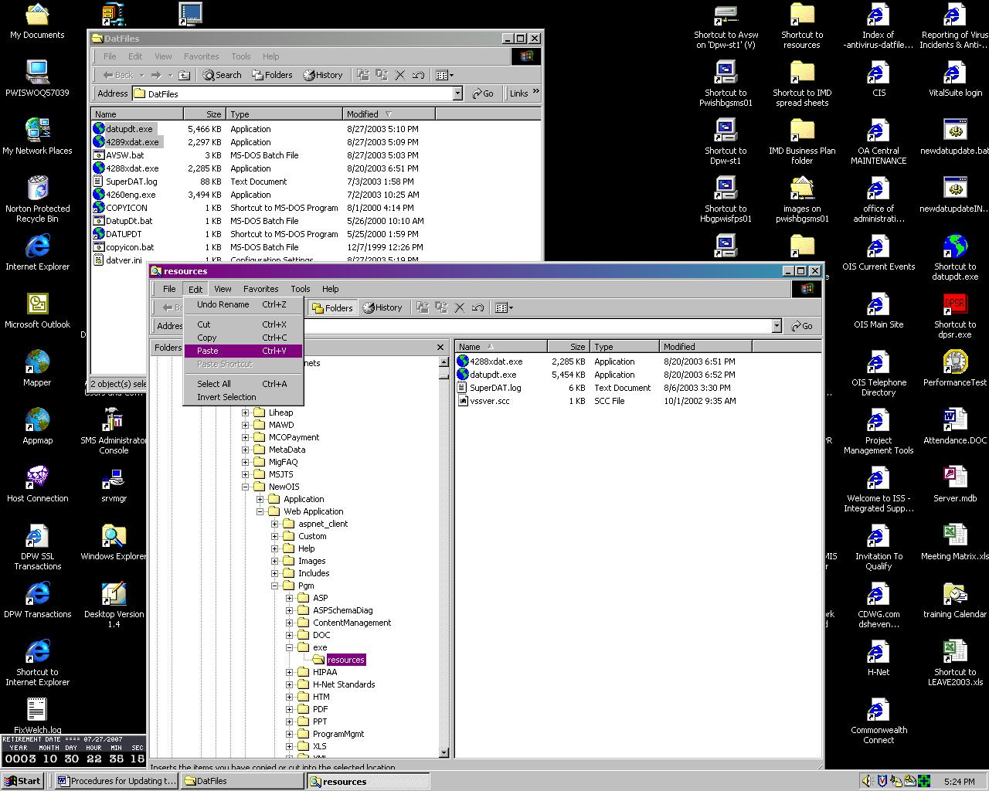

Document Change Log

Change Date | Version | CR # | Change Description | Author and Organization
01/06/2005 | 1.0 |  | Initial creation. | Mary Ann Delp  Desktop Section

