COMMONWEALTH OF PENNSYLVANIA
DEPARTMENT OF HUMAN SERVICES

INFORMATION TECHNOLOGY PROCEDURE

Name Of Procedure: | Number:
Unlocking User Accounts | PRO-ENSS019
Domain: | Category:
Procedures | EAS Enterprise Procedures
Date Issued: | Issued By:
01/08/2003 | DHS Bureau of Information Systems
Date Reviewed: | DHS Bureau of Information Systems
05/27/2016 | DHS Bureau of Information Systems

General:
This section uses a designated set of procedures to unlock user accounts.
The purpose of this document is to produce a set of easy to follow procedures to perform the unlocking of user accounts

Procedure:
Unlocking User Accounts
PASSWORD RESET & UNLOCKING ACCOUNTS FOR USERS

CWOPA UNLOCK ACCOUNTS ONLY – 1-800-281-5340
ALL OTHER ACCOUNT PROBLEMS – 1-800-296-5335

Strong Password Guidelines
No part of your name (first or last) should be used as part of the password itself.

Passwords consist of alpha-numeric as well as special punctuation characters. Any combination of at least six (6) characters from the list provided below will help you in eliminating future password problems when prompted to change your password by a system generated message or by you changing your password at will.

Passwords must:

Description | Examples
Not be NULL
Be a minimum of 8 characters
Not contain the user id or any part of name
Be unique from previous 10 passwords
Expire after 60 days
Not be changed more than once every 15 days
Use English Upper Case Letters | A, B, C, D, E, F…Z
Use English Lower Case Letters | a, b, c, d, e, f…z
Use Westernized Arabic Numerals | 0, 1, 2, 3, 4, 5, 6, 7, 8, 9
Use Non Alpha-Numeric Punctuation Symbols (Special Characters) | #, (, *, $

Password Example Only – Store#12 – (This example shows how a typical password with at least 1 character from each of the four categories would look).

CWOPA Password Lockouts
Lockouts primarily occur because the operator is not properly Signed On or Sighed Off the pc.

SOME OF THE MORE COMMON LOCKOUTS OCCUR WHEN:
- Typing in your password and bumping another character that is not intended to be there.
- Typing the password with the CAPS LOCK key engaged.
- Typing the password in all lower case letters without using the proper format.
- Typing without entering a CAPITAL LETTER where it is intended to be.
- Typing with the NUMBER LOCK key engaged.
- Entering the wrong password several times in a row.
- Trying to sign on to a second PC while still active in another PC.
- A shared PC where each person has their own password and the password has been changed to a common one without all shard users aware of the change. (Especially in EES application where shirt workers are involved).
- Forgetting your newly changed password and trying to sign on with your old one.
- System going down.
- The replication of the newly created password had not completely authenticated.

There are other ways to cause you to get locked out of your system; these are the most common causes we run across.

Avoidance of Lockouts
- If you are a shared user of the same pc, check with your shift supervisor to see if any changes have occurred.
- Check with your supervisor to see if there are any system problems.
- Take your time when entering your password into the system.
- Remember your new password, especially if it is a significant change from your old password.
- Allow up to 15 minutes for the password to replicate into other applications especially for e-mail.

Follow these tips carefully before dialing 1-800-281-5340 (Help Desk)

A Detailed Guide to Locking, Unlocking and Resetting Password Accounts

ACCESSIBILITY --- RESTRICTED --- NO RIGHTS REQUIRED TO ACCESS ACCOUNTS

DOCUMENTATION: Received by Phone Calls from the Users or Supervisors

Process Used to Enter Accounts

DESKTOP NAVIGATION REQUIREMENTS needed to ACCESS ACCOUNTS
A. If you do not have ACCESS RIGHTS you cannot start this PROCESS
B. If you do not have ACTIVE DIRECTORY ICON you cannot start this PROCESS
C. If you do have ACTIVE DIRECTORY ICON you can start this PROCESS

1. ACTIVE DIRECTORY NAVIGATION PROCESS USED TO ACCESS ACCOUNTS
A. DOUBLE LEFT CLICK on the ACTIVE DIRECTORY ICON on the DESKTOP Screen

Desktop Screen

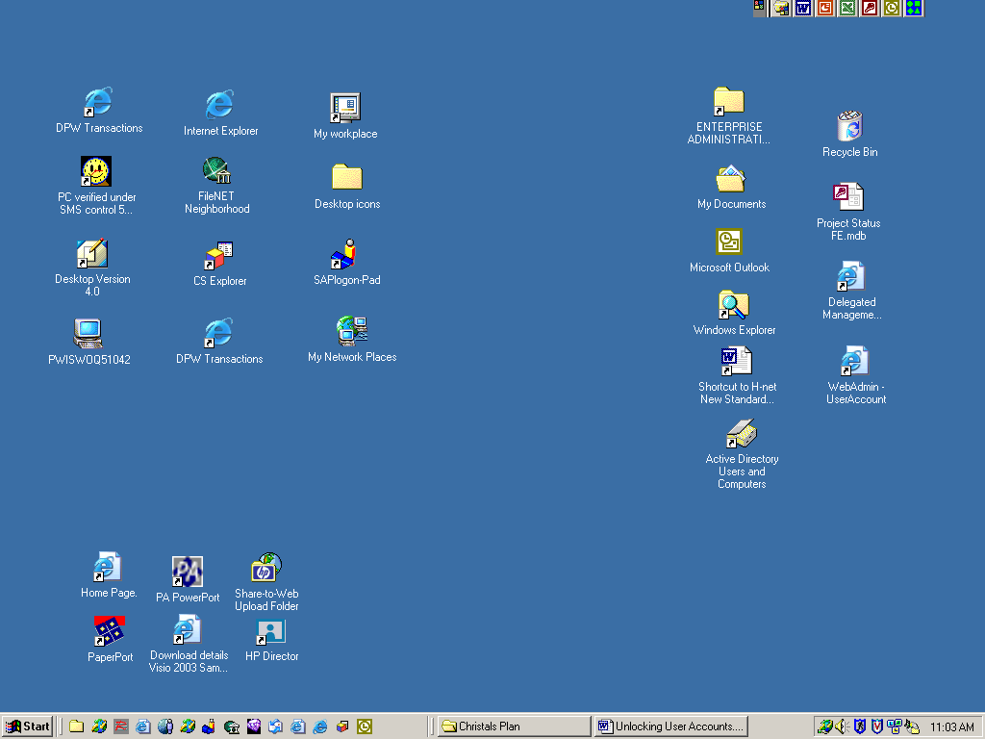

B. The Active Directory Users and Computers Window Appears Divided
1. The TREE ROOT Side
2. The DETAIL DESCRIPTION Side

Active Directory Users and Computers
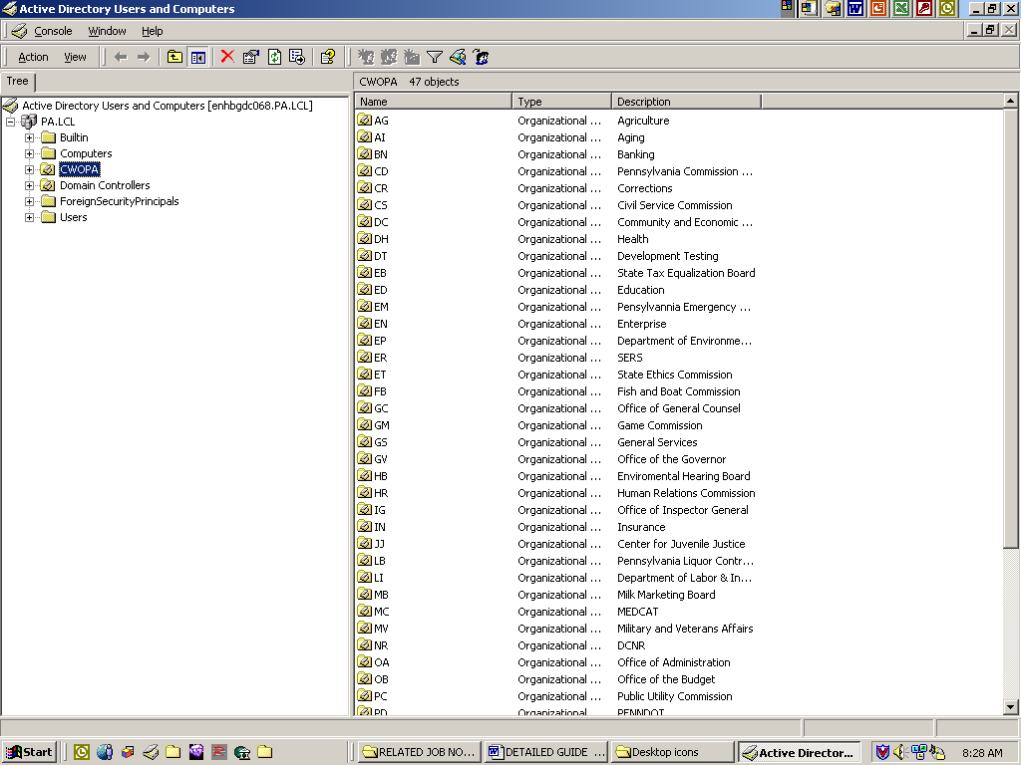

C. HIGHLIGHT the CWOPA Account in the TREE ROOT FOLDER Side of the
Divided Screen.

D. Up in the TOOL BAR line, across the top of the WINDOW
1. LEFT CLICK on the FOLDER with the SPY GLASS on it.
In the window look for the FIND USERS, CONTACTS and GROUPS Insert.

Find Users, Contacts and Groups (Insert)
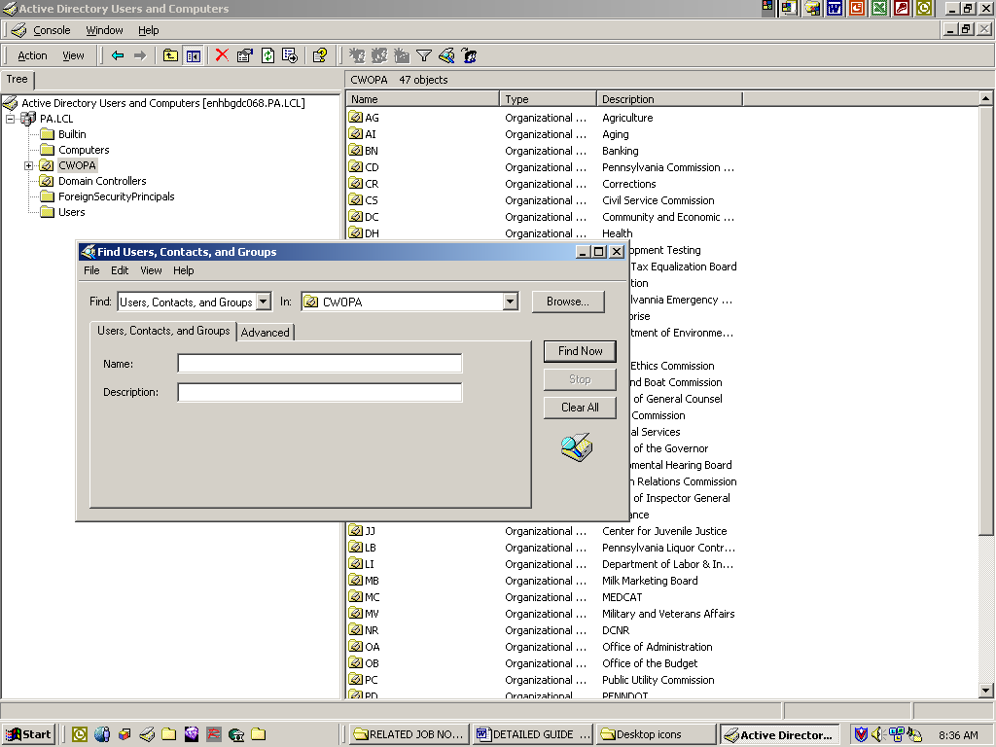

1. This Window insert has 4 white BLANK BOXES - 2 of which contain Drop down Arrows -
and 4 Buttons
a. Browse
b. Find Now
c. Stop
d. Clear All

2. This Window insert also contains 2 TABS
A. Users, Contacts and Groups TAB
1. NAME Line: Enter the name of the client using his CWOPA Alias
2. DESCRIPTION Line: Remains Blank
B. Advanced TAB: We do nothing here

Users Contacts and Groups (Drop Down Insert))
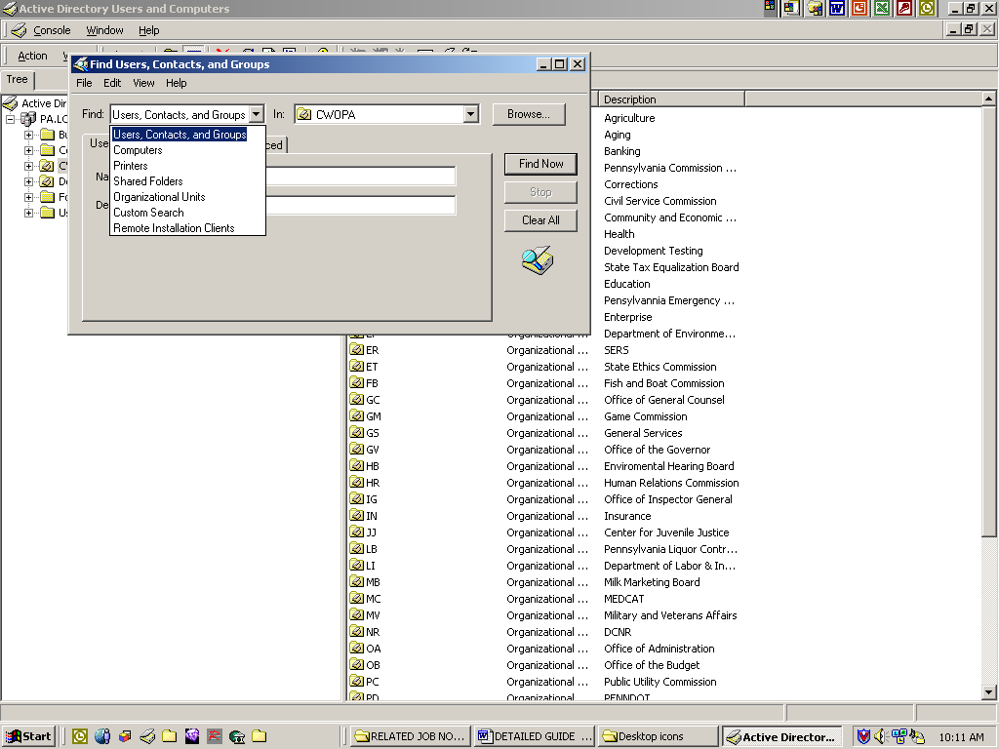

1. Find box: Has a Drop down Arrow. The Box contains several Groups to select from.
As you select the one you want, the WINDOW name will change.

Selecting the wrong Field, you can enter data into the wrong Window

You should be in the FIND, USERS, CONTACTS and GROUPS Window.

Find, Contacts and Groups (Drop Down Insert)

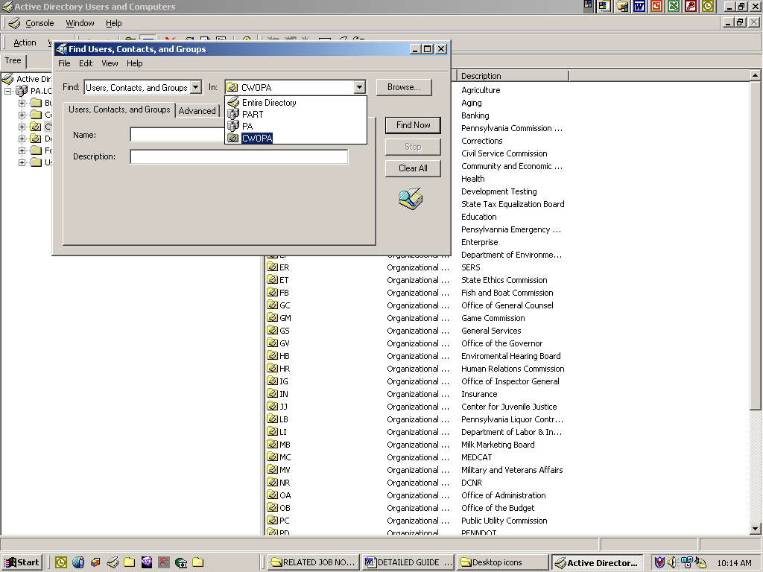

2. IN box: Contains four Groups to select from. You select the CWOPA Group.

The Browse Button will give a two character listing of all the accounts. (Not Needed)

3. Once you have selected the Group you need to be in, GO to the NAME: line box.

Find Users, Contacts, and Groups (Insert)

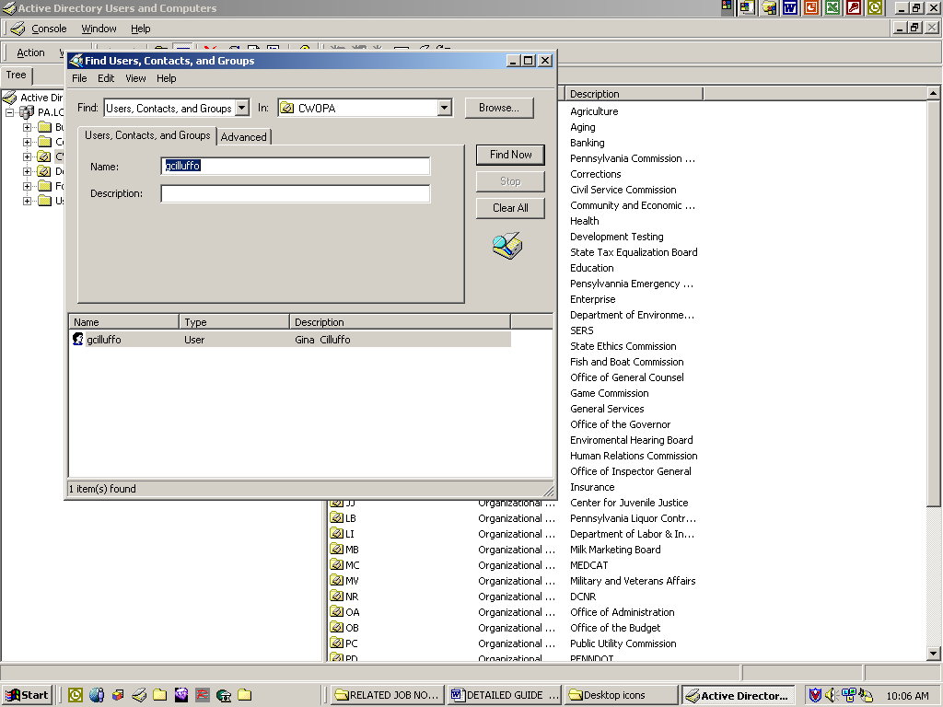

3. In the word Name: box enter the client’s name, then Single Left CLICK on the FIND NOW button.

4. The ACCOUNTS name will appear on the Bottom Half of the Window.
a. Single Right CLICK on the ACCOUNTS name
b. A window insert appears.

Find Users, Contact, and Groups (Insert with options)
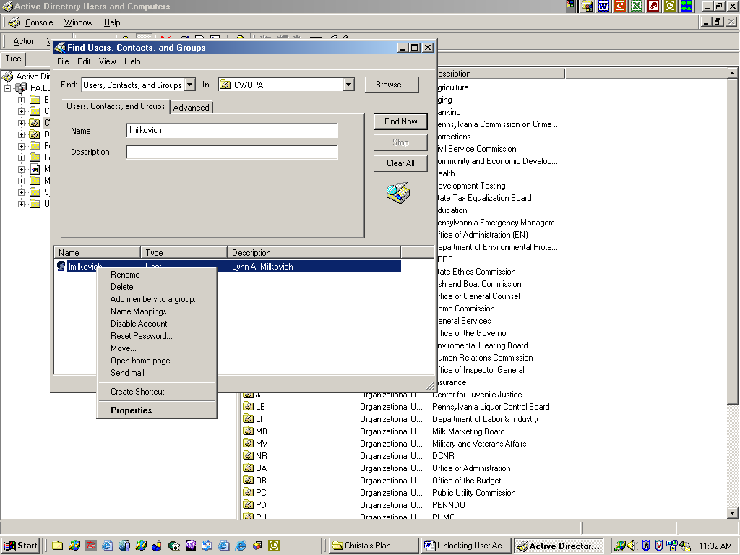

c. CLICK on the word Properties.

Alias Properties (Insert)
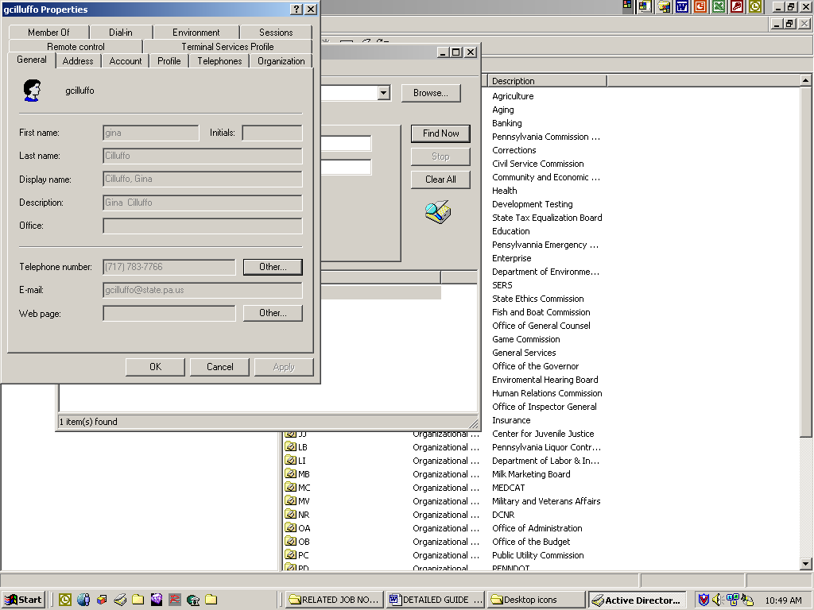

d. The ACCOUNTS PROPERTY Window will appear

ACCOUNTS PROPERTY WINDOW

PROPERTY WINDOW has several TABS with it.
A. GENERAL F. REMOTE CONTROL
B. ADDRESS G. TERMINAL SERVICES PROFILE
C. ACCOUNT H. MEMBER OF
D. PROFILE I. DIAL-IN
E. TELEPHONES J. ENVIRONMENT
F. ORGANIZATIONS K. SESSIONS

GENERAL TAB will be mainly grayed out.
You will be allowed to enter
a. ACCOUNTS PHONE NUMBER
b. OFFICE
c. WEB Address if given.

ACCOUNT TAB
A. LOCKING ACCOUNTS
1. Halfway down the PROPERTIES BOX Beneath
the LOG-ON Hrs and the LOG TO is a white box.
If the client IS NOT LOCKED OUT a CHECKMARK must be inserted .
a. CLICK in the white space and a
System Generated CHECKMARK will appear.
b. CLICK APPLY
c. CLICK OK
d. The CHECKMARK will indicate a LOCKED ACCOUNT

B. UNLOCKING ACCOUNTS
1. If a CHECKMARK appears in the Account is Locked Out box,
a. CLICK on CHECKMARK, it will go away
b. CLICK APPLY
c. CLICK OK
2. Close out the account

Client Properties insert box
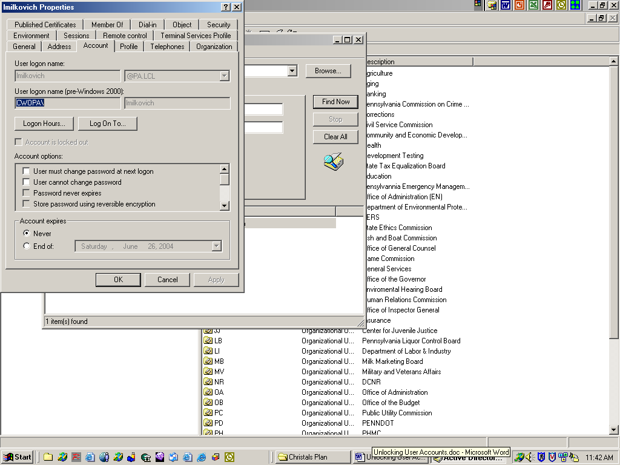

- If a CHECKMARK is not there, and the client still claims to be LOCKED OUT, their PASSWORD may need to be RESET. If so, you need Rights and or PERMISSIONS to effect a change.
- The PASSWORD in question is your normal CWOPA, signon password. This is the one you sing in on your system with. As the ADMINISTRATOR, you will be told from the client what password to use, If not, you assign the client a generic password of Password#1. This will allow the client to access his account.

C. PASSWORD RESETS
1. Passwords are generally selected by the USER. If not, the
password is DEFAULTED to Password#1.
- You need RIGHTS and or PERMISSIONS to RESET Password Accounts.
- Single Right CLICK on the clients name at Bottom of Window and a
window insert appears.

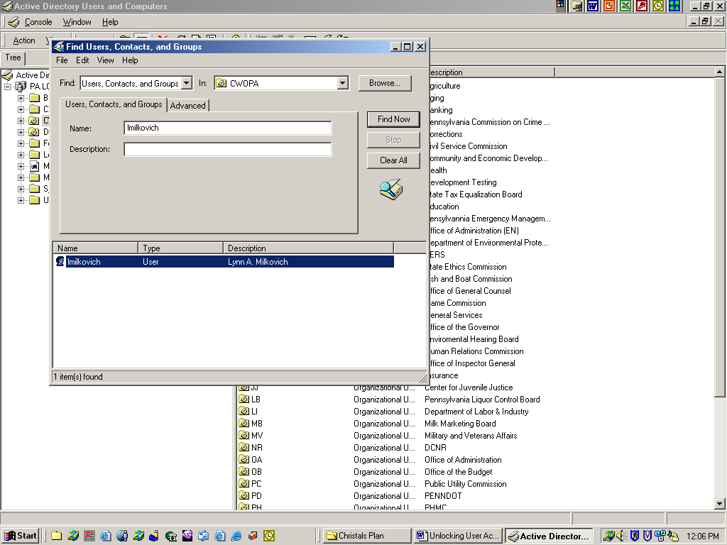
Find Users, Contacts, and Groups window with insert

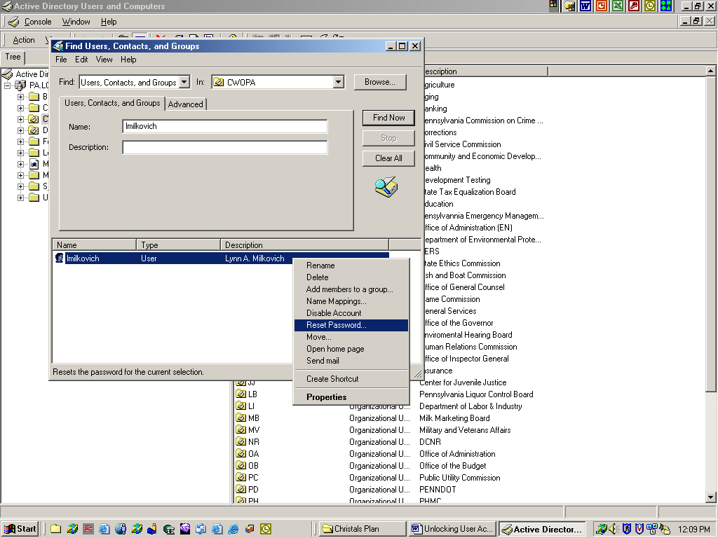

4. Window insert appears
A. Single Left Click on Reset Passwords
1. Type in your new password in the New Password Box
2. Type in new password in the Confirm Password Box
3. CLICK OK
4. Close Out

D. THE PROFILE TAB
In the PROFILE TAB you need to have the LOGON SCRIPT correct
It should read in this format: PW-logon.bat

E. Once you have created the password resets or unlocking of accounts, you should have
the client signon while you are on the phone with them to see if all is OK or advise a 10
minute wait for replication to occur.

Refresh Schedule:
All procedures and referenced documentation identified in this document will be subject to review and possible revision annually or upon request by the DHS Information Technology Standards Team.

Procedure Revision Log:

Change Date | Version | Change Description | Author and Organization
01/08/2003 | 1..0 | Initial creation. | Charles H. Strange
07/07/2004 | 2.0 | Revised standard | Lynn Milkovich
02/25/2005 | 2.0 | Reviewed content – No changes | Dave Shevenock
02/06/2009 | 2.1 | Reviewed and edited style | Toni Lugosky
07/14/2010 | 2.1 | Reviewed | Toni Lugosky
05/27/2016 | 2.1 | Updated Guidelines | Matthew Ashenfelder

