Pennsylvania
Department of Public Welfare
Bureau of Information Systems

OUTLOOK WEB ACCESS

Version 1.0

February 17, 2005
Table of Contents

Introduction 3
Purpose 3
Document Change Log 3
Outlook Web Access 4
Inbox Overview 7
Changing the Viewer 7
Creating and Sending New Messages 7
Checking for New Mail 7
Opening Messages 7
Working with Folders 8
Adding a Folder View to your List of Favorites 9
Creating, Deleting, Moving, and Copying Folders 9
Changing Pages 9
Customizing the Message List 10

OUTLOOK WEB ACCESS
Introduction
Outlook Web Access enables authorized Commonwealth users the capability to access their e-mail on the CWOPA exchange server from any pc workstation or laptop that has internet access.
Purpose
The purpose of this document is to show step by step procedures when using Outlook Web Access.

Outlook Web Access
Outlook Web Access provides the capability for authorized Commonwealth users to access their e-mail at the Commonwealth Exchange System (CWOPA) from any PC that has Internet access.

This is a secured site that can be accessed using the following internet address: https://www.owa.state.pa.us. The letters “https” must be included when the address is entered. Users will be prompted to enter their network userid and password two times to enter the site.

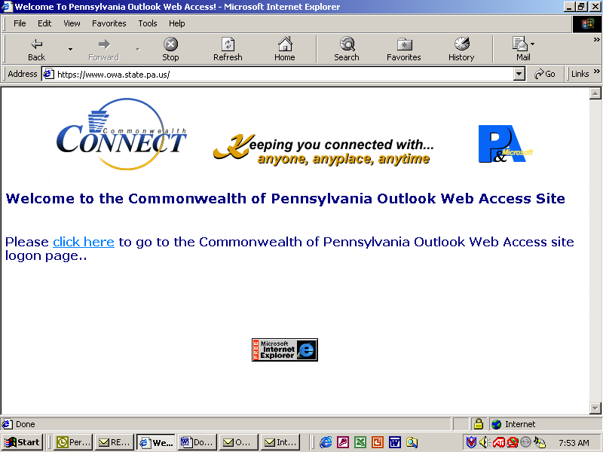
Click here to begin

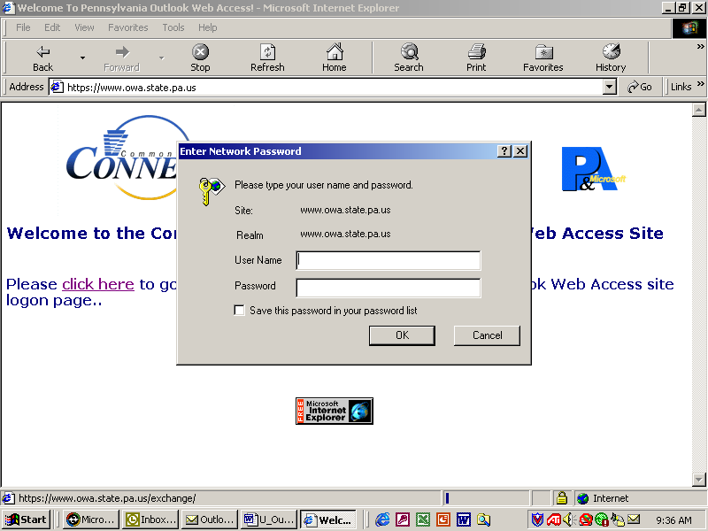
Enter your CWOPA network userid and password and press OK

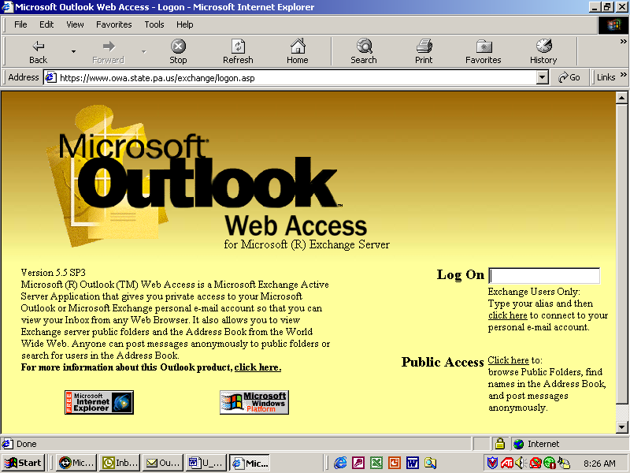
Enter your network userid. This is the same userid you just entered above. Then click on the “click here” link.

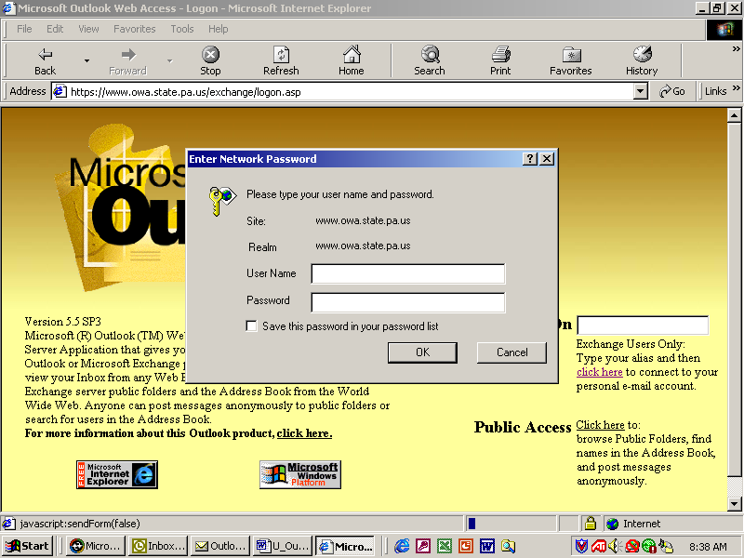
The system will automatically fill in your user name.

Enter your network password again and press OK.

You now have access to your calendar, e-mail, contacts, public folders, etc. Please review the instructions on the next few pages on how to view and reply to email.

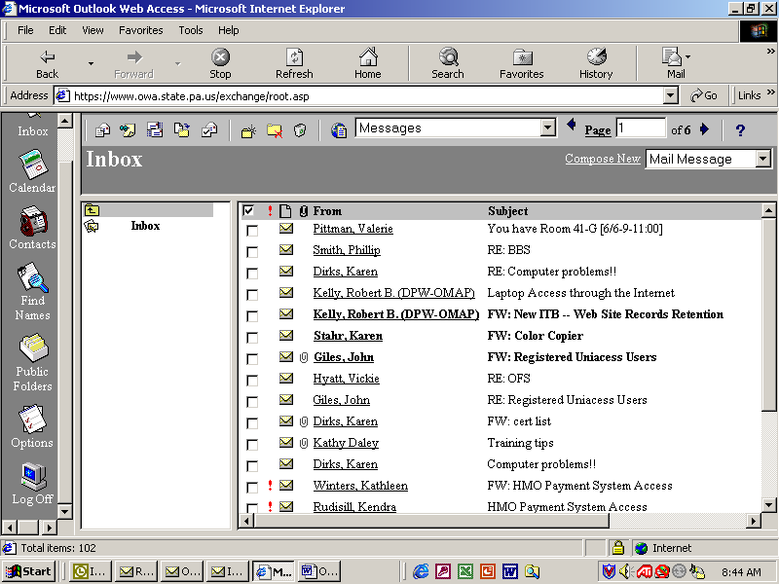
Important: Remember to Log Off
Log off after you finish using Outlook Web Access. By logging off, you close the session between the client and the server. If you close only the Web browser, there is no guarantee that your session is closed.

Inbox Overview

Inbox Overview
Your mailbox is located on the Microsoft Exchange Server computer where your e-mail is delivered. Messages are stored in your Inbox by default. You will not be able to access any messages that you have saved in your personal folders. You must access these messages on your PC at work using Microsoft Outlook instead of Outlook Web Access.

Changing the Viewer
The Inbox Viewer is the main window in Outlook Web Access. It includes the folder list and the folder contents list. The folder list is the set of folders that appears on the left side of the Viewer (adjacent to the Outlook Bar).
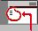Folder List
Use the Outlook Bar to switch between views to see your Inbox, Calendar, Contacts, or Public Folders. Other functions of the Outlook Bar enable you to find names in the Address Book, set user options, and log off your current Outlook Web Access session.

Creating and Sending New Messages
- In the Compose New message category list, select either Mail Message or Post to this Folder.
- Click Compose New.
- Type your message.
- Click the Send button on the toolbar.

Checking for New Mail
To check for new messages that have arrived since you opened your Inbox, click Check for new mail on the toolbar. Unread messages appear with bold titles. Once you read a message, its title appears in your user area in plain text.

Opening Messages
- From the list of messages in the user area, locate the message you want to read.
- Click the text of the first field that displays information. If a message has neither a sender nor a subject, click the size.
The Read Message form is displayed.
Deleting Messages
There are three ways you can delete messages.
- To delete an open message, click the Delete button on the toolbar.
- To delete a message while viewing the Inbox Viewer, select the check box adjacent to the sender's name, and then click Delete marked messages .
- To delete multiple messages while viewing the Inbox Viewer, select the check box adjacent to the sender's name for each message that you want to delete, and then click Delete marked messages . Deleted messages are sent to the Deleted Items folder. They are not removed permanently unless they are deleted from the Deleted Items folder.
You can delete open messages from the open message forms or from the Inbox Viewer using Delete marked messages.

Working with Folders
Your mailbox contains folders with specific functions: Calendar, Contacts, Deleted Items, Inbox, Outbox, and Sent Items. You can create additional folders to organize messages in different categories, such as Urgent, Alpha Project, or Personal. Folders that you create reside on the same level as your existing (default) folders, or you can create subfolders within existing folders. The folder contents list for the currently selected folder appears to the right of the folder list in the user area. To display the contents of a folder, click it. To view the contents of a higher-level folder, click Up one folder . Outlook Web Access provides the following default folders:

Calendar
Stores meeting and appointment information. To view and update your Calendar, click Calendar in the folder list.

Contacts
Stores contacts that you create. To view the contents of the Contacts folder, click Contacts in the folder list.

Deleted Items
Stores messages that you delete. You can view or permanently delete messages in the Deleted Items folder.

Inbox
Stores new mail that is delivered. To view the contents of the Inbox folder, click Inbox in the folder list. Items that you have not yet opened are displayed in bold type in the folder contents list to the right of the folder list.
Outbox
Holds mail until it is sent. To view the items in your Outbox, click Outbox in the folder list.

Sent Items
Stores a copy of each message that you send.

Adding a Folder View to your List of Favorites
To add the current folder view to your list of favorites (or bookmarks) in your Web browser, click Update page address . If your Web browser is Microsoft Internet Explorer, from the Favorites menu, choose Add To Favorites. If your Web browser is Netscape Navigator, from the Bookmarks menu, choose Add Bookmark.

Creating, Deleting, Moving, and Copying Folders
You can organize your messages into a hierarchical file system, and continue to adjust it as your needs change. For example, you can have a folder called My Team with subfolders for each person on your team. If someone leaves your team, you can delete the folder. If someone moves to another team, you can move the folder to that team folder.
- To create a new folder, click Create a new folder , type a name for the new folder, and then click OK. To cancel the operation, click Cancel.
- To delete a folder, click the name of the folder in the user area to open it, and then click Delete the current folder . When you do so, the following message appears: "Are you sure you want to delete the current folder and its subfolders?" To delete the folder, click OK. To cancel the operation, click Cancel.
- To move a folder, click the name of the folder in the user area to open it, and then click Move/Copy Folder . In the list of names of all the current folders, click the name of the destination folder. Click Move. To cancel the operation, click Close.
- To copy a folder, click the name of the folder to open it, and then click Move/Copy Folder . A new window opens, displaying the names of all the current folders. Click where you want to copy the destination folder, and then click Copy. To cancel the operation, click Close.

Changing Pages
The Page box is located on the toolbar, lists the total number of pages of messages that are in the current folder, and indicates which page is currently displayed. The list of messages is longer than can be displayed on one page of the viewer at once.
To display a different page, do one of the following:
- To display a specific page, click the first number (in the Page box), type the page number, and then click Page.
- To display the previous page, click Previous Page .
- To display the next page, click Next Page .

Customizing the Message List
You can change the message list to display messages that have related information. You can also change the message list to display messages sent by the same person or that have the same title.
To change the message list display, choose a command in the View box. You can select any of these categories:
- Messages displays messages as they are received, starting with the most recent message at the top of the list.
- Unread Messages displays only unread messages.
- By Sender groups messages sent by the same person. All messages in the folder are grouped alphabetically by sender.
- By Subject groups messages according to text that appears in the Subject box. All messages in the folder are grouped alphabetically by the subject.
- By Conversation Topic groups messages according to text that appears in the Conversation box. Each conversation group is displayed in the order received, starting with the most recent message at the top of the group. If there is no Conversation box in a message, the message is grouped by text that appears in the Subject box. If the message has neither a conversation nor a subject, the item is grouped under an empty heading.
Unread Messages by Conversation Topic groups unread messages by text that appears in the Conversation box. If there is no Conversation box in an unread message, the message is grouped by text that appears in the Subject box.

Document Change Log

Change Date | Version | Change Description | Author and Organization
02/04/03 | 1.0 | Initial creation. | Mary Ann Delp OIS/BIMO/DESK-TOP Management Section
02/17/2005 | 1.0 | Reviewed content – No change necessary | Dave Shevenock

