COMMONWEALTH OF PENNSYLVANIA
DEPARTMENT OF HUMAN SERVICES

INFORMATION TECHNOLOGY GUIDELINE

Name Of Guideline: | Number:
Work Plan Standard Guideline | GDL-EPPM012
Domain: | Category:
Business | Work Plan Standard
Date Issued: | Issued By:
04/25/2003 | DHS Bureau of Information Systems
Date Revised: | DHS Bureau of Information Systems
05/04/2015 | DHS Bureau of Information Systems

Table of Contents
Introduction 5
Purpose 5
Audience 5
What is the Work Plan Standard? 6
Benefits 6
Features and Functions 6
Standards 6
Phases 7
Key Milestones 8
How to Create a Work Plan Using the Work Plan Standard 9
Overview 9
Activity 1: Identify the Project Deliverables, Milestones, and Phases the Project Must Complete. 9
Activity 2: Build Your Work Plan 10
Activity 3: Estimate Timeframe to Accomplish Activities and Tasks 11
Activity 4: Enter Durations for Completing All Activities and Tasks 11
Activity 5: Assign Resources against Activities and Tasks 11
Action Steps: 12
Add a Resource Name 14
Activity 6: Create Dependencies among Tasks 15
Action Steps: 16
Activity 7: Baseline Your Work Plan and Save it in a Shared Directory 17
Deliverable 17
Closeout Criteria 17
Participants 17
Views for Managing Projects and Updating Tasks 18
Sort Gantt Chart by Finish Date 18
View Tasks Sorted by Governance Team 19
View Status of Project Phases and Key Project Milestones 21
View All Tasks, Their Durations and Section Assignments 22
View Tasks by Section/Resource Group 23
View Tasks Sorted by Section/Resource Group and by Expected Completion Date 24
View Resource Usage by Section 26
Report Progress and Track Actuals 27
Rescheduling Work 28
Glossary 31
Acceptance and Installation Phase 31
Activity 31
Baseline 31
Allocated Baseline 31
Functional Baseline 32
Product Baseline 32
Close-out Phase 32
Detailed System Design (DSD) Phase 33
Development Phase 33
Event 33
General System Design (GSD) Phase 33
Initiation Phase 33
Operational Support Phase 33
Planning Phase 34
Project Phase 34
Project Plan 34
Project Schedule 34
Requirements Definition Phase 34
Schedule 34
Software Integration and Testing Phase 35
Stakeholder 35
Task 35
Work Planning and Scheduling 35
Appendix 1 – Phase Definitions 36
Initiation 36
Planning 36
Requirements Definition 36
General System Design (GSD) 37
Detailed System Design (DSD) 37
Development 38
System Integration and Testing 38
Acceptance and Installation 39
Close-Out 39
Operational Support 39
Appendix 2 – Key Milestones 40
Key Milestones 40
Initiation 40
Planning 40
Requirements Definition 40
General System Design (GSD) Phase 41
Detailed System Design (DSD) Phase 41
Development Phase 42
Software Integration and Testing Phase 42
Acceptance and Installation Phase 42
Close-out Phase 43
Operational Support 43
Appendix 3 – Delegating Use of the Standard 44
Refresh Schedule 45
Guideline Revision Log 45

Work Plan Standard Guideline
Introduction
Information Technology (IT) projects need to be planned according to a set of standardized project life cycle indicators. Planning projects with standardized project life cycle indicators prevents the unintentional omission of activities early in a project, causing unnecessary resource conflicts and deadline crunches in the future. Planning projects with standardized project life cycle indicators also prevents inconsistent progress reports across projects. When status reports across projects are based on the same life cycle indicators, the Department of Human Services (DHS) Management can effectively assess each project’s level of need for physical, financial, and management resources.
The Work Plan Standard (WPS) is a tool DHS IT project managers can use to plan projects according to the standard project life cycle indicators as expanded from the BIS System Development Methodology (SDM). Though a standardized template, the Project Work Plan Standard is flexible enough for project managers to tailor the DHS Work Plan to the specific needs of the project without losing the cross-project comparability DHS Management needs to effectively assess a project’s needs and progress.
Purpose
This document provides information for understanding, and guidelines for using the Program Management Office (PMO) Work Plan Standard.
Audience
This document is for all project managers, and supporting staff working on IT projects under the DHS in the Commonwealth of Pennsylvania.
What is the Work Plan Standard?
Within the WPS are four types of files:
- Checklists – A set of documents listing issues to consider and work items to perform in order to completely satisfy a task, such as scheduling work for a project phase, designing a physical data model, or building a capacity plan. Completing the Work Plan Milestones Checklist will identify all the deliverables, tasks, milestones and life cycle phases the project must complete in order to be successful. The Checklists in the Standard can help to determine what detail is needed, or not needed in this process.
- Templates – A listing of document templates and instructions for completing each template. Such templates include: Requirements Traceability Matrix, Conversion Plan, Training Plan, etc. The templates will help achieve various milestones in the work plan, and will help define and organize requirements, plans and processes for the project.
- Guidelines – Documentation to guide teams through performing procedures such as holding deliverable walk-through sessions, establishing project communication plans, or conducting project phase exit reviews.
- Sub-Work Plan Templates – Project plan templates for supplementary pieces of work, which may or may not be required in order to achieve project success, such as outsourcing, or creating a communications plan. Sub-Work Plan Templates can be inserted into your work plan according to the needs of the project.
Detailed instructions for building a work plan using the DHS Standard Work Plan are located in the section ‘How to Create a Work Plan Using the Work Plan Standard.’
Benefits
By using the DHS Work Plan Standard, a project manager can more quickly create detailed project plans and documents that follow PMO standards.
By using the DHS Work Plan Standard as the base of a comprehensive project schedule, a project work plan will have the project phases and milestones that senior management is using to monitor project progress.
Features and Functions
Standards
This section outlines the standards that will be followed in preparing a work plan.
- Microsoft (MS) Project 2000 will be used to do project scheduling.
- The structure of a project will be:
  - Releases
- Phases within a release
  - Activities within a phase
    - Tasks within an activity
- Name Activities and Tasks with a leading action verb.
- Key milestones - at a minimum, use the milestones defined in the Standard to identify key points of progress on your project. Create others as necessary.
- Exit reviews must be conducted as the last activity in all phases.
- A “% Complete” (rounded down to a whole number) must be included in the work plan.
- Let MS Project determine the Scheduled/Estimated Start/Completion Dates. MS Project determines these dates from the durations entered and the dependencies set among activities.
- Include Actual Start/Completion Dates in the work plan after the activity has actually started or completed.
- Develop the work plan calendar by resource type. Modify the Standard to reflect the project resources that are required for the project.
- Assign resources at either the activity or task level. DHS will assign resources for its internal staff. Outsourced project contractors will assign resources for their staff.
- Enter duration for tasks. Duration should be elapsed time, not work effort, and should be expressed in days or partial days. Note the percent of time available for each task.
- ‘Work day’ designations will be determined either by DHS for its own staff or contractors for their staff.
- Baseline - A baseline will be established at the start of a project. A baseline can only be changed if it is authorized by the approval/signoff of a change request. Each baseline will include a note with the ID(s) of the change request(s).
- Repository - Both a Master Work Plan and Individual Work Plans will be stored centrally. Individual Work Plans will be linked to the Master Work Plan. Project Managers will have read/write access to their project’s work plan and read-only access to the Master Work Plan. The Department’s standard for this activity is FileNET’s Enterprise Content Management (ECM) System
Phases
The phases outlined in the Work Plan Standard correspond to and augment the phases outlined in the BIS System Development Methodology (SDM). The phases are outlined in the diagram below and are defined in detail in the glossary and Appendix 1.
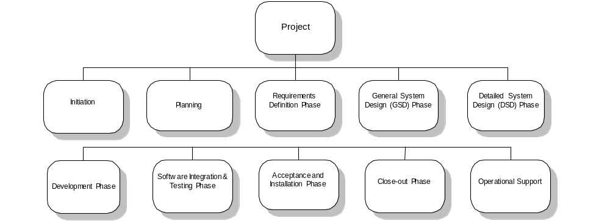
Key Milestones
Key milestones are typical achievements during the development life cycle of a project (i.e. Testing Scenarios Complete) that must be reached in order to successfully complete each project phase. A project manager may or may not use all of the provided milestones, or may elect to add milestones to the project schedule based on the specific needs of the project. However, a project manager needs to be aware that senior management may be using these milestones to monitor project progress, and may require explanations for why milestones were omitted or added. A comprehensive list of Key Milestones appears in Appendix 2.
How to Create a Work Plan Using the Work Plan Standard
Overview
There are seven basic activities to perform to build a work plan for your project using the Work Plan Standard:
- Use the Work Plan Milestones Checklist to identify deliverables and milestones the project must complete, as well as the project phases (Planning, Development, Acceptance and Installation…etc.) your project must work through.
- Create the project work plan by modifying a copy of the DHS Standard Work Plan.
- Estimate the time frames needed to complete each of the project tasks
- Enter durations for completion of all activities and tasks.
- Review and assign resources to tasks
- Create dependencies among tasks.
- Save copies of your work plan in FileNET and save a baseline to the work plan.
The following instructions assume the project manager will be responsible for all seven activities. If the project manager plans to delegate the responsibility of modifying the activities and tasks of each phase of the project to team leads (activities 3, 4, and 5), please review Appendix 3 of this document.
Activity 1: Identify the Project Deliverables, Milestones, and Phases the Project Must Complete.
The Work Plan Milestones Checklist provides the ability to identify the milestones, phases, deliverables, and tasks needed to complete your initial project plan, all in one exercise.
By choosing a milestone from the Work Plan Milestones Checklist, recognizes the project’s need to include four (4) aspects of the Work Plan Standard in your project plan:
- Project Phases: Each milestone is listed in the Work Plan Milestones Checklist according to the project phase it should be completed in. For example, by choosing a milestone listed under the ‘Planning Phase’ heading, recognizes that the Planning Phase must be included in the project plan.
- Project Deliverables: Each milestone in the Work Plan Milestones Checklist is associated with the completion of a deliverable in the Work Plan Standard. For example, by choosing the milestone, “General System Design Document Completed and Signed-Off”, recognizes the project must create and deliver a General System Design Document to project stakeholders.
- Project Tasks: The DHS Work Plan Standard lists specific sets of tasks as the required work needed to complete each milestone. By choosing a milestone in the Work Plan Milestones Checklist, recognizes the activities and tasks associated with the completion of that milestone in your work plan.
- Progress Indicators: Each milestone is an indicator of project progress in the Work Plan Standard, and can be used as such in progress and status reporting.
Activity 2: Build Your Work Plan
After determining the necessary deliverables, milestones, tasks and phases of the project’s life cycle, use that information to complete your work plan. The steps below illustrate this process in detail.
These instructions assume you have a working knowledge of Microsoft Project 2000.
- Open the DHS Work Plan Standard.
- Click Cancel on the use resource dialog box.
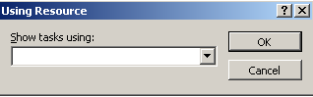
- The standard work plan will appear. Select File→Save As and save the work plan under the project name in another location.
- Modify the first task line to display the project name and, if appropriate, project release.
- Review the completed copy of the Work Plan Milestones Checklist. Delete the phases from the work plan identified as unnecessary.
- Evaluate the activities and tasks in the Standard against the Work Plan Milestones Checklist. Delete the detail that does not support completing the milestones and deliverables chosen in the Work Plan Milestones Checklist.
- Add new activities, tasks, subtasks, deliverables or milestones as necessary, according to the specific needs of your project.
  - To add a new activity:
    - Put the cursor on the line where a new activity will be entered and press the Insert key.
    - Type the task name
    - Tab to the Governance Team Owner field and select the governance team for this task from the drop-down list.
    - When all new tasks have been added, save the project without saving a baseline.
Activity 3: Estimate Timeframe to Accomplish Activities and Tasks
Determine the number of people and other resources needed to efficiently achieve each activity or task in your project plan.
Note: For this version of the work plan standard, ‘resource’ refers to the office/bureau/division/ section to which an activity is assigned. Future enhancements will drill down to the specific resource level.
Activity 4: Enter Durations for Completing All Activities and Tasks
‘Duration’ means the elapsed time from the start of an activity or task until it is completed. Durations should be entered as a measure of days, or partial days. Durations must be entered for all activities and tasks in the work plan.
The action steps in Activity 5 should be followed for entering duration. The task form at the bottom of the screen displayed provides a place for entering task duration. Enter the duration in this field.
Activity 5: Assign Resources against Activities and Tasks
Two columns titled ‘Governance Teams’ and ‘Section Assignments’ appear in the DHS Work Plan Standard. When populating those fields for each task, use the drop-down property or manually enter the Governance Team and DHS Section associated with the resource.
Note: For this version of the work plan standard, ‘resource’ refers to the office/bureau/division/section to which an activity is assigned. Future enhancements will drill down to the specific resource level.
Action Steps:

- From the menu bar select View→DHS - Assigning Section |  |  | 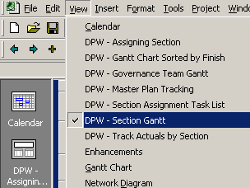
- The ‘Using Resource’ window will appear.
- A drop-down list contains the names of pre-determined resource groups. Click the down arrow and begin to type a section name. The section name will appear in the field.  - Click OK.  - To see all tasks, click Cancel, and all tasks for all resource groups will be shown. |  |  |  | 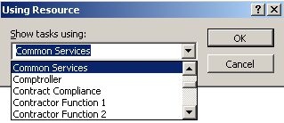
- The screen on the left shows the results of selecting Common Services and clicking OK.  The top of the window shows all the tasks assigned to the selected section. The bottom of the window shows a task form. |  | 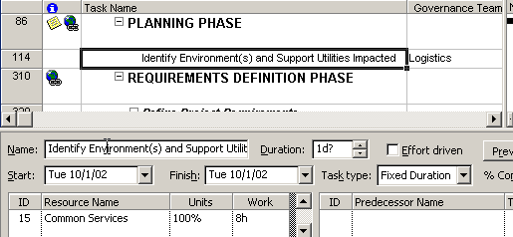

- Click on a task in the top window to see the task information reflected in the lower window.
- If required, change the resource assignment by clicking on the resource in the Resource Name field in the lower window and selecting another from the drop-down list.
- If a resource needs to be added, see steps below.
- Provide the duration for the task by entering a number in the Duration field.
Add a Resource Name
The work plan standard shows offices, bureaus, divisions, and sections within various DHS organizations. If you are setting up a plan that uses resources from offices, bureaus, divisions, or sections, not listed, you can add those resources to the plan.

- Open the resource sheet by selecting View→Resource Sheet from the menu. |  | 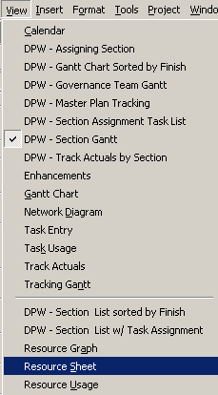
- The Resource Sheet for the work plan will appear. | 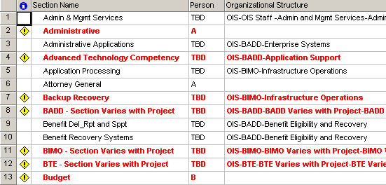
- Select Insert→New Resource from the menu or press the Insert key on the keyboard.  - A blank line will appear in the Resource Sheet. |  |  | 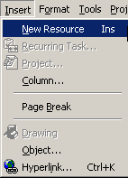
- Enter the Section name in the Section Name field.
- Tab to the Initials field. The value in this field will default from the entry in the Section name field, but you can change the value if you wish.
- Tab to the Organizational Structure field and enter the Program Office-Bureau-Division-Section to show the appropriate organizational structure.
- Save the plan without a baseline.
- Upon returning to the task list to enter another resource, the resource just created will appear on the drop-down list.
Activity 6: Create Dependencies among Tasks
In order for Microsoft Project to properly calculate project start and end dates, dependencies between tasks must be identified before completing this activity. The default dependency setting in Microsoft Project is finish-start, indicating that one task cannot be started until its predecessor is completed.

Action Steps:

- From the menu, select View→Task Entry |  |  | 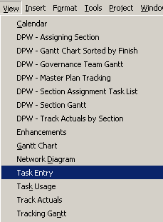
- The Task Entry view will appear showing all tasks in the top pane and specific task information in the bottom pane. | 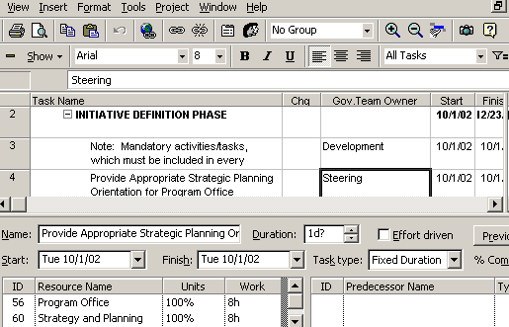
- To link tasks click on the tasks and click the link tasks icon.
- The tasks will be linked with a finish to start relationship.
Note: If a change is needed to the relationship, click on the task, go to the detailed task information in the lower pane and change the relationship by clicking on the drop-down arrow. |  | 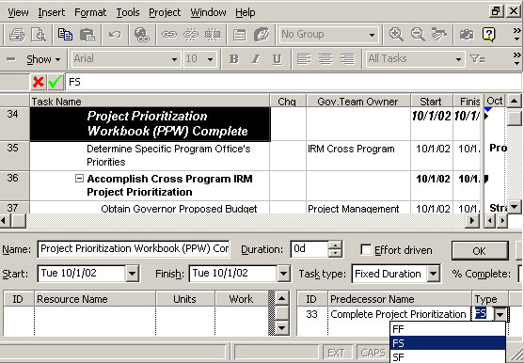

Activity 7: Baseline Your Work Plan and Save it in a Shared Directory
After completion of the plan, review and approval by project and steering teams, and after every update to the work plan, save a copy of the plan (with a baseline) in your own project folder. Email a copy of the plan to PW, DCSS-Process.
Deliverable
- A completed work plan with tasks, dependencies, milestones, checklists, and deliverables
Closeout Criteria
- The work plan has been created.
- The work plan contains tasks, durations, milestones and dependencies.
- A baselined copy of the Work Plan is saved in the Project Folder in FileNET.
Participants
- Primary participants using the Work Plan Standard include: PMO staff, project managers, and project sponsors.
Views for Managing Projects and Updating Tasks
Several custom views have been built into the Work Plan Standard. These views allow for the sorting of work plan details in various ways for managing and reporting. The detail below shows how to access each view and shows screen shots of the views.
Sort Gantt Chart by Finish Date

- From the menu select View→DHS - Gantt Chart Sorted by Finish. |  |  | 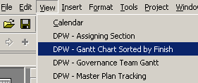
- A screen will appear showing all project tasks sorted by expected finish date within the main phase. The Governance team owner and the start date will also be displayed. |  | 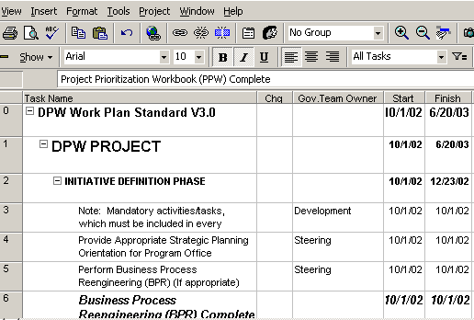
View Tasks Sorted by Governance Team
Each task in the Work Plan Standard is assigned to a governance team. Sorting by this option; shows which tasks have been assigned to which governance team.
- To view the tasks assigned to a specific governance team select View→DHS – Governance Team Gantt from the menu. |  |  |  |  |  | 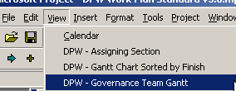
- The Governance Team window will appear asking to enter a governance team name. Type the governance team name. Options are: Steering, Project Management, Development, Testing, User Education, or Logistics. If Cancel is clicked without entering any data, the screen will return showing all tasks sorted by governance teams. |  |  |  |  | 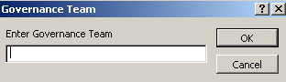
- The screen at the left shows all tasks sorted by governance team, with some of the team headings collapsed to show only the governance team name. To expand a section, click the . To collapse a section, click .  NOTE: “No Value” shows the tasks that have not been assigned to a governance structure team. |  |  | 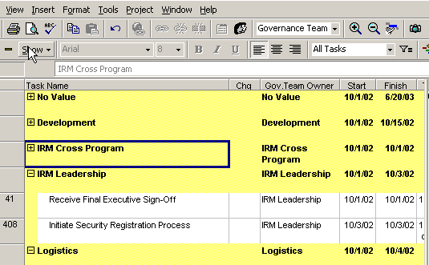
- If a specific governance team is selected, the resulting screen shows only those tasks assigned to the specific governance team. |  |  |  | 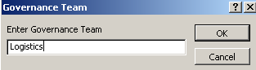
- The screen at the left displays the tasks assigned to the Logistics team. |  | 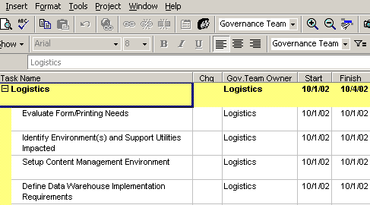
View Status of Project Phases and Key Project Milestones

- To view the status of high-level project phases select View→DHS - Master Plan Tracking. |  | 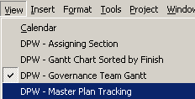
- The resulting view shows the status of the plan’s components at a high level. It also lists milestones under each phase.  Clicking will close the phase and result in a. Click the and the phase and all its tasks will be shown. | 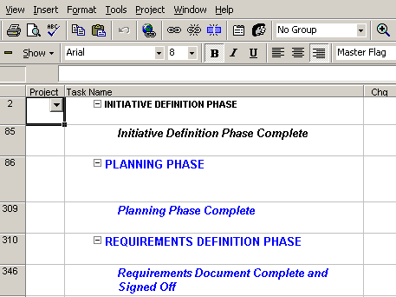
View All Tasks, Their Durations and Section Assignments

- To view all tasks and their durations and section assignments, select View→DHS – Section Assignment Task List |  | 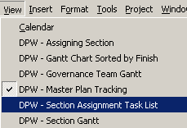
- A screen will appear showing all tasks, their durations and their section assignments. Scrolling to the right, the expected start and finish dates for each task will be shown. | 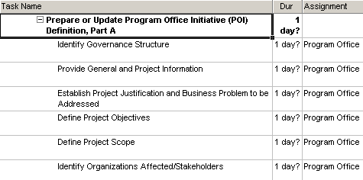

View Tasks by Section/Resource Group

- To view only the tasks assigned to a specific section, select View→DHS - Section Gantt. |  |  | 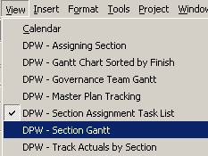
- The Using Resource window will appear to enter the resource for which you wish to see specific tasks.
- A drop-down list contains the names of all listed sections. Click the down arrow and begin to type a section name. The section name will appear in the field.  - Click OK. If you make no selection and click Cancel, you will see all tasks. |  | 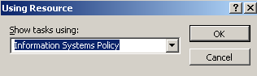
- The screen at the left shows the results of selecting Information Systems Policy and clicking OK.  The tasks that have been assigned to Information Systems Policy section are listed. | 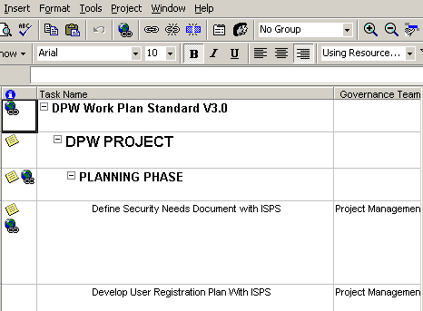
View Tasks Sorted by Section/Resource Group and by Expected Completion Date

- To see tasks sorted by section and by expected completion date, select View→DHS - Section List sorted by Finish. |  |  | 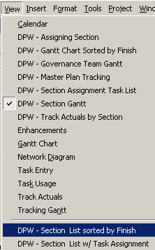
- The screen at left will appear.  - The top frame shows the tasks sorted by Section (in this case BIS Section) and then by expected finish date within that section.  - Clicking on a task in the top frame will reveal the task information in the bottom frame. This information can be updated by clicking on the field and either typing or making a selection from the drop-down list. |  | 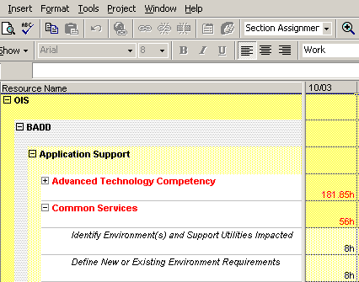
- Clicking on the Section level will reveal all tasks for that section along with their specific task information.
- If all detail in the top frame for a division is highlighted, the task information for all tasks assigned to that division will appear in the bottom frame.
- Scroll bars on the side allow you to scroll up and down to see all tasks.

View Resource Usage by Section

- To view the number of hours various resources within a section are assigned, select View→Resource Usage. |  | 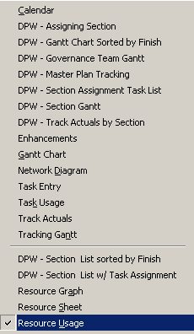
- The following screen will appear. The data is sorted by Program Office (in this case BIS), then by bureau and then by section. Within each section, tasks are listed along with the number of hours assigned to each task. | 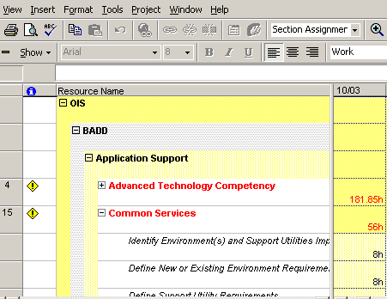
Report Progress and Track Actuals
The work plan should be revisited and progress reported on tasks regularly (weekly or biweekly). A view has been set up for reporting progress.

- From the menu, select View→DHS - Track Actuals by Section |  | 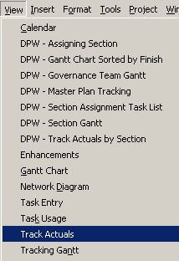
- A window will appear asking for the name of the Section to report.
- A drop-down list contains the names of all sections/resource groups entered on the Resource Sheet. Click the down arrow and begin to type a section name. The section name will appear in the field.
- A screen will appear showing tasks for the section selected, along with fields for entering resource actuals.  - Do not change the Planned Start and Planned Finish dates.  - Go to the Actual Start field and enter the date on which the task actually started. | 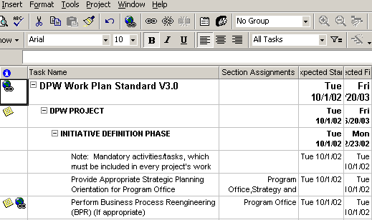
- If the task has been completed, go to the Actual Finish field and enter the date on which the task actually completed.
- If the task is complete or underway, go to the % Complete field and enter the % complete.
Rescheduling Work
After all tasks have been updated, reschedule the remaining work. This will bring the work plan up to date and see which tasks are ahead of schedule and which tasks are on or behind schedule.
Return to the DHS – Section Gantt view for all tasks.
- Verify that the current project date is accurate. Select Project→Project Information from the menu. |  |  | 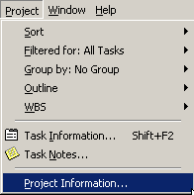
- The Project Information screen will appear.  - Check that the current date is today’s date. The drop-down arrow will access a calendar; change the date if needed. Click OK to close the Project Information window. |  |  | 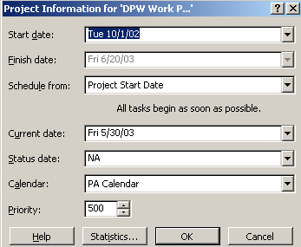
- Click the box in the top right corner to select all tasks before rescheduling the work plan tasks.  - To reschedule only some tasks, do not click this box. Go to each task that needs to be rescheduled and select it individually. Hold the Ctrl key down and click on tasks to select several. | 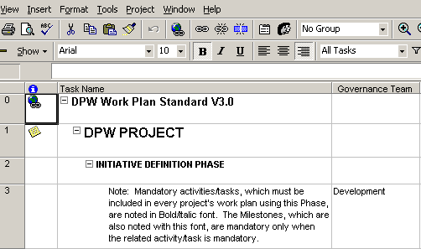
- From the menu bar select Tools→Tracking→Update Project. |  |  |  | 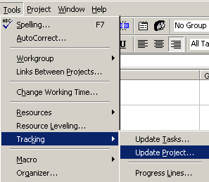
- The Update Project window will appear. |  | 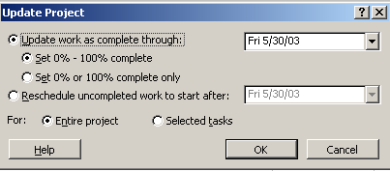
- Select the second option: “Reschedule uncompleted work to start after:” Fill in a date here or allow the system default of today’s date.
- The entire project is selected, so make sure that the radio button in front of Entire project is selected. If only selected tasks are to be updated, go back to the previous step, select only the tasks that are to be updated, and select the radio button in front of Selected tasks to update those tasks.
- Click OK.
- The work plan will update, and the Gantt chart will indicate where tasks have slipped.
- As an alternative to steps 5-10, you can click the Reschedule Work icon on the tool bar to reschedule the tasks. Dates will be automatically adjusted.
- The Tracking Gantt view (View→Tracking Gantt) will show tasks and the changes generated by rescheduling tasks.

Glossary
Acceptance and Installation Phase
A phase of the System Development Methodology (SDM) and Work Plan Standard (WPS) in which the new system is formally tested to determine whether it satisfies the predefined acceptance criteria; the system is installed, and the system owner formally accepts the system. Successful completion of the acceptance process results in formal transfer of the system support responsibilities from development to operational support personnel.
Activity
An activity is a major unit of work to be completed during a software development project. An activity incorporates a set of tasks to be completed, consumes resources, and results in work products. An activity may contain other activities in a hierarchical manner. All project activities should be described in the Project Plan.
Baseline
A Baseline is a set of control items (software components and documents) that has been formally reviewed and agreed upon, that serves as the basis for further development, and that can be changed only through formal project change procedures.
A Baseline is a document or a set of such documents formally designated and fixed at a specific time during the lifecycle of a configuration item.
A Baseline includes the original plan, (for a project, a work package, or an activity) plus or minus approved change requests. Usually used with a modifier (for example, cost baseline, schedule baseline, performance measurement baseline.) [Source: Project Management Institute Project Management Book of Knowledge]
Allocated Baseline
The Allocated Baseline is that point in a project when all of the resources required to develop and to install a system have been identified and obtained or allocated. This baseline is used on all future project activities in determining whether a proposed aspect of the system should be developed or installed. It is the baseline that allocates functional requirements to specified hardware and software items, too. The Work Plan Standard (WPS) stipulates that the Project Team create this baseline near the end of the Detailed System Design (DSD) by using the control items for the Functional Baseline and the documents completed and approved during the DSD. The DSD's documents include the following: the Signed Contract with the Vendor, the project's Physical Data Model, the project's Expanded Data Dictionary, the Proof of Concept, Test Plans, Conversion and Interface Plan, User Training Plan, the Outreach Plan, the project's Final Requirements Traceability Matrix, and the DSD Document.
Functional Baseline
The Functional Baseline is the point in a project when there is a clear definition of what the system to be developed should provide. This baseline will establish the measure that will be used in determining whether a proposed element is to be included in the new system. This baseline includes these descriptions: Project Summary, Project Objectives, Project Scope, Organizations Affected, Project Constraints, Project Assumptions, Project Risks and Mitigation Plans, Key Project Dates, High-Level Project Resource Plan, and Project Procurement Plan. At DHS, this baseline will be attained when these project materials are prepared and approved: Program Office Initiative (POI) Definition, Information Resource Management (IRM) Prioritization Workbook, IRM Strategic Plan, Program Revision Request (PRR) (including Concept Paper), Information Technology Resource Management (ITRM) Service Request, and the System Requirements Document. These documents are completed during the project's Initiative Definition, Planning, Requirements Definition, and General System Design (GSD) Phases. The Work Plan Standard (WPS) states that the Project Team establishes the Functional Baseline usually near the end of GSD.
Product Baseline
A product baseline is that point in a project when the entire system is developed. This baseline identifies the fact that the system is ready for the testing, implementation, and operations portions of a project. Subsequent to this point, an evaluation can be conducted to review the processes and tools that were used to develop the new system. These experiences can be captured, catalogued, and filed for use in future system development projects.
Close-out Phase
The Closeout Phase in the project lifecycle is the phase when a project is officially ended. It includes generating, gathering, and disseminating information environment. Pilots are used to formalize project completion. During this phase, the various resources used in developing the system are dispersed, and project records provide feedback to refine the final version of the product and are captured and filed for historic purposes. Numerous activities will be accomplished in this phase, such as holding review meetings to assess the project experience, identifying best practice items that can be filed for use in future projects, releasing the project members and reassigning them, and capturing and filing lessons learned.
In Project Closeout, the Project Management Team assesses the outcome of the project by soliciting and evaluating feedback from customers, Project Team members, consumers, and other stakeholders, and documenting best practices and lessons learned for use on future projects.
Detailed System Design (DSD) Phase
The DSD translates the functional design requirements specified in the General System Design (GSD) into a detailed set of system requirements. This includes detailed system flows, program specifications, and database specifications that are required to construct the application.
Development Phase
The Development phase is a phase of the work plan standard where system's components, such as software and facilities, are created using the design specifications created earlier. Testing is performed on the individual system elements, particularly the software units. Important plans such as a capacity plan, a transition to operations plan, and a detailed installation plan are developed.
Event
An event is a significant problem, occurrence, or happening.
General System Design (GSD) Phase
The GSD phase is a phase in the project lifecycle during which the designs for architecture, software components, interfaces, and data are created, documented, and verified to satisfy project requirements. The purpose of this phase is to determine 'how' the requirements will be satisfied by the new system. This design is typically more user-oriented. Security considerations, as well as the user training and installation strategies, are addressed in this phase.
Initiation Phase
The Project Initiation phase confirms the reasoning and logic for the Business Case used in Project Origination that lead to project prioritization, selection, and approval. A project's goals, objectives, and major milestones are defined here and some of the core processes, required to manage the overall project, are put in place during this phase.
Operational Support Phase
Operational Support is in fact not part of the project process. Operational Support represents the ongoing maintenance and support of the product of the project. However, the functionality necessary for operational support to be effective is established during the project.
Planning Phase
During this phase in the project development lifecycle, the project sponsor and users' needs and expectations are identified; the feasibility of the project is determined, and a detailed project plan is developed.
Project Phase
A Phase is a major period in the life of a project culminating in a major milestone. They are all phases within the System Development Methodology (SDM).
Project Plan
A document describing the technical and management approach to be followed for a project. The project plan typically describes the work to be done, the resources required, the methods to be used, the procedures to be followed, the schedules to be met, and the way the project will be organized. The plan includes a list of deliverables, milestones, actions required, and other key events needed to accomplish the project.
A project plan is a formal, approved document used to guide both project execution and project control. The primary uses of the project plan are to document planning assumptions and decisions, to facilitate communication among stakeholders, and to document approved scope, cost, and schedule baselines. A project plan may be summary or detailed.
Project Schedule
See ‘Work Planning and Scheduling’
Requirements Definition Phase
In this phase of the project lifecycle, the requirements for a system are defined and documented. The focus of this phase is identifying and documenting "what will the system do?" In addition, the initial testing strategy is defined, and an acceptance test plan is created.
Schedule
See ‘Work Planning and Scheduling’
Software Integration and Testing Phase
This phase in the project lifecycle involves the integration and testing of the components of the system to determine whether the system meets predetermined functionality, performance, quality, interface, and security requirements. Types of tests could include integration, system, web accessibility, and performance. At the conclusion of this testing, a go/no-go decision is made concerning whether the system should be implemented.
Stakeholder
A stakeholder is an individual or group with an interest in the outcome of a project, either as a result of being affected by it positively or negatively, or by being able to influence the project in a positive or negative manner.
Task
A Task is the smallest unit of work subject to management accountability. A task is a well-defined work assignment for one or more project team members. Related tasks are usually grouped to form activities. A task is the lowest level of work division typically included in the Project Plan and the Work Plan Standard (WPS).
Work Planning and Scheduling
Work Planning and Scheduling creates a project schedule based upon a set of tasks and due dates, and then monitors these tasks through project completion. Creating an accurate project schedule involves breaking the major activities down into the associated sub-tasks and estimating the resources and schedule required to complete these tasks. These are reviewed for dependencies and relationships between the tasks.
Appendix 1 – Phase Definitions
The following definitions describe what kinds of work should be performed during each phase of a project.
These definitions can help Project Managers determine which phases should be inserted into a new work plan for projects already underway.
Initiation
- Define Governance Structure
- Conduct Resource Assessment
- Develop Procurement Strategy
- Business Process Re-engineering (BPR), if needed
- Program Revision Request (PRR), Advance Planning Document (APD), as needed
- Funding and Approval Received
- Develop Document Management Plan
Planning
- Project Plan (Revised in each subsequent phase)
- Develop Work Plan and Schedule
- Develop Risk Management Plan
- Develop Communications Management Plan
- Develop Change Control Management Plan
- Develop Quality Management Plan
- Develop Resource Management Plan
- Define Performance Management Success Criteria
- Contract Signed-Off/Start Work, if necessary
Requirements Definition
- Requirements Traceability Matrix
- Requirements Definition Document
- Disaster Recovery Plan
- Project Test Plan
- Change Request Form
- Change Control Log
- Description of Analysis Technique
General System Design (GSD)
- Description of Design Technique
- General System Design Document
- Data Dictionary Revised
- Logical Data Model
- Requirements Traceability Matrix Expanded
- System Architecture Document
- Capacity Plan
- Acquisition and Installation Plan
- Training Plan
- Conversion Plan
- Architecture Review Board Document
- Test Plan (revised)
Detailed System Design (DSD)
- Proof of Concept, if needed
- Detailed System Design Document
- Data Dictionary Expanded
- Physical Data Model
- Requirements Traceability Expanded
- System Architecture Document (revised)
- Conversion Plan (revised)
- Electronic Commerce Security Assessment (ECSA) Document
- Test Plans (revised)
Development
- Application Code
- Unit Test Scenarios Checklist
- Requirements Traceability Matrix Expanded
- Test Scenarios
- Operating Documentation
- Transition Plan
- Training Plan
- Final Capacity Plan
- Batch Operations Manual (BOM)
- Batch Operations Services Request
- Test Plan (final)
- Detailed Implementation Plan
- Site Preparation
- Infrastructure Preparation
- Service Level Agreement
- Outreach Materials
- Policy, Procedures, and Job Responsibility Change Materials
- Users Manual
System Integration and Testing
- Test Report
- Requirements Traceability Matrix (final)
- Operating Documentation (revised)
- Performance/Stress/Volume – Standalone & Enterprise
- Training Plan (final)
- Go/No Go (Stakeholder signoff)
Acceptance and Installation
- Pilot
- Deployment Playbook
- Installation Test Materials
- Operating Documentation (final)
- Outreach
- Operations Training
- User Training
- Implementation or Rollout
- Performance/Stress/Volume Testing - Standalone & Enterprise
- Test for Production (TFP)
- Security Testing
- Warranty Support
Close-Out
- Compile Results
- Release Facilities & Equipment
- Handle personnel closures
- Capture History
- Update Lessons Learned/Best Practices
Operational Support
- Support Daily Operation
- Help Desk Fully Operational
Appendix 2 – Key Milestones
Key Milestones
Key milestones are typical achievements during the development life cycle of a project (i.e. Testing Scenarios Complete) that must be reached in order to successfully complete each project phase. A project manager needs to be aware that senior management may be using these milestones to monitor project progress and manage cross-project dependencies. Senior Management may require explanations for why milestones were omitted or added. The following is a list of all Key Milestones applicable to DHS IT projects.
Initiation
- Business Process Reengineering (BPR) Complete (if needed)
- Advance Planning Document (APD) Complete
- Work Plan for Future Phases Prepared and Signed-Off
- Funding Sign-Off Received
- Initiative Definition Complete
Planning
- Project Feasibility Report Complete and Signed-Off
- Initial Capacity Plan Complete and Signed-Off
- Contract Signed/Start Work (if appropriate)
- Project Plan Complete and Signed-Off
- Communication Strategy Complete and Signed-Off
- Planning Phase Complete
Requirements Definition
- Requirements Document Complete and Signed-Off
- Security Requirements Documented and Signed-Off
- Initial Requirements Traceability Matrix Prepared and Signed-Off
- Service Level Agreement Complete and Signed
- Project Test and Acceptance Test Strategies Defined and Signed-Off
- Requirements Definition Phase Complete
General System Design (GSD) Phase
- Security Architecture Design Documented and Signed-Off
- Logical Data Model Built and Signed-Off
- Revised Data Dictionary Complete and Signed-Off
- System Architecture Design Complete and Signed-Off
- Testing and Installation Strategies Complete and Signed-Off
- Software Configuration Management Plan Complete and Signed-Off
- User Training Strategy Complete and Signed-Off
- Outreach Strategy Complete and Signed-Off
- Policy, Procedures, and Job Responsibility Changes Identified
- General System Design Document Complete and Signed-Off
- General System Design Phase Complete
Detailed System Design (DSD) Phase
- Contract Signed/Start Work
- Physical Data Model Designed and Signed-Off
- Expanded Data Dictionary Complete and Signed-Off
- Proof of Concept (If Needed) Complete and Signed-Off
- Test Plans Complete and Signed-Off
- Conversion and Interface Plan Complete and Signed-Off
- User Training Plan Complete and Signed-Off
- Outreach Plan Complete and Signed-Off
- Expanded Requirements Traceability Matrix Complete and Signed-Off
- Detailed System Design Document Complete and Signed-Off
- Detailed System Design Phase Complete
Development Phase
- 100% of Components Unit Tested
- Integration, System and Acceptance Testing Scenarios Complete and Signed-Off
- Final Requirements Traceability Matrix Complete and Signed-Off
- Final Capacity Plan Complete and Signed-Off
- User Manual Complete and Signed-Off
- User Training Program Complete and Signed-Off
- Outreach, Policy, Procedures, and Job Responsibility Change Materials Complete and Signed-Off
- Development Phase Complete
Software Integration and Testing Phase
- Application System Integration and Testing Results Compiled and Signed-Off
- Acceptance Test Team Training Complete
- Installation Go/No Go Sign-off Received
- System Integration and Testing Phase Complete
Acceptance and Installation Phase
- Installation in Test for Production (TFP) Environment Complete
- Performance/Stress/Volume Testing – Standalone & Enterprise Complete
- Test For Production (TFP) Complete
- User Training Started
- Operations Training Complete
- Implementation Go/No Go Signoff Received
- Pilot Complete
- Operations Accepted System
- Implementation (Rollout) Complete
- User Training Complete
- Warranty Support Complete
- Stakeholders Signed-Off on Installed System
- Acceptance and Installation Phase Complete
Close-out Phase
- Project Records Filed
- Project Complete
Operational Support
- Operational Support Areas Assume Responsibility for System
- Maintenance Activity Report Submitted
Appendix 3 – Delegating Use of the Standard
The following instructions inform project managers and their delegates how to use the Standard to cooperatively build a project plan.
These instructions assume project managers and their delegates have a working knowledge of Microsoft Project 2000.Legend: ‘PM’ – Project Manager
‘Delegate’ – Project Manager’s Delegate for Work Planning
- PM - Send a copy of the DHS Standard Work Plan to each delegate. Establish a shared folder for the delegates’ finished documentation.
- PM - Notify delegates of the phase(s) they must build, including all relevant dates/deadlines.
- Delegate - Use the Work Plan Milestones Checklist to identify deliverables and milestones the project must complete during the project phase being planned.
- Delegate - Review completed copy of the Work Plan Milestones Checklist. Based on that checklist, modify the detail in the phase(s) required to build. Modify the detail such that, only the milestones, deliverables, activities, and tasks related to the choices in the Work Plan Milestones Checklist are left in the phase.
- Delegate - Add new milestones, deliverables, activities, and tasks, or to the assigned phase(s) as necessary, according to the specific needs of the project.
- Delegate - Suggest durations and resources to the activities/tasks according to the specific needs of the project.
- Delegate - Save the modified plan to the Project Manager’s shared folder (see task 1).
- Review Delegate submittals, request modifications as necessary. When complete, copy the modified information from the Delegate’s plan, into the official work plan.
- Estimate the Level of Effort to accomplish each activity and task.
- Assign resources by Governance Team, as well as relevant Section, to each activity and task.
- Save the completed work plan with a baseline, in a shared folder.
Refresh Schedule
All guidelines and referenced documentation identified in this standard will be subject to review and possible revision annually or upon request by the DHS Information Technology Standards Team.
Guideline Revision Log

Change Date | Version | Change Description | Author and Organization
04/25/2003 | 3.0 | Initial Creation. | DCSS – Process Section
05/17/2004 | 3.1 | Reviewed and Format Changes | DCSS – Process Section
06/17/2005 | 3.1 | Reviewed content – No change necessary | DCSS – Process Section
11/01/2005 | 3.2 | Reviewed content – minor editing changes | DCSS – Process Section
01/08/2007 | 3.2 | Reviewed content – No change necessary | PMO-DCSS
06/15/2007 | 3.3 | Format Change | PMO-DCSS
05/04/2015 | 3.4 | Changed DPW to DHS | PMO-DEPPM

