COMMONWEALTH OF PENNSYLVANIA
DEPARTMENT’S OF HUMAN SERVICES, INSURANCE, AND AGING

INFORMATION TECHNOLOGY PROCEDURE

Name Of Procedure: | Number:
Architecture Review Board (ARB)
Domain: | Category:
Business
Date Issued: | Issued By:
4-8-2009 | DHS Bureau of Information Systems
Date Revised:
5-14-2015

General: This Procedure describes the details explaining why, when and how to conduct Architecture Review Board (ARB) meetings.
TABLE OF CONTENTS
Background 3
ARB Process Overview 4
ARB 1 4
ARB 2 5
ARB 3 6
ARB 4 6
ARB Process Guidance 7
Calendar and Scheduling 8
Scheduling the ARB Meeting (> 3 Weeks Prior to ARB) 9
ARB Meeting Rehearsals (1 Week Prior to ARB) 9
Final ARB Document Submission (Monday on week of ARB) 9
ARB Meeting Activities 10
Post-ARB Activities 10
Templates and Example Materials 10
Frequently Asked Questions 10

Background

The DHS Architecture Review Board (ARB) process was created to provide a series of overviews that allow BIS domain leads to become familiar with the architectural and technical implications of upcoming application releases. The goal is to help ensure that BIS domain leads are adequately informed and have time to plan for changes and additions needed in their technical area. ARB reviews focus on all architectural components of an application with a business-centric view.

Mission Statement
The mission of the Architecture Review Board is to review the architectural direction proposed for applications to verify that the DHS strategic technical vision is maintained, existing solutions are leveraged, lessons learned are communicated and the proposed technical solution is supported and understood by all stakeholders.
Goals
- Ensure that the project’s overall technical direction is in alignment with DHS’s architectural direction
- Decrease design time by using pre-existing enterprise services or business processes that have been previously approved and designed
- Decrease support costs by using the same solution across multiple projects
- Decrease machine resource consumption by leveraging economies of scale
- Increase Return on Investment
ARB Outcomes
- Action items will be assigned to project/technical staff.

- Logistical and design assistance will be provided by board members.

- All presentation materials and notes will be posted to DocuShare for future reference.

ARB Process Overview

The current ARB process has 4 distinct review steps. All are mandatory unless authorization is received from the CTO to skip or combine meetings. Figure 1 visually represents the current standard ARB process. A set of detailed narratives for each of the review steps follows the illustration.
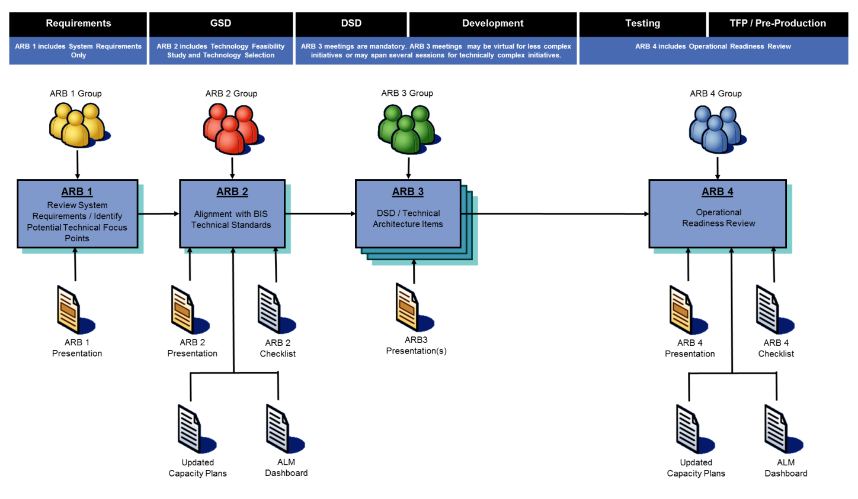
Figure 1 – ARB Process Visual Overview

Figure 1 illustrates where the ARB meetings fall with respect to the phases of the system development lifecycle (SDLC) which are indicated along the top of the figure. The different colored ARB review groups represent that the ARB review teams for each of these meetings may be different due to the nature of the initiative, although there are regular BIS staff who participate in all ARB meetings throughout the SDLC. It can be derived from the diagram that the ARB 2 and ARB 4 meetings are the most preparation intensive. Also note that the materials for the ARB 4 meetings are the same as ARB 2 meetings providing the opportunity to reuse the same materials.

ARB 1
The ARB 1 meeting represents the first opportunity to present the system requirements to a wide BIS audience. BIS can then validate that system requirements align with the stated business imperatives driving the initiative and make early assessments of technical impacts that might stem from the initiative.

An ARB 1 meeting is usually 1 hour in length and the only required input material for this meeting is an ARB 1 presentation. The main elements of an ARB 1 presentation are:

- Background
- Scope and Initiative Overview
- System Requirements
- Architecturally Significant Use Cases
- Known Reporting, Batch, or Security Implications
- Other Important Non-Functional Requirements
- Timeline

More than any other ARB meeting, attendance of line-of-business leadership and BIS project and portfolio managers is critical to a successful ARB 1 meeting. Every effort should be made to ensure that business and BIS project and portfolio managers are in attendance at ARB 1 meetings to validate that the system requirements are in alignment with the initiative goals.

ARB 2
The ARB 2 meeting could be considered the most important of the ARB meetings. The fact that it occurs during the GSD phase means that it’s still early enough to impact the final design. During the GSD phase, business and system requirements have been collected, allowing for a much more in-depth conversation to occur than during the ARB 1 meeting.

The ARB 2 meeting is usually 1 hour in length. The input materials for the meeting are the ARB powerpoint presentation, the ARB checklist with the ARB 2 column filled in, an up-to-date ALM dashboard that reflects any changes by virtue of the release in question (if no changes, this is optional), and production and non-production capacity plans. These documents have standard templates that need to be filled in and submitted prior to the ARB meeting (link found later in this document). The following elements are standard across most ARB 2 presentations:

- Background
- Initiative Overview
- Architecturally Significant Use Cases
- Services
- Interfaces
- Conversion
- Batch
- Archive / Purge
- Disaster Recovery
- Security
- Testing and Validation
- Capacity Highlights
- Next Steps
- Implementation Timelines

It should be noted that not all of these elements are required for an ARB 2 meeting. More or less detail may be required based upon the scope of the initiative and how its architecture aligns with the elements being highlighted in the presentation.

In addition, the ARB 2 meeting is the point at which initial feasibility study results are presented should new technologies be needed for the initiative in question. The feasibility study introduces software that is new to one of BIS’s domains or expounds upon how existing software will be used in new ways. The feasibility study is not a required ARB 2 element and is only present when significant new technologies are being introduced and the DHS technology evaluation process needs to be invoked.

ARB 3
ARB 3 meetings serve as technical checkpoints prior to initiating development. ARB 3 meetings may sometimes be virtual, with documents being submitted and reviewed by the team without a formal meeting for initiatives that are less technically complex. The BIS CTO (Chief Technology Officer) makes the decision whether a virtual meeting is permitted based upon the complexity of the work order(s) and technologies involved. Larger initiatives, especially those introducing new and complex technologies, sometimes require more than one physical ARB 3 meeting.

The ARB 3 powerpoint presentation is the only required element of the ARB 3. The following elements are standard across most ARB 3 presentations:

- Initiative Overview
- Architecture Details
- Results of any POCs conducted
- Key DSD Considerations (Domain-Based DSD Highlights)
- Next Steps

ARB 4
ARB 4 meetings most closely resemble ARB 2 meetings in their content and form. Due to the timing of the ARB 4 meetings, they are focused on pre-operational readiness preparations; whereas ARB 2 meetings are focused on discussing and reviewing design considerations. ARB 4 meetings have the same material inputs as ARB 2 meetings and are expected to have been updated to reflect changes or updates that occurred between the ARB 2 and ARB 4 meetings. Items such as testing, validation, capacity, and implementation timelines are the main focus for this meeting.

One specific ARB 4 element is an operational readiness review which includes a system checklist and a business checklist. These checklists are included in the ARB 4 deck for BIS and program office participants’ endorsement. The checklist includes the following elements:

- Performance Testing
- Vulnerability Testing
- UAT Testing
- Outstanding TFS Defects From Testing
- Batch Schedule and Manual Updated
- Playbook / Deployment Instructions
- Final User Roles / Account Sign-Offs
- Health Checks and Business Metrics
- Operational Preparations and Field Support

TRT (Technical Review Team)

The purpose of a TRT meeting is for the Domain Leads and Subject Matter Experts (SMEs) to review a potential new product that is either needed or being proposed that will have an impact across the technical domains. During a TRT meeting, the presenter should explain what the need is as well as possible solutions. The results of the TRT meeting will be a decision as to whether to proceed or not with investigating or procuring the new product.

ARB Process Guidance
This section provides more detailed guidance around the ARB process, including how to schedule ARB meetings and references to templates and other materials you will need for preparation of an ARB meeting. In general, the Project team is responsible for providing the documents and presenting the meeting. BIS domain leads are expected to attend all of the scheduled ARB meetings unless there is a simultaneously occurring emergency. Project leads, developer leads, and program office staff also attend.

The BIS Domains represent the following areas of BIS:

Security: Unified security for applications, Enterprise-wide Security Policies
Network: Data and voice. Public access and business partner access
Knowledge Management: Enterprise Content Management, GIS, Business Intelligence
Platform: Hardware / Software
Integration and Middleware: Common integration architecture, Interface protocols
Data: Metadata, Data Dictionary, Data Definitions
Operations and Support: Capacity Planning, Recovery Planning, Service Levels
Application: Reusable applications/business processes, Browser integration

ARB Roles / Responsibilities
- Project Team
  - Initiate ARB review by contacting ARB coordinator (through the BIS CTO office)
  - Present summary information of business process change
  - Identify architectural impacts and present proposed solution
  - Work with the ARB team to finalize technical architecture
  - Communicate jointly defined solution to the project team
  - Verify jointly defined solution is implemented throughout development
  - The project manager and program office sponsor must sign-off on the operational readiness from the business perspective before implementation
- ARB team
  - Attend weekly meetings
  - Provide subject matter expertise / experience
  - Communicate presentation information to peers within BIS
  - Work with presenting team to determine / validate architectural direction
  - Support presenting team efforts once development commences
  - BIS must sign-off on the system readiness from the technical perspective before implementation

Calendar and Scheduling
BIS leadership has reserved 3 ½ hours per week on Wednesday and Thursday for ARB meetings. This includes ARB types 1, 2, 3, 4 as well as the TRT (Technical Review Team) group. The reserved meeting slots fall on the following times each week, unless holidays or other events preclude holding the ARB meeting for a particular week. Most meetings are 1 hour in length although complex discussions may need more time. It is also possible to schedule a 30 minute ARB meeting for those projects that do not need much feedback or discussion.

- Wednesday, 10:30 – 12:00 (Any mix of 30 minute meetings to 1.5 hour meetings)
- Thursday, 10:00 – 12:00 (Usually two 1 hour meetings)

Figure 2 provides a high level overview of the ARB preparation activities from an application team vantage point. The remainder of this section breaks down the timeline further; explaining ARB activities and post-ARB activities and detailing what is involved in each step of the process.
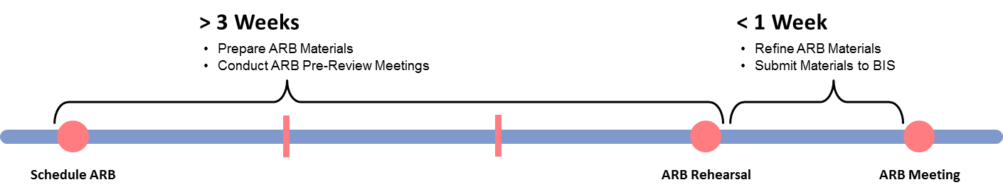
Figure 2 – ARB Preparation Timeline

Scheduling the ARB Meeting (> 3 Weeks Prior to ARB Meeting)
Scheduling an ARB meeting is the first step in the lifecycle of an ARB event. This step should occur 3 weeks or more prior to the date of the anticipated ARB meeting to allow adequate time for preparation. In the case of an expedited initiative, an ARB meeting can be scheduled the day before the meeting date if the calendar is open and the team and materials are ready. There are several key activities that occur during this step. These activities are enumerated and described below:

- Find an open calendar slot – The ARB calendar is available on the CWOPA network and is accessible to all DHS CWOPA users. The calendar can be reached at the following URL: http://docushare.dpw.lcl/docushare/dsweb/View/Collection-25647
- Teams looking to schedule an ARB meeting should check the calendar and note a primary and alternate ARB meeting date / time. Submit the date/time requested along with the ARB meeting number, and the name of the Initiative or Work Order to the ARB Coordinator (currently lbaer@pa.gov or bawadlinge@pa.gov ).

Final ARB Document Submission
Final ARB document submission needs to occur no later than 1 day before the ARB meeting. The materials submitted by the application team are uploaded by BIS into DocuShare. The location of the documents is at the same calendar link above and is organized by Date: Year, Month, Day.

ARB Meeting Activities
During the ARB meeting, materials will be projected onto a screen. Under most circumstances there is no need to bring hand-out materials. The room where the ARB meetings are held (Currently Room 31 in the Willow Oak Building in the DGS Annex Complex Harrisburg) is equipped to support special projections or demonstrations from laptops or other mobile devices if necessary. This is helpful when presenting live demonstrations of products or interfaces. BIS takes notes at the ARB meeting. Time permitting, the notes and action items are recapped at the end of the meeting. In all cases, these notes are made available electronically on DocuShare after the meeting in the same location as the ARB presentation materials. It is up to the participants to follow up on the items captured in the notes that fall under their responsibility.

Post-ARB Activities
Post-ARB activities include following up on the action items, questions and concerns in the meeting minutes. The application teams must be sure all are addressed before the next ARB meeting occurs.

Templates and Example Materials
Templates and example materials for the ARB process including the ARB Presentation Template (powerpoint), the ARB Compliance Checklist and the template for the production and non-production Quarterly Capacity Plans can be found on the BIS ARB site at: http://mydhs/oa/bis/busandtechstandards/arb/index.htm.

Frequently Asked Questions
The final section of this document presents a series of frequently asked questions (FAQ) and provides answers and guidance to address and assist with understanding the ARB process.

Question: Has DHS published any formal guidance and standards on the ARB process?
Answer: DHS’s formal documentation of the ARB process can be found on the BIS webpage at http://mydhs/oa/bis/busandtechstandards/arb/index.htm This webpage has been referenced throughout this document.

Question: Who attends the ARB meetings?
Answer: Attendance at ARB meetings varies by initiative and ARB type, and roles and responsibilities of ARB attendees. Typically attendees will be:
- Architecture Review Board Chair (CTO)
- Architecture Review Board Team Members (Domain Leads – BIS) as well as domain SMEs
- Application / Project Managers
- Program Office Sponsor
The CTO and their direct staff make a concerted effort to attend each of these meetings unless there are other circumstances that prohibit this. The application teams should make sure their application manager, application architect and track/initiative lead are present at all ARB meetings. In addition, the application teams should help ensure the presence of program office sponsors and subject matter experts.

Question: Can ARB 1 and ARB 2 meetings be combined into a single ARB 1 & 2 meeting?
Answer: There are some work orders that are of a completely technical nature and have few or no business impacts where combined ARB 1 and ARB 2 meetings will be considered. However, this must be approved by the BIS CTO before they are submitted for scheduling.

Question: Is there any possibility of doing multiple ARB meetings of a single type – e.g. 2 ARB 1 meetings?
Answer: ARB 3 meetings can occur more than one time for a single initiative, especially for more technically complex initiatives. ARB 1, 2, and 4 meetings very rarely have more than one occurrence for a single work order.

Question: Are conference calls permissible for ARB meetings?
Answer: In general, BIS advises against conference call participation for key meeting participants. Information from informal communication and side conversations is lost by not being present in the room at the time of the ARB meeting. However, BIS recognizes that it may be difficult for those who have to travel to the building and will allow conference call participation in those circumstances. The conference call must be configured by the project team, not the ARB Coordinator, since the project team will be familiar with who needs to receive the conference call invitation.
Change Log

Change # | Changed By | Changed On | Description
1 | Thomas Beck | April 8, 2009 | Document Creation
2 | Thomas Beck | May 10, 2012 | Revision to Align with Contract 16-09  1) focus on system requirements as part of the ARB 1 review with business requirements being handled with the lot 1 – 5 vendors outside of the ARB structure; (2) shift in ARB 4 coverage to include pre-production validations and operational readiness activities; and (3) removal of the TRT section of this document; yielding to DHS standard STD-EASS006 COTS, Transfer Technologies and Emerging Technology Evaluation & Selection.
3 | Lisa Baer | May 18, 2015 | Updated changes to the ARB process, corrected URL links and Agency name. Additional information added for clarity. Various grammar mistakes corrected.

