Pennsylvania
Department of Human Services, Insurance & Aging
Bureau of Information Systems

.NET Deployment Process
For Test Environments

Version 2.1

September 30, 2015

Table of Contents

Introduction 3
Purpose 3
Build process checklist 4
Deployment 4
Document Change Log 6

.NET Deployment Process
Introduction
With the advent of .NET development within the Department of Human Services (DHS), standards and guidelines must be maintained. The deployment process for an application written in .NET is one of these areas.
Purpose
The purpose of this document is to provide a short build process checklist and deployment strategy for .NET applications
Build process checklist
Ensure that a proper and complete build is available for deployment
- Ensure that the Solution build specifies ‘Release’ mode.
- Ensure that the build is current: Execute Rebuild on the VS.NET Solution.
- Ensure that the project uses project references rather than external references. This will ensure uniform dependency of internal references and also ensures your references are found when deployed to your environment specific Web Servers.
- Ensure that the assembly information for each project is set to control the versioning per project requirements
Deployment
With ASP.NET applications, the File System Publish method provides the easiest distribution mechanisms. The option to delete all existing files before publishing or simply replacing matching files is available. Because .NET is self-describing and requires no registry entries, the application simply can be copied to an appropriate directory. The application can then be run from that directory.
Metadata and Self-Describing Components
http://msdn.microsoft.com/en-us/library/xcd8txaw.aspx
How to Publish Web Application Projects
http://msdn.microsoft.com/en-us/library/aa983453(v=vs.90).aspx
Quick Reference:
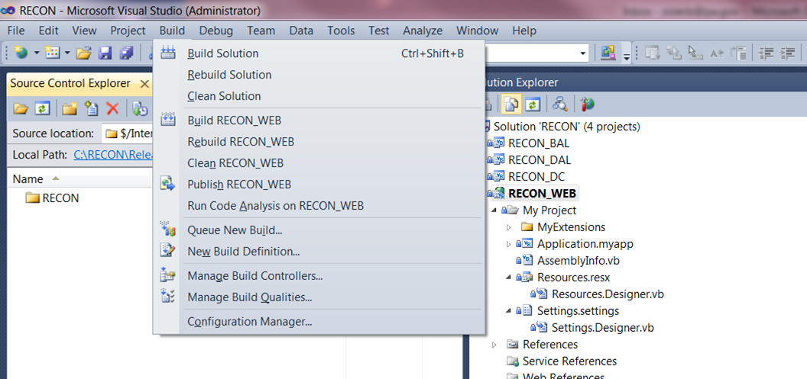
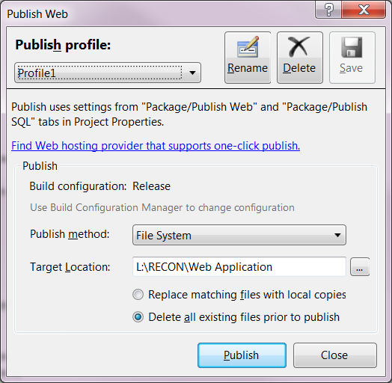

Document Change Log

Change Date | Version | CR # | Change Description | Author and Organization
10/14/03 | 1.0 |  | Initial creation. | Deloitte Consulting
11/05/03 | 1.1 |  | Updated and finalized for submission | Deloitte Consulting
06/21/04 | 1.1 |  | Content Review – No change necessary | Carla Solomon
10/11/13 | 2.0 |  | Deployment to Test Servers. Deployment to Production servers requires a build and the services of the Web Publishing group | Steve Isleib
09/30/15 | 2.1 |  | Name change from DPW to DHS | Virjean Dauksha

