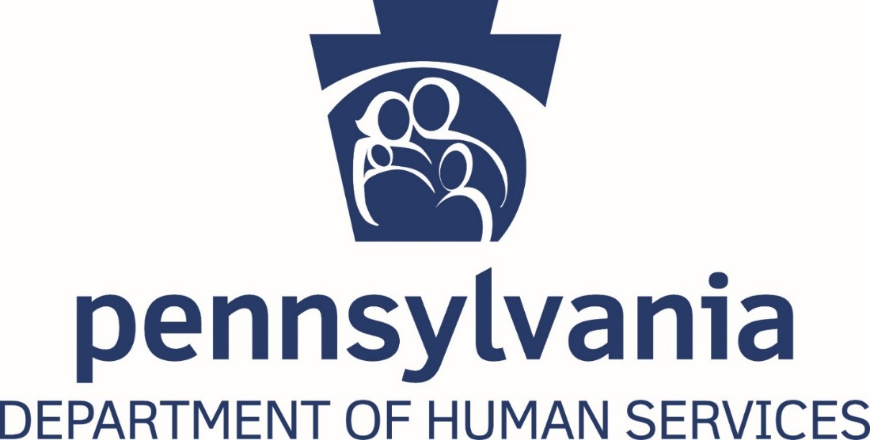

Report of Tips of Suspected and Confirmed Provider Fraud Received by the Medical Assistance Fraud Hotline

Act 132 of 2014

2018-19 Fiscal Year

Background

The Department of Human Services’ (DHS) Bureau of Program Integrity (BPI) is committed to identifying and eliminating fraud, waste, and abuse within the Medical Assistance program. As part of that commitment, BPI operates a toll-free DHS Fraud Hotline at 1-844-DHS-TIPS (1-844-347-8477). The hotline is used to report cases of suspected Medical Assistance provider fraud to BPI for additional follow up.
BPI also receives tips relating to suspected provider fraud via an online reporting system that can be found at:
http://www.dhs.pa.gov/learnaboutdhs/fraudandabuse/maprovidercompliancehotlineresponseform/index.htm, through the U.S. Mail and via fax.

Tips may include information on a provider that is potentially billing fraudulently or billing for services they did not perform. BPI staff carefully review each tip that is received.
When a tip discloses information relating to criminal activity, BPI will send the information to the Office of the Attorney General’s Medicaid Fraud Control Unit or to the appropriate law enforcement agency.

When a tip relating to a recipient that may be committing suspected welfare fraud is received, BPI will send the information to the Office of the Inspector General (OIG) for additional investigation. The OIG’s toll-free Welfare Fraud Tip Line is 1-800-932-0582.

Reporting Requirements

Act 132 of 2014 amended Act 132 of June 13, 1967 (P.L. 31, No. 21) to require DHS to establish a fraud tip line that would allow members of the public to report suspected fraud related to the provision or receipt of public assistance benefits. Section 1418(b) requires DHS to publish an annual report related to its fraud prevention activities. The report must contain the following information:

- The number of complaints received through:
  - The toll-free DHS Fraud Tip Line telephone number
  - Regular mail
  - The internet
- The number of investigations conducted by DHS and OIG as a result of such complaints.
- The number of criminal prosecutions and civil actions resulting from such investigations.
- The estimated total cost avoided and funds reclaimed by DHS as a result of such complaints.

Data

During fiscal year 2018-2019, BPI’s DHS Fraud Hotline received 124 calls reporting suspected provider fraud. BPI determined that 53 of those calls warranted additional investigation. Additionally, BPI received 1,164 other referrals via the website and U.S. Mail, which resulted in 89 Investigations.

DHS reclaimed approximately $1,350,065.00 dollars from providers as a result of tips received through the hotline, mail and website.

For information regarding DHS’ referrals to OIG, as well as their investigations, civil actions, and recoveries, please refer to OIG’s annual report.

