Appendix: Metric Graphs

- Assessment of need and qualification for SUD services
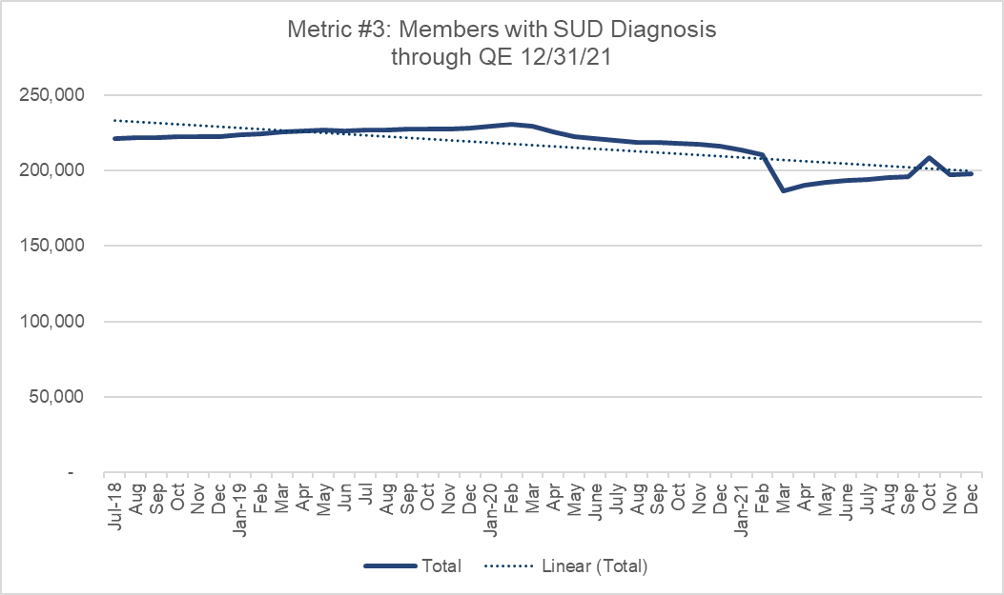
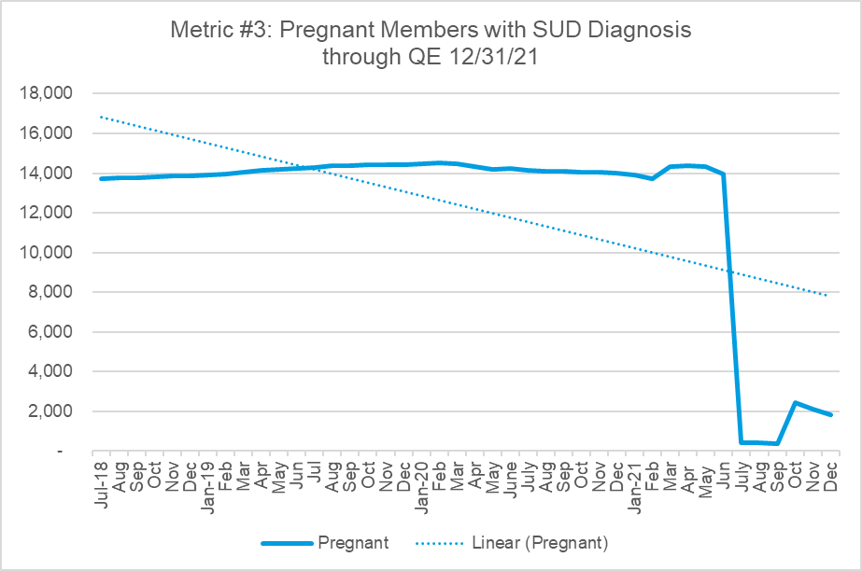

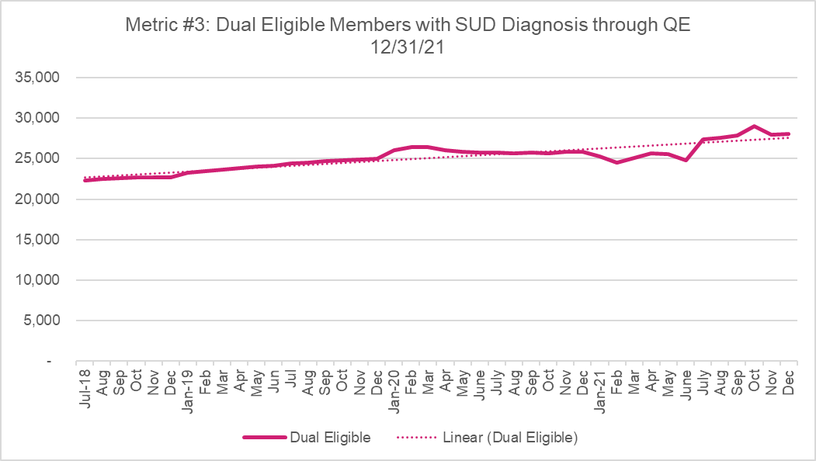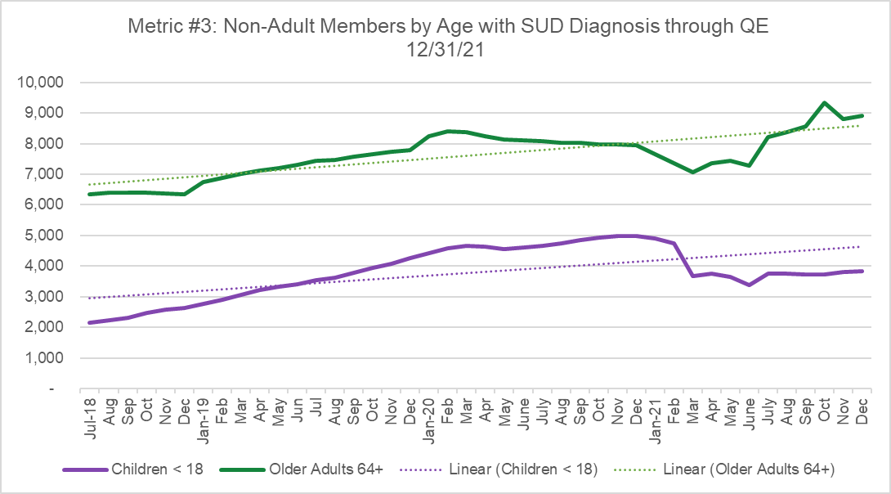

- Access to Critical Levels of Care for OUD and other SUDs (Milestone 1)
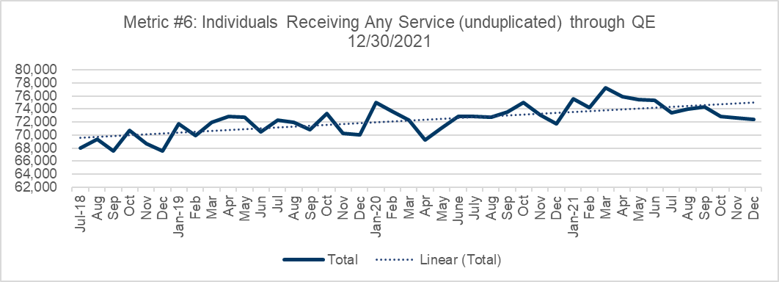
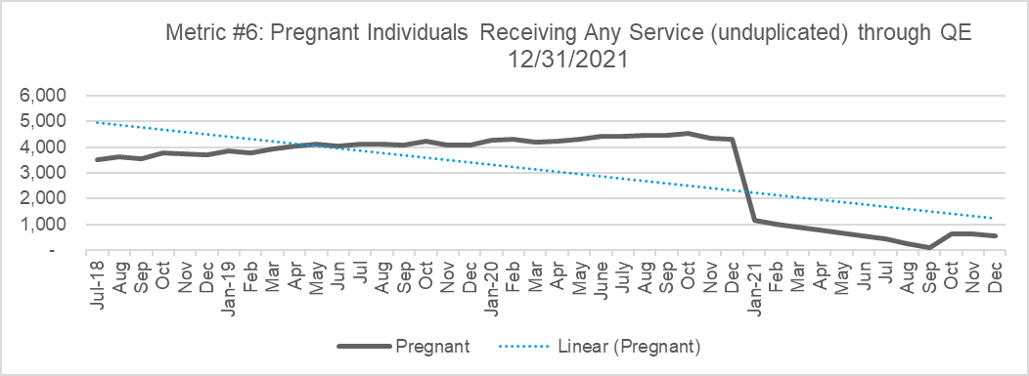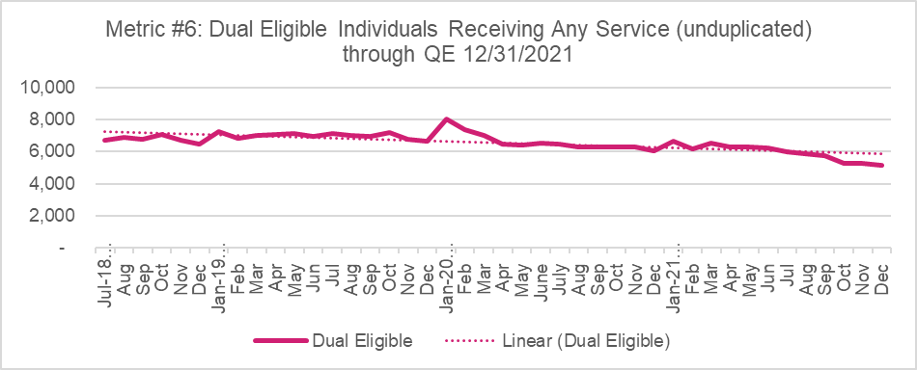
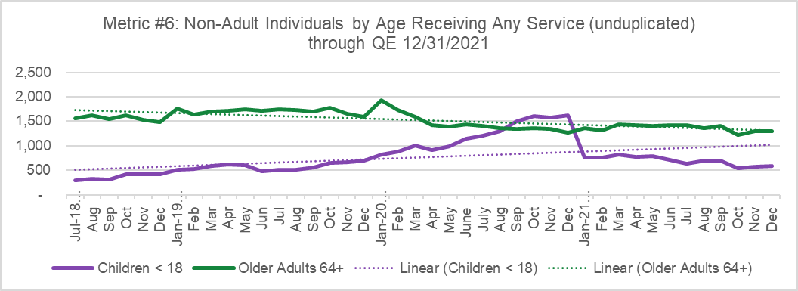

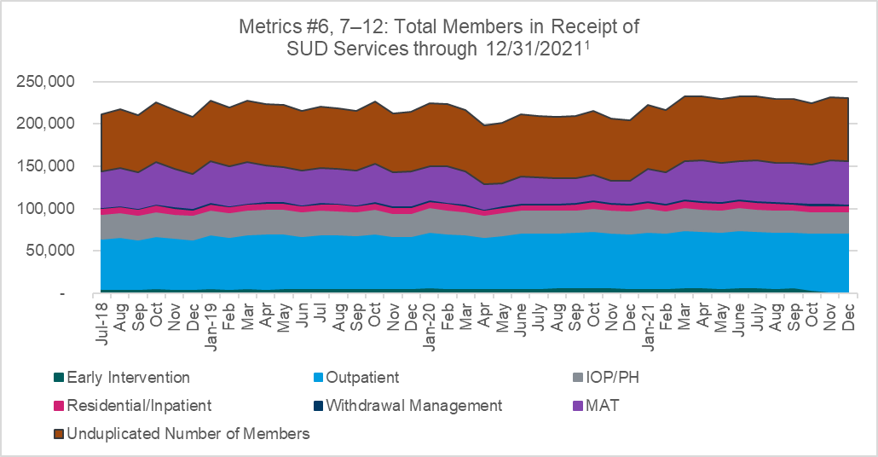
¹Total Members in receipt of SUD services DY1 (Metric #6 Unduplicated number is black line; Metrics #7-12 are in the stacked areas)

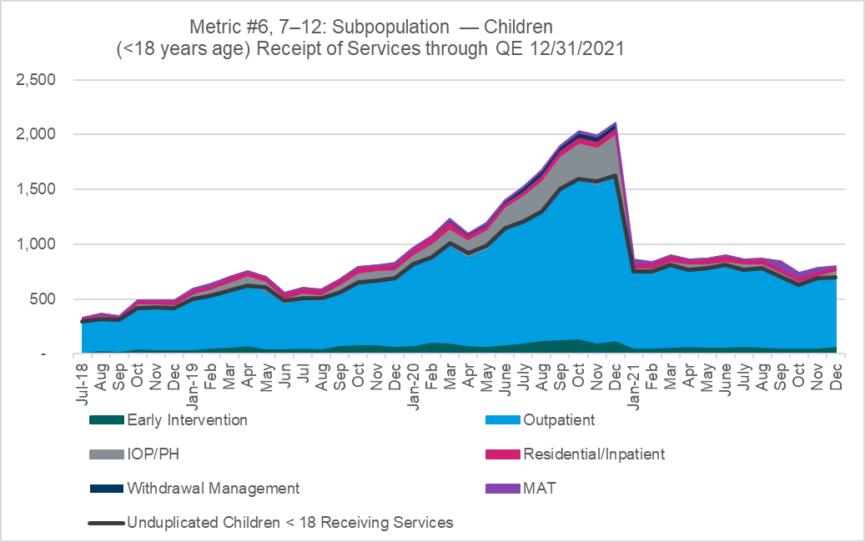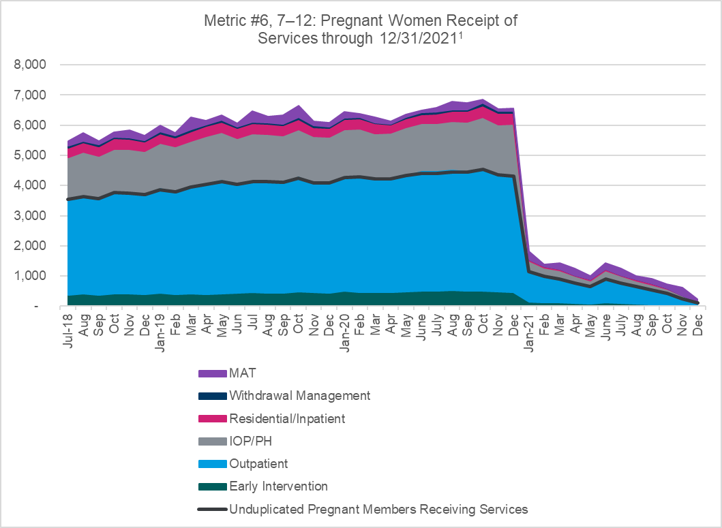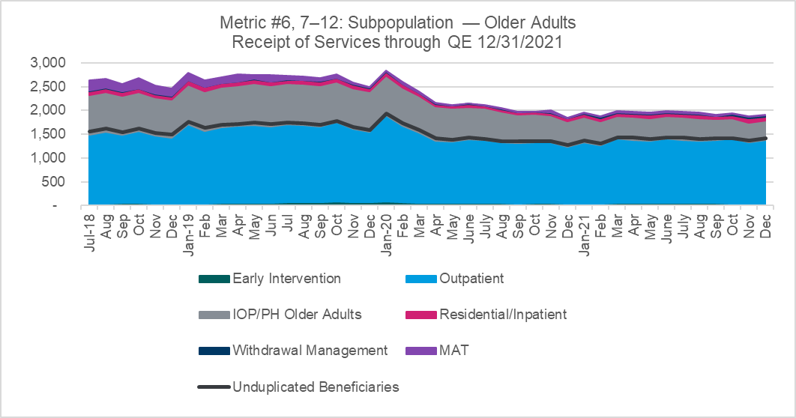
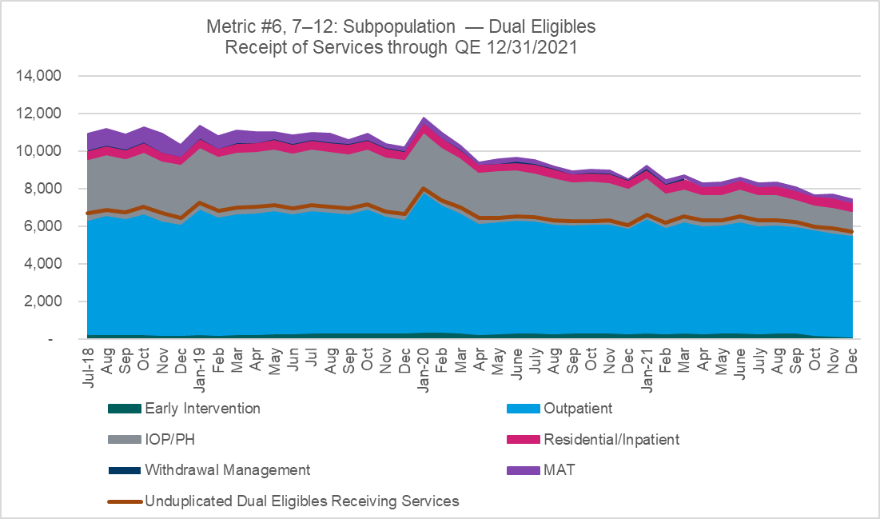

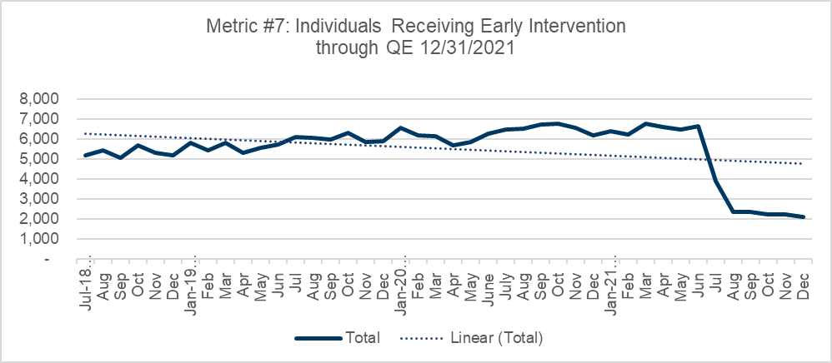
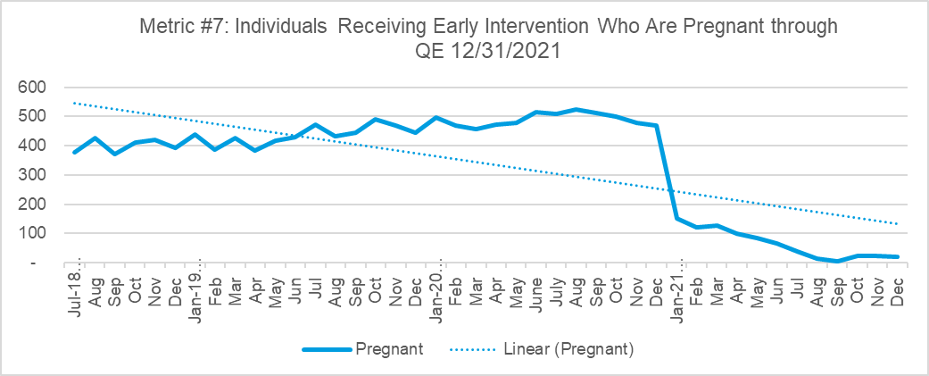
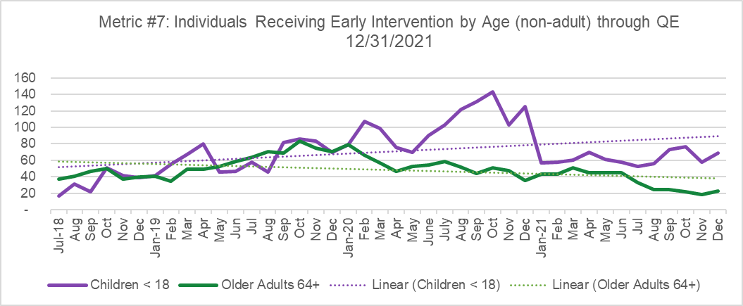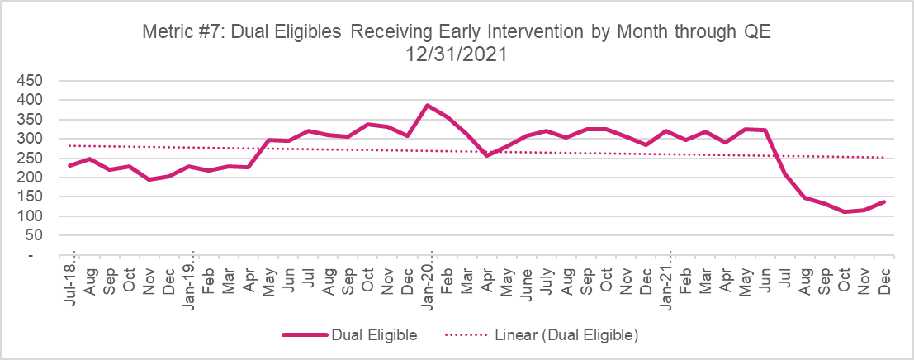

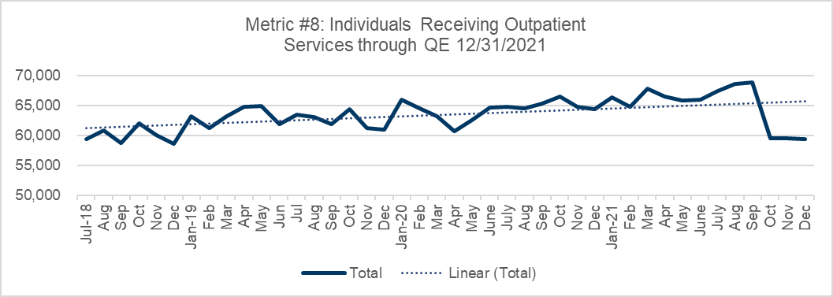
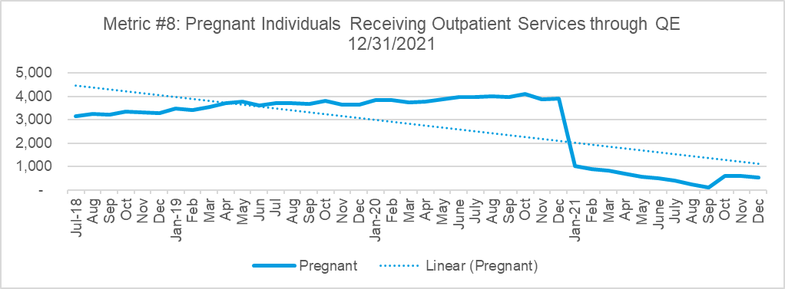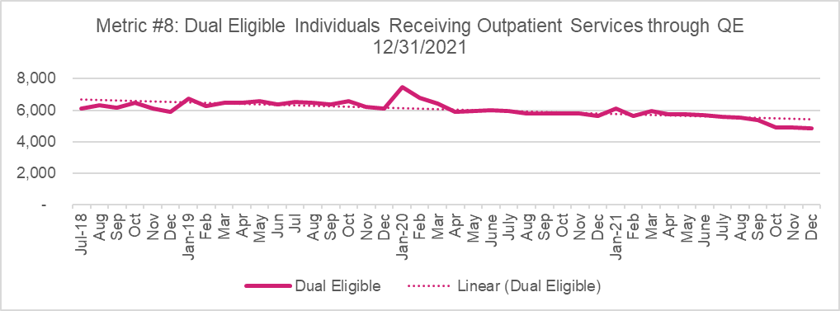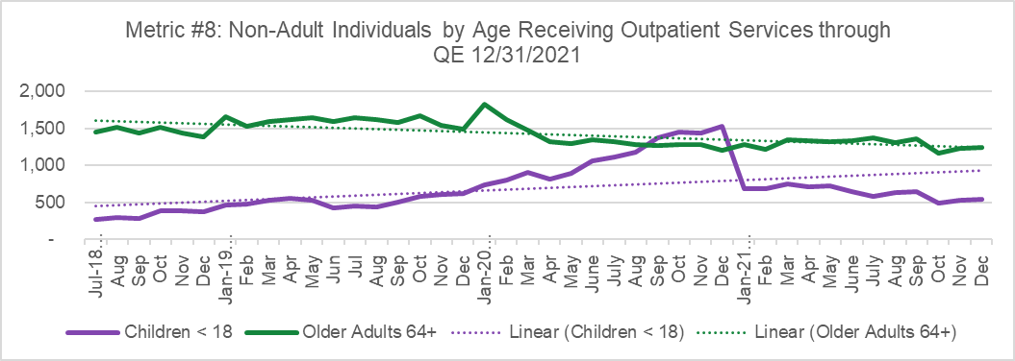

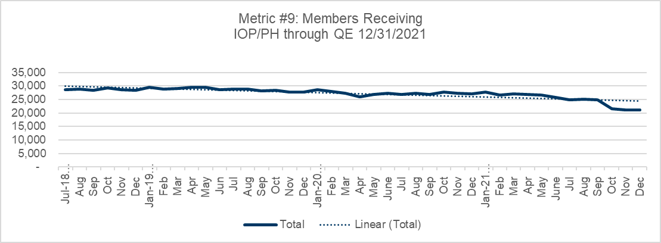
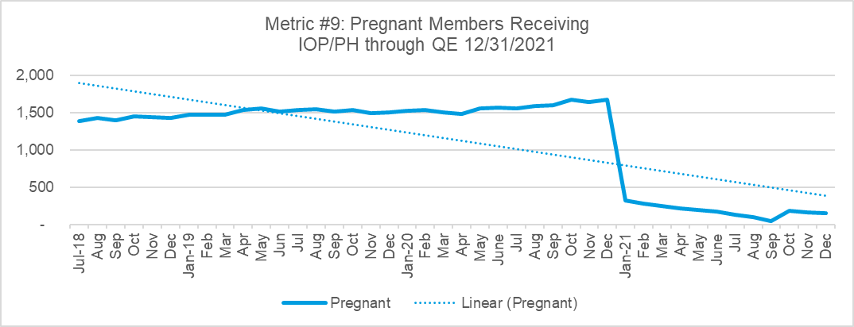

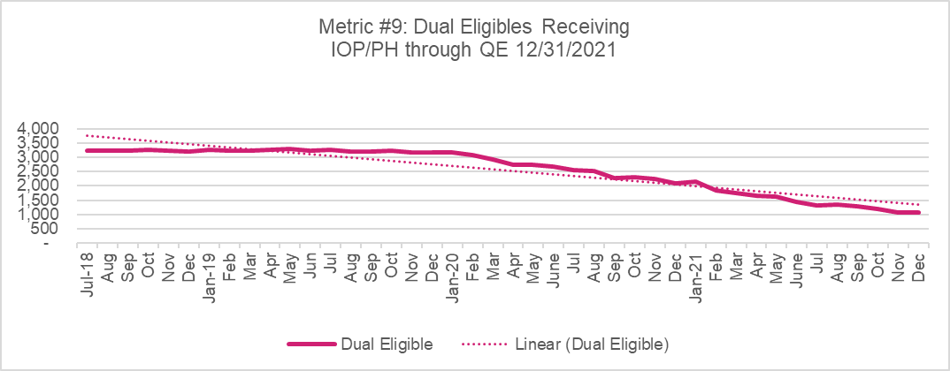

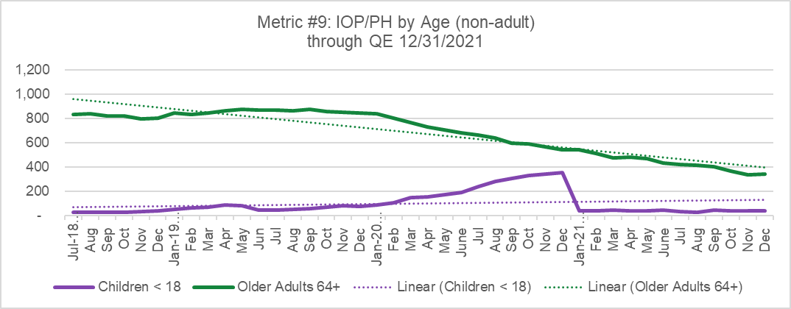

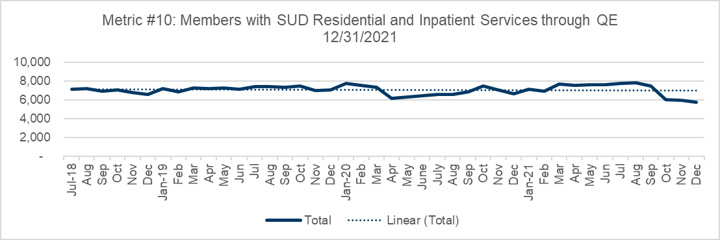
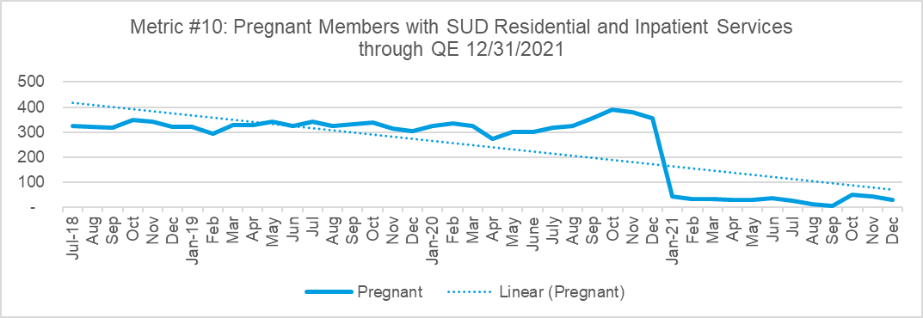
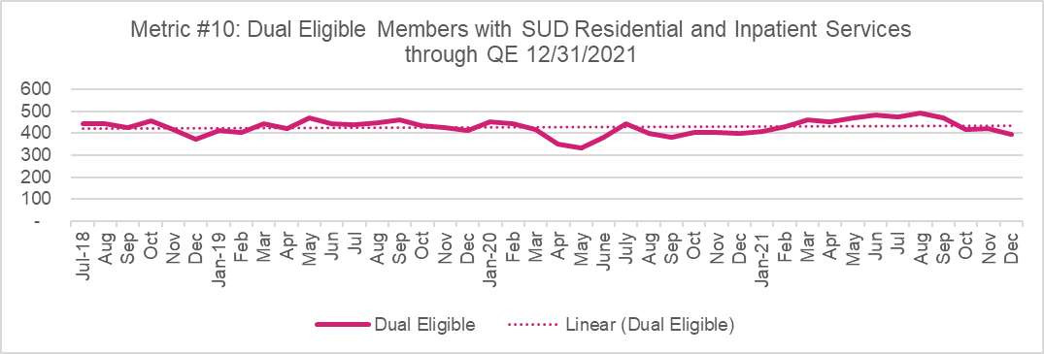
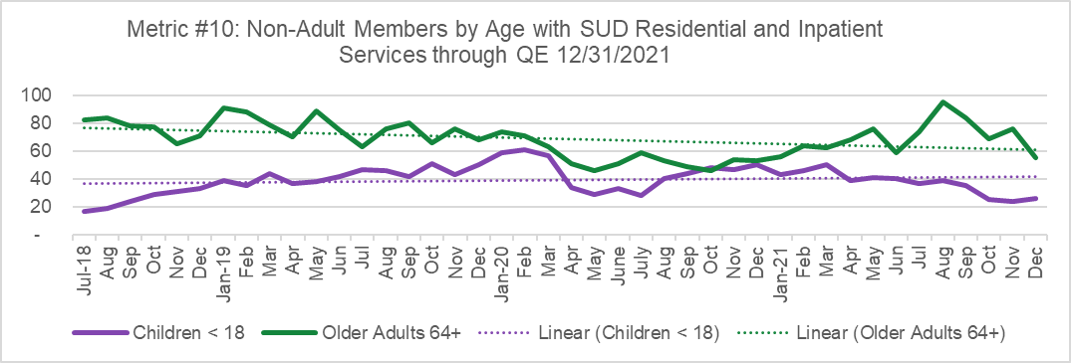
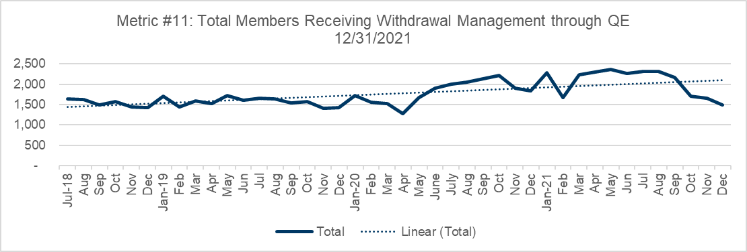
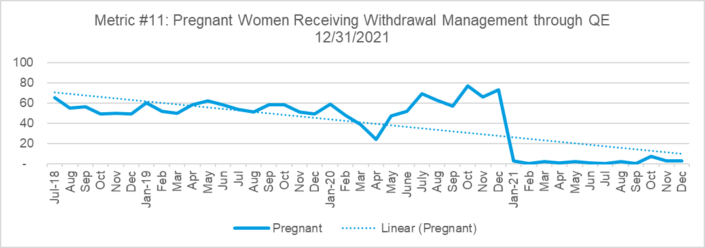
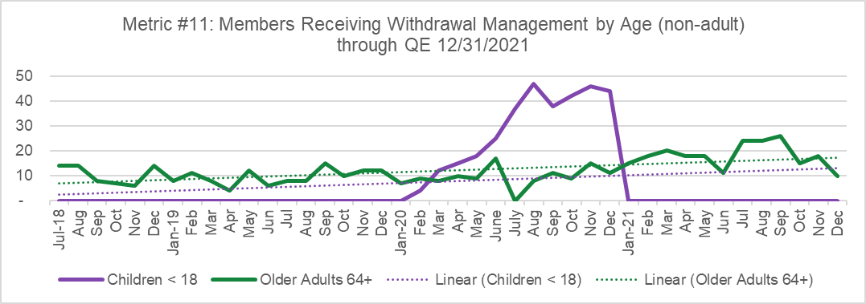
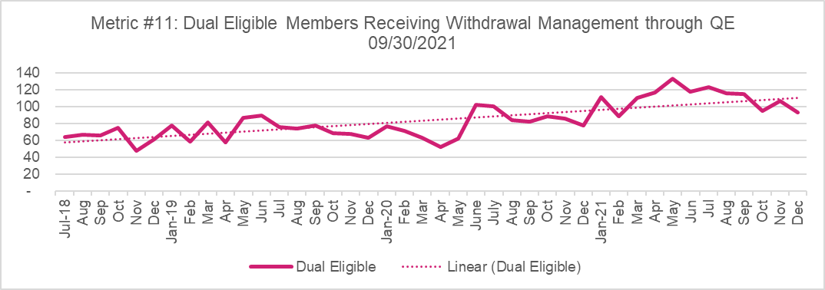
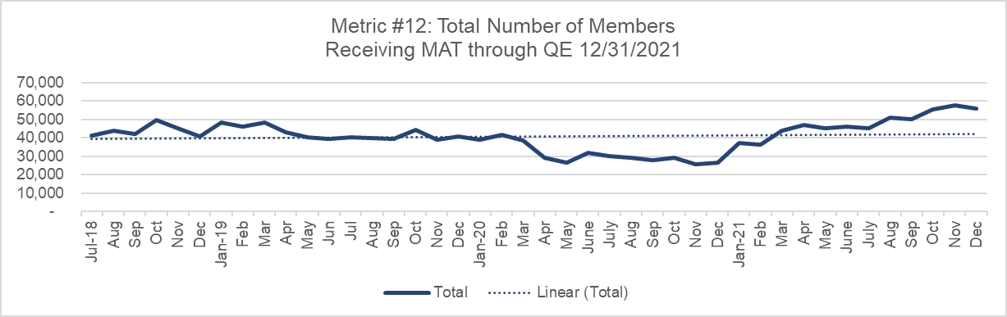
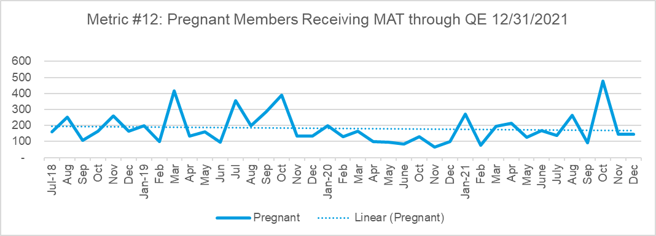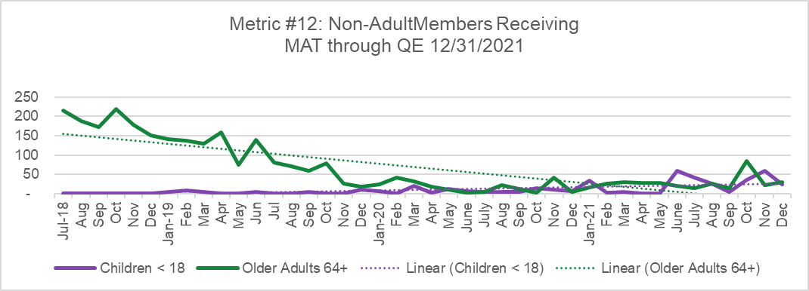
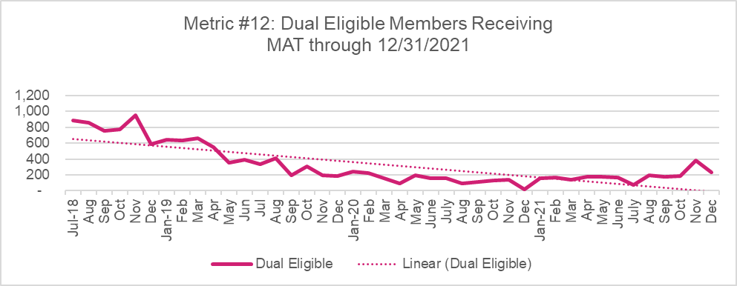

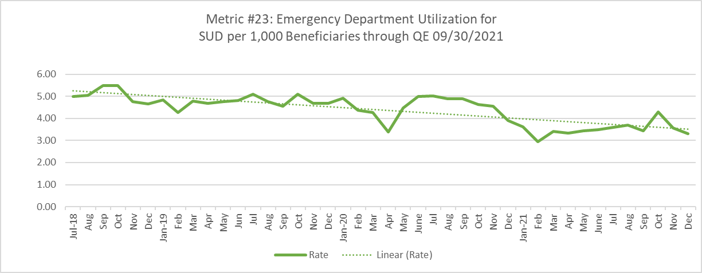
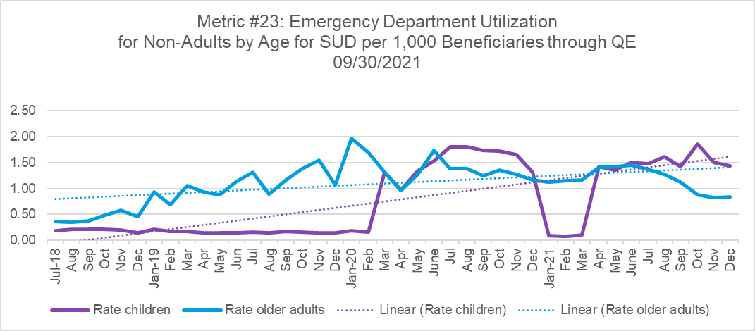
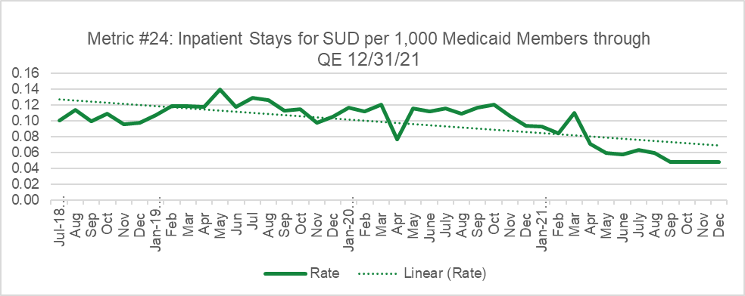
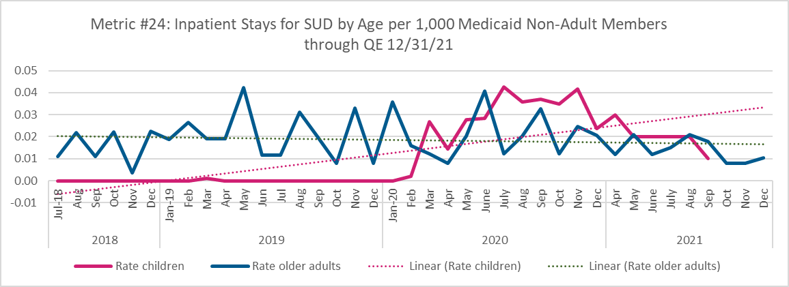

- SUD health information technology (health IT)
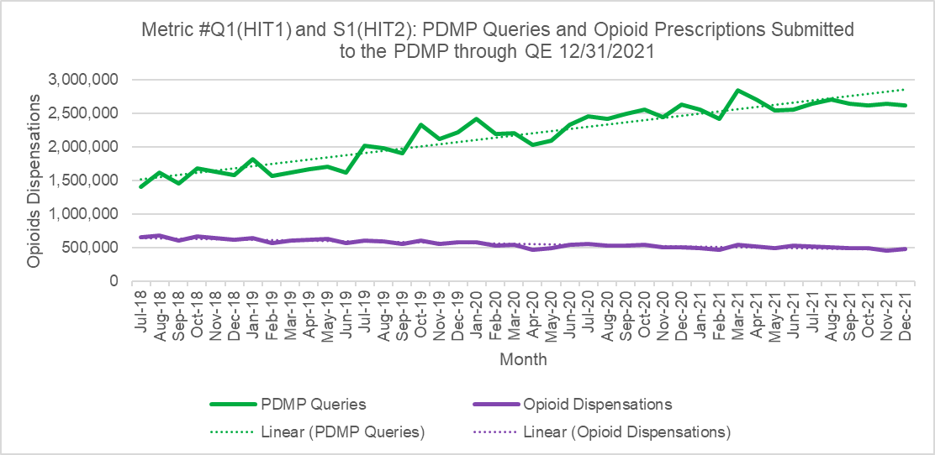
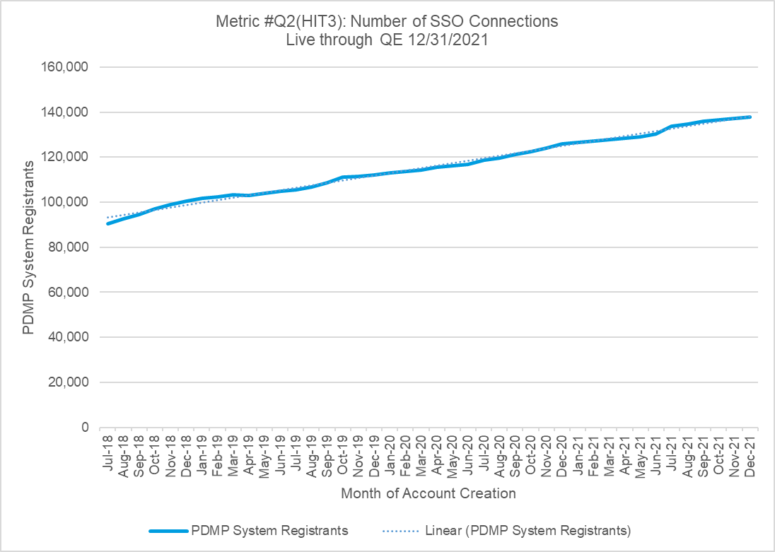
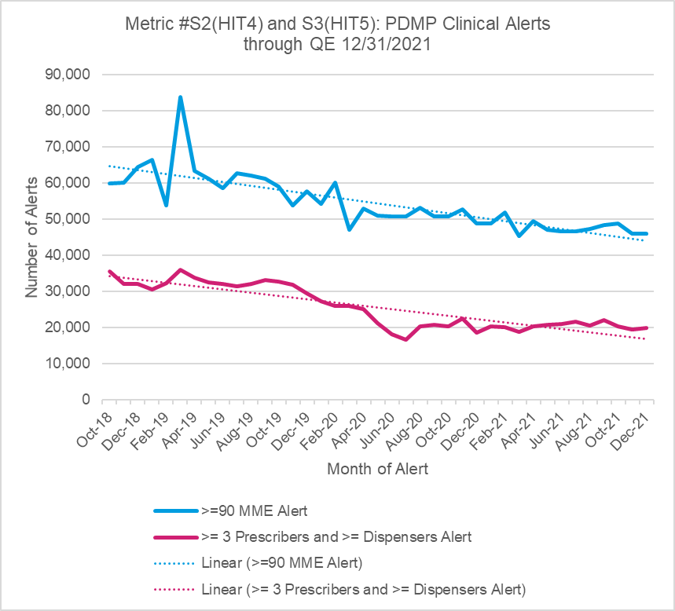
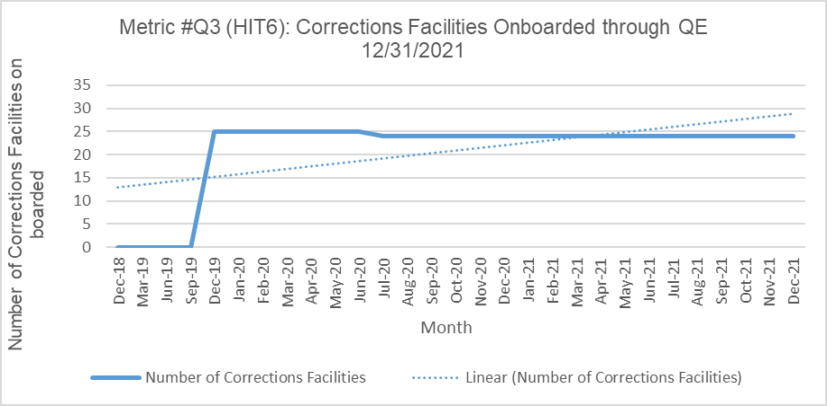
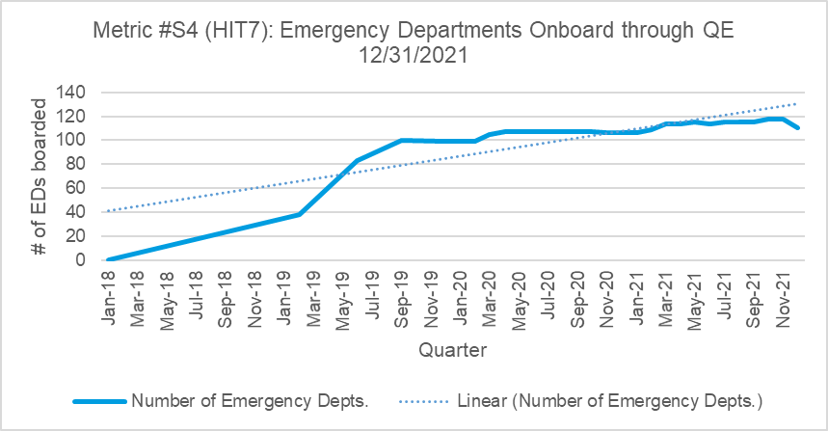
Grievances | SFY 18/19 | SFY 19/20 | SFY 20/21 | Rate 18/19-19/20 | Rate 19/20-20/21 | Description
N | 729 | 625 | 539 | -14.3% | -13.8% | The number of grievances related to SUD continues to drop over the life of the demonstration.
D | 2936 | 1987 | 1,818 | -32.3% | -8.5% | The number of grievances related to behavioral health continues to drop over the life of the demonstration.
Metric | 25% | 31% | 30% | 26.7% | -5.7% | The percentage of behavioral health grievances related to SUD increased in the first year of the demonstration and then slightly decreased in the second year of the demonstration.
Appeals | SFY 18/19 | SFY 19/20 | SFY 20/21 | Rate | Rate 19/20-20/21 | Description
N | 298 | 80 | 5 | -73.2% | -93.8% | The number of appeals related to SUD continues to drop over the life of the demonstration.
D | 1761 | 680 | 218 | -61.4% | -67.9% | The number of appeals related to behavioral health continues to drop over the life of the demonstration.
Metric | 17% | 12% | 2% | -30.5% | -80.5% | The percentage of behavioral health grievances related to SUD decreased over the life of the demonstration.
*SFY 19-20 counts have been corrected and no longer include withdrawn or pending grievances and appeals.
Not Peer Reviewed

2021 Demonstration Year Metrics
2020 DY Metrics reported to CMS DY3Q2 |  |  |  |  |  | DY2 Metrics reported to CMS DY3Q1 |  |  |  |  |  | DY3 Metrics reported to CMS DY4Q2
4 | Year | 07/1/2018-06/30/2019 |  | 289,120 |  |  | 7/1/2019-6/30/2020 |  | 313,488 |  | 7/1/2020-6/30/2021 |  |  | 308,173
5 | Year | 07/1/2018-06/30/2019 |  | 28,342 |  |  | 7/1/2019-6/30/2020 |  | 27,449 |  | 7/1/2020-6/30/2021 |  |  | 30,859
13 | Year | 07/1/2018-06/30/2019 |  | 6,575 |  |  | 7/1/2019-6/30/2020 |  | 4,643 |  | 7/1/2020-6/30/2021 |  |  | 4,643
14 | Year | 07/1/2018-06/30/2019 |  | 3,694 |  |  | 7/1/2019-6/30/2020 |  | 3,693 |  | 7/1/2020-6/30/2021 |  |  | 3,703
25 | Year | 07/1/2018-06/30/2019 |  |  |  |  | 7/1/2019-6/30/2020 | 300 | 38 | 0.126667 | 7/1/2020-6/30/2021 |  | 861 | 28 | 0.03252
26 | Year | 07/1/2018-06/30/2019 |  | 2,620 |  |  | 7/1/2019-6/30/2020 |  | 3,486 |  | 7/1/2020-6/30/2021 |  |  | 5,078
27 | Year | 07/1/2018-06/30/2019 | 3,926,077 | 2,620 | 0.667333 |  | 7/1/2019-6/30/2020 | 3,127,360 | 3486 | 1.114678 | 7/1/2020-6/30/2021 |  | 2,141,928 | 5078 | .27
36 | Year | 07/1/2018-06/30/2019 | 36,079 | 229,696 | 6.366474 |  | 7/1/2019-6/30/2020 | 31,704 | 216,713 | 6.83551 | 7/1/2020-6/30/2021 |  | 30,389 | 203,635 | 6.70094

